Data Standards Subcommittee

SCTE INDUSTRY REFERENCE

SCTE 284 2023

Cable Operator’s
Aging in Place and Telehealth Opportunity Analysis

NOTICE
The Society of Cable Telecommunications Engineers (SCTE) Standards and Operational Practices (hereafter called “documents”) are intended to serve the public interest by providing specifications, test methods and procedures that promote uniformity of product, interoperability, interchangeability, best practices, and the long term reliability of broadband communications facilities. These documents shall not in any way preclude any member or non-member of SCTE from manufacturing or selling products not conforming to such documents, nor shall the existence of such standards preclude their voluntary use by those other than SCTE members.
SCTE assumes no obligations or liability whatsoever to any party who may adopt the documents. Such adopting party assumes all risks associated with adoption of these documents and accepts full responsibility for any damage and/or claims arising from the adoption of such documents.
NOTE: The user’s attention is called to the possibility that compliance with this document may require the use of an invention covered by patent rights. By publication of this document, no position is taken with respect to the validity of any such claim(s) or of any patent rights in connection therewith. If a patent holder has filed a statement of willingness to grant a license under these rights on reasonable and nondiscriminatory terms and conditions to applicants desiring to obtain such a license, then details may be obtained from the standards developer. SCTE shall not be responsible for identifying patents for which a license may be required or for conducting inquiries into the legal validity or scope of those patents that are brought to its attention.
Patent holders who believe that they hold patents which are essential to the implementation of this document have been requested to provide information about those patents and any related licensing terms and conditions. Any such declarations made before or after publication of this document are available on the SCTE web site at https://scte.org.

All Rights Reserved
© 2023 Society of Cable Telecommunications Engineers, Inc.
140 Philips Road
Exton, PA 19341

Document Tags

☐ Specification | ☐ Checklist | ☐ Facility
☐ Test or Measurement | ☐ Metric | ☐ Access Network
☒ Architecture or Framework | ☐ Cloud | ☐ Customer Premises
☐ Procedure, Process or Method

Document Release History

Release | Date
SCTE 284 2023 | 5/1/2023
Note: Standards that are released multiple times in the same year use: a, b, c, etc. to indicate normative balloted updates and/or r1, r2, r3, etc. to indicate editorial changes to a released document after the year.

Table of Contents
Title Page Number
NOTICE 2
Document Tags 3
Document Release History 3
Table of Contents 4
1. Executive Summary 8
1.1. Scope 9
1.2. Benefits 10
1.3. Intended Audience 10
1.4. Areas for Further Investigation or to be Added in Future Versions 11
2. Normative References 11
2.1. SCTE References 11
2.2. Standards from Other Organizations 11
2.3. Published Materials 11
3. Informative References 11
3.1. SCTE References 11
3.2. Standards from Other Organizations 11
3.3. Other Published Materials 11
4. Compliance Notation 12
5. Abbreviations and Definitions 13
5.1. Abbreviations 13
5.2. Definitions 16
6. Introduction 17
6.1. Introduction to Aging in Place 18
6.2. Introduction to Telehealth 20
6.3. Intersection of AIP and Telehealth 21
6.4. Why Telecom for healthcare? 22
6.4.1. Why should Telecom and Healthcare leaders collaborate? 23
6.4.2. What Telecom technological innovations are fueling this collaboration? 23
6.5. Organization of the document 24
7. Market landscape 25
7.1. Framework of analysis 25
7.2. Aging in Place company survey 26
7.2.1. U.S. companies 26
7.2.2. International companies 37
7.2.3. AIP company summary 39
7.3. Telehealth company survey 40
7.3.1. U.S. companies 40
7.3.2. Canadian companies 46
7.3.3. International companies 47
7.3.4. Telehealth company summary 49
7.4. Recommendations for opportunities 51
7.4.1. AIP opportunities 51
7.4.2. Telehealth opportunities 51
8. Business requirements 52
8.1. Aging in Place business requirements 52
8.1.1. Older adult/Patient needs 52
8.1.2. Provider needs 53
8.1.3. Payor needs 54
8.1.4. Support Team 54
8.1.5. Infrastructure 55
8.1.6. Serviceability needs 56
8.2. Telehealth business requirements 58
8.2.1. Patient needs 58
8.2.2. Provider needs 59
8.2.3. Policy needs 60
8.2.4. Payors needs 61
8.2.5. Hospitals needs 61
8.2.6. Support team needs 62
8.2.7. Infrastructure needs 63
8.2.8. Serviceability needs 64
9. Use Cases 66
9.1. Introduction 66
9.2. The Opportunity 66
9.3. The Stakeholders 68
9.3.1. Infrastructure 69
9.4. Key Use Cases 70
9.4.1. Aging in Place 70
9.4.2. Independent Living 71
9.4.3. Hospital at Home 71
9.5. Services 72
9.6. Cable Operator Solutions 73
9.7. Conclusions 73
10. Business case for operators 74
10.1. Aging in Place business case 74
10.1.1. Market sizing 74
10.1.2. Business model 77
10.1.3. Business case analysis 81
10.2. Telehealth business case 85
10.2.1. Market sizing 85
10.2.2. Business model 86
10.2.3. Business case analysis 90
10.3. Conclusions and recommendations 94
10.3.1. Aging in Place conclusion and recommendations 94
10.3.2. Telehealth conclusions and recommendations 95
11. Overall recommendation to Cable Operators 97
12. Appendix A: Terminology 99
12.1. Aging in Place terminology 99
12.2. Telehealth terminology 100
13. Appendix B: Detailed business requirements 113
13.1. Aging in Place business requirements 113
13.1.1. Elder/Patient 113
13.1.2. Provider 122
13.1.3. Payor 125
13.1.4. Support Team 127
13.1.5. Infrastructure 127
13.1.6. Serviceability 134
13.2. Telehealth business requirements 134
13.2.1. Patient 134
13.2.2. Provider 142
13.2.3. Policy 142
13.2.4. Payors 150
13.2.5. Hospitals 150
13.2.6. Support Team 157
13.2.7. Infrastructure 161
13.2.8. Serviceability 164

List of Figures
Title Page Number
Figure 1 - The cable industry can bring reach, investments and workforce to the wellness industry 18
Figure 2 - High level mapping of the cable operator capabilities and the AIP needs 20
Figure 3 Mapping of Telehealth needs, the operator capabilities and the metrics to assess success 21
Figure 4 Categories of literature provided by AgingInPlace 27
Figure 5 Specialized care provided by Comfort Keepers 27
Figure 6 Elli Q Assistant 28
Figure 7 Functions of the Elli Q Assistants 28
Figure 8 FirstLight care services 29
Figure 9 Lively's smartphone and flip phone 29
Figure 10 Balanced Care Method created by Home Care Assistance 30
Figure 11 TeleCalm device to reroute calls 31
Figure 12 Benefits of using TeleCalm 31
Figure 13 Tricella pillbox and corresponding app 32
Figure 14 TytoCare prices 32
Figure 15 TytoCare for professionals 33
Figure 16 TytoCare devices 33
Figure 17 Visiting Angel's Life Care Navigation provides personalized care 34
Figure 18 What Vayyar Home sensors detect 35
Figure 19 How businesses can use Vayyar Home 35
Figure 20 Vayyar Home devices 36
Figure 21 Some of Domalys' products 37
Figure 22 cAlarm service provided by FocusCura 38
Figure 23 Kraydel interface 38
Figure 24 Package and benefits for Konnect Device 38
Figure 25 SOFIHUB home and beacon assisted living device and safety pendant 39
Figure 26 Functionalities of SOFIHUB 39
Figure 27 Breakdown of AIP companies based of White House Emerging Technologies paper 40
Figure 28 Product categories that AMD targets 41
Figure 29 Amwell simulated platform and forms of technology 41
Figure 30 Market segments Amwell is currently working in 41
Figure 31 Arista MD aims to expand the customers health network 42
Figure 32 AristaMD's eConsults system 42
Figure 33 Different sectors of BioTelemetry 42
Figure 34 Telehealth arrhythmia monitoring 43
Figure 35 Medtech breakthrough award 43
Figure 36 Simulated Doctors on Demand platform 43
Figure 37 3 steps Lemonaid health follows 44
Figure 38 Services Livongo provides through their platform 44
Figure 39 Conditions NurtiMedy has targeted 45
Figure 40 Philip’s enterprise telehealth guide for scaling their infrastructure 45
Figure 41 InTouch Health's integrated platform called Solo™ 46
Figure 42 InTouch Health's integrated platform called Solo™ 46
Figure 43 Description of how Maple works 46
Figure 44 Workflow of the diagnostic point 47
Figure 45 Focuscura services 47
Figure 46 SthethoMe's technology incorporated into the stethoscope 48
Figure 47 Resideo Life Care Solution's platform components 48
Figure 48 Best Practice Award given by Frost & Sullivan 49
Figure 49 A conservative estimation of US telecom for wellness opportunity from DTS³⁴ 67
Figure 50 A telehealth environment framework 68
Figure 51 Different stakeholders an operator can address with their AIP solutions 74
Figure 52 2020 AARP report forecasts that 53 million acted as caregivers to older adults 75
Figure 53 Projected AIP market size for different stakeholders 75
Figure 54 Mapping aging population needs to offer which in turn mapped to the operator capabilities 76
Figure 55 Telecom operators projected market size by the offers 79
Figure 56 High level business models assumed in the revenue, cost and profitability analysis 80
Figure 57 10-year revenue forecast for different market segments 81
Figure 58 10-year revenue forecast by different offers 81
Figure 59 High level estimated cost breakdown by AIP product offering 84
Figure 60 AIP 10-year profitability forecast by offer 85
Figure 61 Different stakeholders an operator can address with their Telehealth solutions 85
Figure 62 Projected Telehealth market size for different stakeholders 86
Figure 63 Cable operators projected market size by the stakeholder 88
Figure 64 High level business model assumed in the revenue, cost, and profitability analysis 89
Figure 65 10-year revenue forecast for different market segments 90
Figure 66 10-year revenue forecast by different offers 90
Figure 67 High level estimated cost breakdown by AIP product offering 93
Figure 68 Telehealth 10-year profitability forecast by offer 94
Figure 69 Overall recommendations to address Telecom for Wellness by the cable operators 97

List of Tables
Title Page Number
Table 1 Aging-in-place Services 70
Table 2 Independent living Services 71
Table 3 Hospital-at-home Services 71
Table 4 Common problems in healthcare industry and which stakeholders face them 87

Executive Summary
US healthcare costs are increasing at 5.4% year over year and are estimated to reach $5.6 trillion by 2026. The US healthcare industry is huge, and policymakers have been concerned by its growth relative to total gross domestic product (GDP). The criticism is sometimes characterized by the idea that the US healthcare system is a sick-care system and that boundaries must be broadened to effect positive change on the national healthcare. Wellness and social determinants of health are important items for discussion within the healthcare industry. In this report, we have expanded beyond the traditional market boundaries of the healthcare industry and consider segments like wellness and elements of the social determinants of health such as housing for older adults. This represents an interesting opportunity for cable telecommunication operators with a strong residential and business franchise presence. We call these inter-industry collaborations the Telecom for Healthcare (T4H) opportunity.
The caregiving industry has been modernizing its infrastructure intending to control costs and improve the quality of care. Telehealth is one such mechanism that has been gaining adoption. Telehealth played a critical role in virtualizing care during the COVID pandemic. Telehealth has been growing at a yearly rate of ~15% with 2020 seeing a 175x increase in telehealth adoption mainly due to COVID-19. This telehealth infusion is driven by increased patient and provider adoption, better reimbursements, and relaxed regulations. Although adoption may slow after COVID, telehealth benefits are recognized and are here to stay. Telehealth is not just video communications, but it also touches on different technological solutions that cable operators have mastered and been deploying. Healthcare has lagged most industries regarding the virtualization of services. Consider how the retail, finance, and entertainment industries have been transformed by digital technology over the last decade. The potential disruption to healthcare is inevitable. The cable industry not only brings technology but also leadership in building standards-based platforms that can deliver critical cost reductions required to assist the healthcare industry.
Center for Medicare and Medicaid Services (CMS) projects up to $5.5T healthcare spend in 2026. We project, of the total spend, $3T can be better addressed by virtualizing the care models with telehealth and better connecting the existing wellness and housing sectors to the healthcare industry. Out of which, $1.3T can be addressed by cable operators. In this report, we demonstrate some of the needs that cable operators can support using their developing capabilities such as in-home technologies, Internet of Things (IoT), broadband communication enhancements, consumer service development, platform standardization expertise, back-office capabilities, and installation and support resources.
In this report, we analyze different services which are driving caregiving costs that can be addressed by these T4H initiatives. These services include aging in place (AIP) and telehealth (TH) services. TH and AIP present exciting opportunities for cable and fiber operators to offer new products and add value to existing services.

Scope
This technical report provides detailed information on the TH/AIP market landscape, business requirements, use cases, business case for operators, and terminology.
Market Landscape: AIP and telehealth are a multi-trillion and multi-billion-dollar industry, respectively. As people shift to wanting to age at home as well as the expansion of virtual health services become more adopted, operators need to understand the market landscape. This section will:
- Describe the current state and anticipated growth of each market
- Discuss some companies we analyzed and how we evaluated these companies
- Detail shortcomings and gaps in available solutions
The market landscape section will discuss what market areas operators can target and make recommendations on how they can approach the TH/AIP market.
Business Requirements: The delivery of telehealth and AIP solutions involves a complex web of stakeholders. This section highlights business requirements pertinent to the below stakeholders in each market
- Telehealth
  - Patients
  - Providers
  - Payors
  - Policy
  - Hospitals
  - Support team
  - Infrastructure
  - Serviceability
- Aging in place (considers White House categories mentioned above)
- Patients/Older adults
  - Providers
  - Payors
  - Support team
  - Infrastructure
  - Serviceability
The requirements capture multiple aspects of TH/AIP such as data security, medical device integration, and electronic health records. Each requirement is identified with a unique code based on its stakeholder, classification, and sub-classification. A weighting of high, medium, low, or informative was assigned to each requirement; high – life safety, medium – security/privacy, low – quality of experience, informative – instruction/information. The goal of these business requirements is to guide operators on what to consider for each stakeholder when working in the TH/AIP space.
Use Cases: This section identifies the most relevant telehealth and AIP use cases to which cable and fiber operators can add value. These use cases are derived from the prioritized requirements analysis, market survey, and business case development. They can be used to identify solutions cable operators should target that will lead to robust TH/AIP service offerings.
Business Case: Having established the potential of the telehealth and AIP markets we discuss the opportunities for cable operators to add additional value to each space. The business case section is an extension of the papers presented at SCTE Cable-Tec® Expo 2020 and will provide a detailed business analysis of the TH/AIP space. It will present the overall US-based market size before discussing different business models, revenue options, cost drivers, and business model sensitivity.
Terminology: The report concludes by defining important terms unique to the telehealth and AIP markets. For example, everything from assisted living to memory care to independent living facilities will be included. Although AIP is aimed to keep older adults independent in their own homes, it is worth exploring the other options older adults have and their applicable terminologies. For telehealth there are technical terms to understand from both the medical and virtual ends. The terminology section also includes important codes and regulations identified to get started in understanding the nuances of telehealth. While this list is not fully comprehensive of both AIP and telehealth, it is a start to understanding these complex industries.

Benefits
This document motivates the SCTE members (both the operators and the vendors) to invest in the most lucrative Telecom for Healthcare (T4H) opportunities. This document should be used by the operators
- to understand the needs of T4H and how to address them with their current capabilities
- in identifying the differentiators, they should consider in developing the T4H solutions, and
- to develop a roadmap of deployable solutions the operators can develop to address this market

Intended Audience
This document is meant for the telecom operators’ (both cable and fiber operators) strategy, product, and technology leaders who are trying to extend their services to healthcare and wellness industry. This document is created to motivate this T4H inter-industry opportunity.

Areas for Further Investigation or to be Added in Future Versions
Not applicable.

Normative References
The following documents contain provisions, which, through reference in this text, constitute provisions of this document. At the time of Subcommittee approval, the editions indicated were valid. All documents are subject to revision; and while parties to any agreement based on this document are encouraged to investigate the possibility of applying the most recent editions of the documents listed below, they are reminded that newer editions of those documents might not be compatible with the referenced version.

SCTE References
No normative references are applicable.

Standards from Other Organizations
No normative references are applicable.

Published Materials

Informative References
The following documents might provide valuable information to the reader but are not required when complying with this document.

SCTE References
No informative references are applicable.

Standards from Other Organizations
No informative references are applicable.

Other Published Materials
- Ian Wheelock, Charles Cheevers, Sudheer Dharanikota, Ayarah Dharanikota, The business case for Aging in Place with cable operators, SCTE Expo 2020, October 2020
- Sudheer Dharanikota, Ayarah Dharanikota, Why are Cable Operators natural fit to support Telehealth - An inter-industry perspective, SCTE Expo 2020, October 2020
- Sudheer Dharanikota, Ayarah Dharanikota, Dennis Edens, Bruce McLeod, Aging in Place business case for cable operators, SCTE Journal, June 2021
- Sudheer Dharanikota, Ayarah Dharanikota, Dennis Edens, Bruce McLeod, Aging in Place market landscape from a cable operators’ perspective, SCTE Journal, June 2021
- Sudheer Dharanikota, Ayarah Dharanikota, Dennis Edens, Bruce McLeod, Telehealth business case for cable operators, SCTE Journal, September 2021
- Sudheer Dharanikota, Ayarah Dharanikota, Dennis Edens, Bruce McLeod, Telehealth market landscape from a cable operators’ perspective, SCTE Journal, September 2021
- Sudheer Dharanikota, Clarke Stevens, End to End Telehealth Architecture: A Cable Industry Perspective, SCTE Expo 2021, October 2021
- Sudheer Dharanikota, Jason Page, Metadata/Telemetry Support to Enable Telecom for Healthcare Opportunities, SCTE Expo 2021, October 2021

Compliance Notation
shall | This word or the adjective “required” means that the item is an absolute requirement of this document.
shall not | This phrase means that the item is an absolute prohibition of this document.
forbidden | This word means the value specified shall never be used.
should | This word or the adjective “recommended” means that there may exist valid reasons in particular circumstances to ignore this item, but the full implications should be understood, and the case carefully weighted before choosing a different course.
should not | This phrase means that there may exist valid reasons in particular circumstances when the listed behavior is acceptable or even useful, but the full implications should be understood, and the case carefully weighed before implementing any behavior described with this label.
may | This word or the adjective “optional” means that this item is truly optional. One vendor may choose to include the item because a particular marketplace requires it or because it enhances the product, for example; another vendor may omit the same item.
deprecated | Use is permissible for legacy purposes only. Deprecated features may be removed from future versions of this document. Implementations should avoid use of deprecated features.

Abbreviations and Definitions

Abbreviations
AAFP | American Association of Family Physicians
AARP | American Association of Retired Persons
AAP | Academy of Pediatrics
ACA | Affordable Care Act 2010
ADA | American Dental Association
ADLs | activities of daily living
AHCA | American Healthcare Association
AI | artificial intelligence
AIP | aging in place
AMD | AMD Global Telemedicine
AMR | ambulatory medical record
AMS | Aerotel Medical Systems
AMWL | American Well
ArMD | Arista MD
ARRA | American Recovery and Reinvestment Act of 2009
ASC | Accredited Standards Committee
ASTM | American Society for Testing and Materials
ATCB | Authorized Testing and Certification Body
AUC | appropriate use criteria
BA | business associate
BAA | Business Associate Agreement
BBRA | Balanced Budget Refinement Act of 1999
BCMA | Bar Code Medication Administration
BEAT | Bio Telemetry
BH | behavioral health
BHOM | behavioral health outcome management
BIPA | Benefits Improvement and Protection Act
BMD | Bright MD
BMP | basic metabolic panel
BRFSS | Behavioral Risk Factor Surveillance System
BTRIS | Biomedical Translational Research Information System
CAH | critical-access hospital
CAT | computerized axil tomography
CCC | clinical care classification
CCD | continuity of care document
C-CDA | consolidated clinical document architecture
CCDS | common clinical data set
CCM | chronic care management
CCMM | continuity of care maturity model
CCO | chief compliance officer
CCR | continuity of care record
CDA | clinical document architecture
CDC | Center for Disease Control
CDR | clinical data repository
CDS | clinical decision support
CDSS | clinical decision support system
CDT | current dental terminology
CDW | clinical data warehouse
CE | coded element
CEHRT | certified electronic health record technology
CEME | communication-enabled medical encounters
CF | conditional formatting/ coded formatted element
CGI | common gateway interface
CHIN | community health information network
CHIP | Children’s Health Insurance Program
C-HOBIC | Canadian Health Outcomes for Better Information and Care
CHPL | certified health information technology product list
CHV | consumer health vocabulary initiative
CIO | chief information officer
CIS | clinical information system
CISC | complex instruction set computer or computing
CK | Comfort Keepers
CMET | common message element type
CMIO | chief medical information/informatics officer
CMO | chief medical officer
CMR | Comarch
CMS | Centers for Medicare & Medicaid Services
CMS | content management services
CNIO | chief nursing information/informatics officer
CNS | Canadian Nurses Association
COAS | clinical observations access service
COB | coordination of benefits
COVID | Coronavirus disease
CPC | comprehensive primary care initiative
CPC + | comprehensive primary care initiative plus
CPOE | computerized practitioner order entry
CPRS | computer-based patient record system
CPT | Current Procedural Terminology
CQL | clinical quality language
CQM | clinical quality measures
CRA | Countermeasure Response Administration
CTG | cardiotocography
CUI | concept unique identifier
CVS | concurrent versioning system
CWE | coded with exceptions
DMD | durable medical devices
DOM | Domalys
DonD | Doctors on Demand
DOS | denial of service
DSM-IV | Diagnostic and Statistical Manual of Mental Disorders 4
DTS | Duke Tech Solutions
ECG | electrocardiogram
eCQMs | electronic clinical quality measures
eHealth | electronic health
EHR | electronic health record
EMR | electronic medical record
EU | European Union
EQ | Elli.Q
FC | FocusCura
FHC | FirstLight Home Care
FHIR | fast healthcare interoperability resources
FSA | flexible spending account
GC | GreatCall
GDP | gross domestic product
HAH | hospital at home
HCA | Home Care Assistant
HCBS | home and community-based services
HHA | home healthcare agencies
HHS | Health and Human Services
HIMSS | Health Information and Management Systems Society
HIPAA | Health Insurance Portability and Accountability Act
HISC | Home Instead Senior Care
HITECH | Health Information Technology for Economic and Clinical Health
HL7 | Health Level Seven
IADL | instrumental activities of daily living
IandS | Install and Support
ICD-9 | International Classification of Disease – Ninth Revision
ICU | intensive care unit
IHE | Integrating the Healthcare Enterprise
INR | international normalized ratio
IoMT | internet of medical things
ITH | InTouch Health
KPH | Koninklijke Philips
KRA | Kraydel
LMH | Lemonaid Health
LOH | Livongo Health
MDO | MyDoc
MIPPA | Medicare Improvements for Patients and Providers Act 2008
ML | machine learning
MMS | Massachusetts Medical Society
MPL | Maple
MSO | multiple service provider
NAIPC | National Aging in Place Council
NIH | National Institutes of Health
NLC | Nursing Licensure Compact
NMD | NutriMedy
NSSP | National Syndromic Surveillance Program
ONC | Office of the National Coordinator
ONC-ACB | ONC-Authorized Certified Body
ONC-ATLs | ONC-Authorized Testing Labs
PCP | primary care physician
PHI | protected health information
PHIN | public health information network
PHR | personal health record
PIN | personal identification number
POA | power of attorney
PrH | Premier Health
PROs | patient-reported outcomes
RIM | reference information model
RISC | reduced instruction set computing
RLCS | Resideo Life Care Solutions
ROI | return on investment
RPM | remote patient monitoring
RR | respiratory rate
SDOs | Standards Development Organizations
SLA | service level agreement
SHS | Seniors Helping Seniors
SOH | SOFIHUB
STM | StethoMe
T4H | Telecom for Healthcare
TC | TeleCalm
TH | telehealth
TRI | Tricella
TYC | TytoCare
USCDI | U.S. Core Data for Interoperability
VA | Visiting Angel
VH | Vayyar Home
WHO | World Health Organization
YOY | year over year

Definitions
Refer to Appendix A: Terminology for detailed definitions.

Introduction
Over the years the US healthcare spending has been on a continuous rise with $3.8 Trillion being spent in 2019 alone, a 4.6% increase from 2018. It is expected to reach $5.6 Trillion by 2026. The majority of this spend is between hospitals (31%) and physicians & clinics (20%). As the spending continues to increase, it is imperative to how the healthcare system is changing to accommodate for that change. One such change is a move towards value-based care versus a fee-for-service model. Value-based care focuses on paying providers (hospitals/physicians/caregivers) based on a patient’s outcome. Fee-for-service pays providers based on how many services they deliver. This shift opens to door for increased efficiencies, higher patient satisfaction, reduced spending, and overall better patient wellness.
Hand-in-hand with value-based care is the further understanding of social determinants of health. Social determinants of health are an understanding of how environments where we are born, live, worship, age, etc. affect our health and quality of life. These determinants fall under 5 categories: economic stability, education access and quality, health care access and quality, neighborhood and build environment, and social and community context. With an awareness of how these social determinants of health have an impact on our well-being, we get another step closer to addressing health disparities and inequalities in our health system. Both aging in place (AIP) and telehealth take these principles into consideration to help bridge the healthcare gaps and aging needs.
We believe the cable operator assistance to the healthcare/wellness industry, in a short form referred to as Telecom for Healthcare (T4H), offers many opportunities to assist with the value-based services in the healthcare industry. For example:
The aging in place concepts supported by the operators:
- Allows older adults with equitable access to healthcare
- Matches easily with elder needs to the well-vetted solutions that operators have been deploying
- Provides the ability to maintain independence by seamlessly integrating technologies, and
- Offers these solutions at lower costs compared to what the healthcare system is paying right now
The telehealth concepts supported by the operators:
- Helps bring telehealth concept to > 90% of the homes connected by the cable operators
- Reduces the cost and travel constraints with well-developed unified communication solutions
- Interconnects the specialists, providers, and family seamlessly
- Increases the reach for healthcare providers without investment in the brick-and-mortar offices
- Pushes to have equal access to telehealth solutions, and
- Reduces the digital divide in certain groups (social determinants of health in older adults, underserved, etc.)
In turn the cable operators benefit from these solutions in:
- Expanding their current offerings into the healthcare/wellness vertical
- Increasing stickiness of their customer base
- Collaborating with other industries with their existing capabilities, and
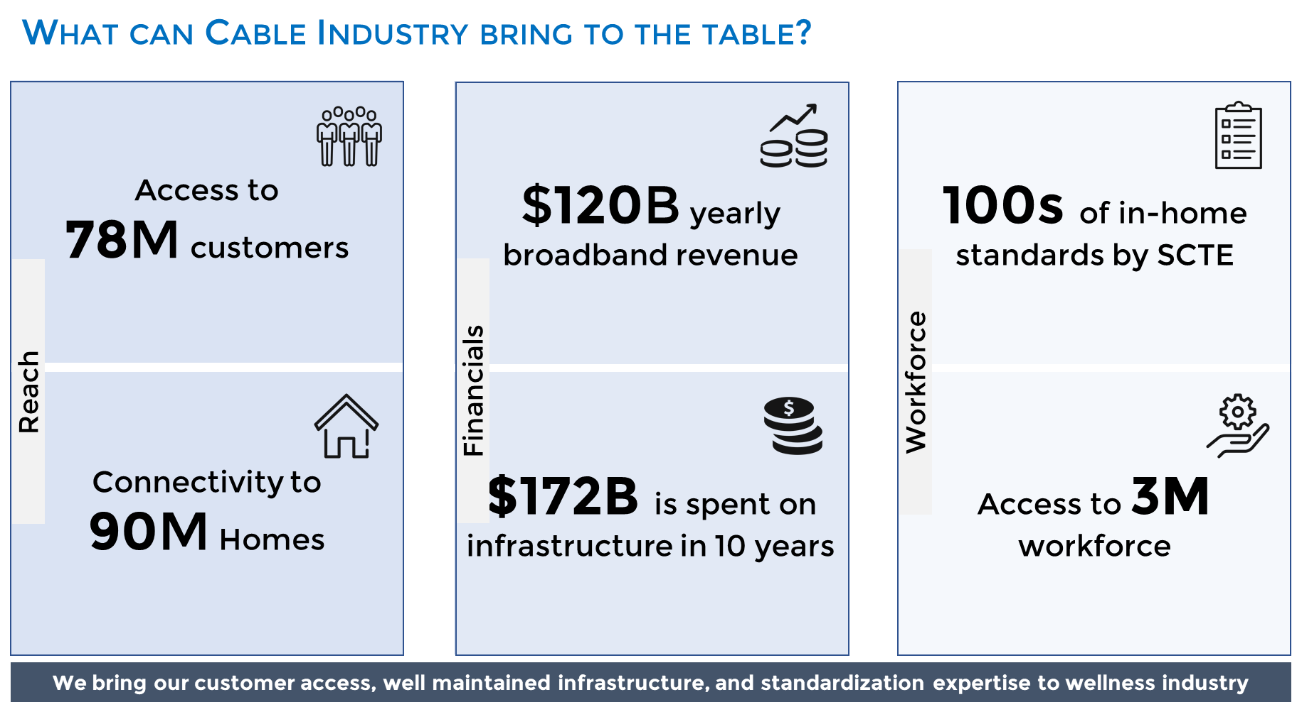
- Assisting the population in making difference in the social determinants
- Figure 1 - The cable industry can bring reach, investments and workforce to the wellness industry
The cable industry is a mature technology partner for the wellness industry where it can offer (as shown in Figure 1) the reach to 90+% of the US population, significant investments to upgrade the telecom and technology infrastructure, and access to the millions of workforce to turn the vision to a sustainable service. These are explained in detailed in the context of AIP and telehealth in this document.

Introduction to Aging in Place
By 2034, in United States (US) older adult population (65+ years of age) will outnumber children (up to 18 years of age). In the US by 2060, the Census Bureau projects⁴ that there will be 95 million people who are above 65 years of age. Additionally, the reduction in nuclear family size for this cohort implies that the population of family members available to serve as unpaid caregivers for older adults is significantly going to reduce compared to previous generations. Such changing demographics are creating significant stress on the healthcare system, which on the brighter side are fostering inter-industry innovations. To counter the healthcare costs, increase convenience, and increase independence the older adults are more and more preferring to stay longer at their primary residence. This concept of staying at home longer is commonly known as aging in place (AIP). AIP is strongly desired amongst older adults, but with a decreasing number of family caregivers, more challenges will arise that were previously addressed by family members. According to Forbes, the current AIP market for those over 50 years of age is $7.1 trillion which is 46% of the US economy. With population of older adults continuing to grow, they projected by the year 2032 the market will be $13.5 trillion. The World Health Organization has also recognized that an environment that has cultivated support through “the built environment, people and their relationships, attitudes, and values, health and social policies” is key to healthy aging. For many people, this cultivated environment is their home.
A few benefits that come with AIP are maintaining independence, a familial environment, a healthy and safer environment, and lower cost. While staying at home, it is easy for older adults to create a day-to-day routine that they can manage compared to if they were living in assisted living. This sense of control allows for an increased sense of independence. With a familial environment to lean on, older adult individuals have a place to look for comfort and security. They have created a space unique to themselves which may be something difficult to achieved at a nursing home or assisted living facility. Especially evident in COVID times, older adults in nursing homes or assisted living facilities are contracting COVID at higher rates and are facing more adverse symptoms because of both their age and potential underlying conditions. Although not in all live-in facilities, some may prefer living in the comfort of their homes without fear of potential exposure. Lastly, in terms of cost, nursing homes or assisted living facilities can cost anywhere between $10K to $20K per year for a shared room and $75K per year for a private room; however, while living at home, older adults can save thousands of dollars in comparison. But to solve this complex problem of AIP, one needs to understand the requirements, integrate different relevant technologies, and manage these services for faster adoption. These topics are extensively discussed in the papers “Cable Operators for Aging in Place – A Business Case” and “Aging in Place business case for Cable Operators”.
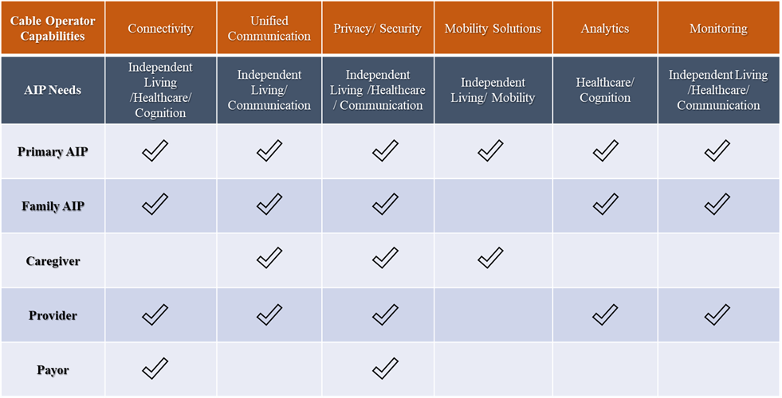
Figure 2 - High level mapping of the cable operator capabilities and the AIP needs
As shown in Figure 2, AIP needs arise from different stakeholders such as the independent living family members, their supporting family, caregivers, providers, and payors. Cable operators can extend their capabilities in connectivity, unified communications, privacy/security, mobility solutions, analytics, and monitoring to these stakeholders to solve the stakeholder needs. These needs and the mapping of cable operator capabilities to address them, as summarized in the figure, will be elaborated later in the document.

Introduction to Telehealth
Telehealth is defined as using telecommunications technologies to support various healthcare services, such as long-distance healthcare, health education, public health administration, etc. The feature many of us are familiar with, is its ability to connect patients and physicians who live in different geographical regions most commonly called telemedicine, a convenience and care to the likes that have never been seen before. Though this initial concept was conceived in the 1960’s, only in the last decade has it started to gain ground and become an emerging industry that is projected to be valued at nearly $130.5 billion by 2025. With many advancements in telecommunications technologies, telehealth is becoming an increasingly important part of the American healthcare infrastructure as healthcare starts to move away from paper and in-person visits and towards virtual and more convenient healthcare.
Telehealth contains numerous benefits to the healthcare industry, not only for the patients, but for other stakeholders. First, telehealth provides convenient and accessible care. Some of the biggest inhibitors to in-person patient care today are the distance and travel time between the patient and care provider. Telehealth overcomes these boundaries and provides care to rural and other areas where clinical shortages exist. It also allows for a healthcare professional to be just one call away, reducing the number of doctor visits, saving time, and preventing unnecessary costs. Cisco reported 74% of patients prefer this easy access over in-person interactionsand a study by the American Hospital Association showed that telehealth care saved 11% in cost and tripled investors ROI. Additionally, telehealth has allowed for better care quality because timetables for medicine and prescriptions are more accurate. These timetables reduce stress and anxiety among patients as their health information is available to them at a moment’s notice with the use of apps and other technologies.
As shown in Figure 3, telehealth needs can be understood from patient, provider, and payor points of view. More discussion on the detailed needs will be provided in later sections of the document. Based on our analysis, to meet the needs of the telehealth environment, such solutions will have to focus on integration infrastructural, serviceability, and a support. These telehealth environment’s success will be measured based on the metrics such as access to care, financial impact and experience to the stakeholders. As we go through this document, we will elaborate how cable operators can address these needs with their current and future physical and human infrastructure. Also, we draw parallels on which of these resources can be shared among the other Telecom for Healthcare solutions such as AIP.
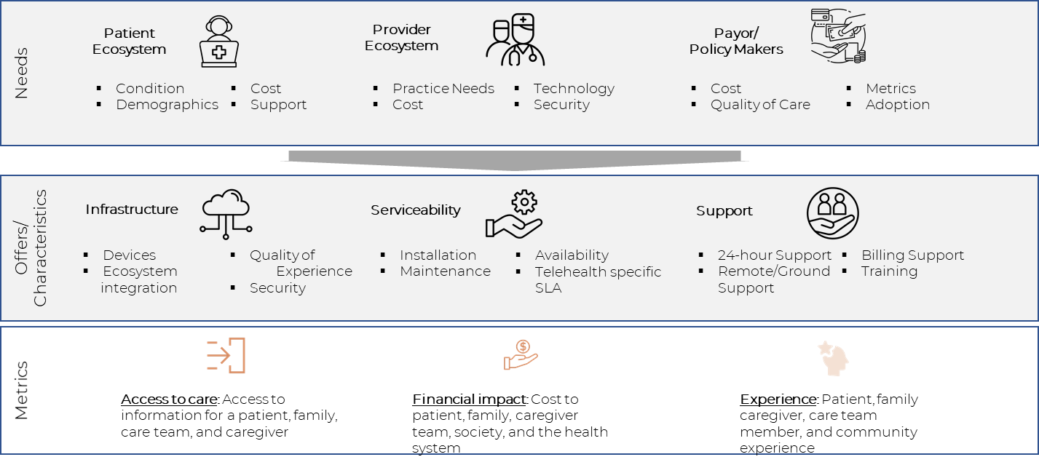
Figure 3 Mapping of Telehealth needs, the operator capabilities and the metrics to assess success

Intersection of AIP and Telehealth
AIP and Telehealth may not share many requirements, but they share the same stakeholders and the infrastructure. This motivated us to analyze these solutions together and explore the commonalities in supporting a Telecom for Healthcare (T4H) solution that assists both markets.
The following are the areas where AIP and telehealth will and will not intersect:
- Stakeholder: telehealth and AIP share the family, individual, healthcare providers and payors as the common stakeholders. AIP, in addition to the above stakeholders needs interaction with the care givers.
- Needs:
  - Telehealth and AIP have clear intersections in the healthcare space
    - Older adults use of telehealth increased during the pandemic with assistance from family or paid caregivers
    - Many older adults (~35% in one study) are using telehealth for the first time during the COVID-19 pandemic. However, technology barriers became prominent
      - Study showed many relied on family/caregiver to go through visit (82%)
      - Some older adults (27%) were unable to use video
  - They have needs for secure and reliable communications, data privacy and managed service needs. The data privacy needs may be more stringent in case of telehealth.
- Architectural overlap:
  - Many of the in-home solutions provided for telehealth are a subset of what is offered under unified communications to the AIP solutions.
  - The device integration for AIP is more elaborate than that for the telehealth solutions.

Why Telecom for healthcare?
Acknowledgement: The following section is extracted as is from Telehealth Market Report, A Telecom Based Opportunity Analysis from Duke Tech Solutions.
Both the telecommunications and healthcare industries have matured independently but, in the process, have developed mutually exclusive capabilities relevant for their collaboration. Some of these capabilities include –
- Healthcare capabilities
  - Healthcare IT (HIT) developments: HIT solutions such as Electronic Health Records and Health Information Exchanges have paved the way for next-generation Healthcare solutions.
  - Remote monitoring capabilities: Many remotely monitorable devices, wearables, and solutions have been introduced in the market space.
  - Telehealth adoption: Telehealth solutions are finally being accepted by the payors and are adopted by the providers. The market is evolving to provide targeted solutions to the Aging in Place population and the targeted specialties.
- Telecom capabilities
  - Ubiquitous broadband connectivity: Telecom operators have reached ~ 90% of US households either through wireline (DSL, cable, fiber) or wireless (4G, 5G) technologies.
  - Stronger in-home devices and offerings: Operators have been constantly developing next-generation service offerings and IoT devices to support targeted in-home applications.
  - Well-oiled managed services: Operators offer mature next-generation in-home services (installation, support, and billing) and managed end-to-end services.
We believe these mutually exclusive developments have positioned both industries to be synergistic and successful if a T4H collaboration is formed. The following section will elaborate on how these two industries can work together to build a sustainable telehealth business.

Why should Telecom and Healthcare leaders collaborate?
We believe both telecommunications and healthcare industries are at the crossroads that they need to collaborate for mutual growth.

Why Telecom for Healthcare?
- Increase reach to the customers through virtual care: Although there are some initiatives to find the exact broadband coverage in the US, it is generally agreed that more than 90% (some even say ~99%) are connected by broadband services. The telehealth offering opens the healthcare industry to reach all the customers with such broadband connectivity.
- Seamless customer management: Cable operators have mastered customer management and services for their in-home service offerings. These capabilities can be engaged/leveraged by the healthcare industry.
- Technology management capabilities: Cable operators manage very complex in-home technologies and are constantly improving their capabilities through self-installation, automated service assurance capabilities, and if needed the boots on the ground for high-quality services. Healthcare will have instant access to this workforce for their telehealth services.

Why Healthcare for Telecom?
- Cannot grow revenue opportunities by being a bandwidth pipe alone: Cable operators are constantly looking for revenue-generating value-added services over their broadband services. The multi-trillion dollar yearly spent in the healthcare industry, which is looking for innovation, is a certain candidate for telecom operator considerations .
- Need for quantifiable revenue-generating in-home services: Telecom operators have developed very elaborate methods and solutions for in-home services. They have been integrating different IoT devices for home automation. The missing piece in the puzzle is the focus to convert these wow gadgets to mainstream necessity-based services.
- Repurpose the people, the processes, and the tools: Operators have a mature customer management process that is fully vetted and tools that are capable of managing complex in-home solutions. They are prime to repurpose these capabilities for next-generation opportunities.

What Telecom technological innovations are fueling this collaboration?
- Ubiquitous connectivity at home using the next generation of in-home technologies: In addition to offering high-speed broadband capabilities to the home, Telecom operators are addressing highly capable in-home interconnection. Some of those that are relevant for healthcare include:
  - Wireless interconnection technologies such as WiFi 6 to bring gigabit streams throughout the home.
  - Plug and play interconnection and in-home wireless hub technologies to seamlessly connect different IoT devices to increase their adoption at home
  - Redundant internet connection – wired backhaul and wireless (5G) backhaul
  - Define standard interfaces that integrate in-home medical devices into the ecosystem
- Increase the adoption through a seamless, secure interface: It is time for operators to go beyond the adoption of in-home devices for a basic triple play.
  - Integrate the easy to use day-to-day devices such as TV console in the telehealth workflow to increase adoption
  - Bring state-of-the-art security concepts that are offered to enterprise broadband customers to enable the seamless integration of telehealth solutions
- Improve the metrics and reduce costs through data-driven capabilities: Many data management tools are used by broadband operators for their customers. Repurpose them to solve the pain points in the telehealth environment. Some of them include:
  - Extending the existing data collection and alarms/traps for future healthcare applications
  - Use application metadata to record, track, report, bill, and audit different Telehealth encounters
  - Measure relevant next-generation healthcare quality and cost metrics. Demonstrate the application of broadband telecom capabilities to solve healthcare problems.
- Bring adjacent partners together to create formidable managed services: Gone are the days of fragmented healthcare solutions. Bring together the relevant telecommunications relations and partnerships for this inter-industry collaboration. Some of these partners include solution integrators, builders (to create future telehealth ready homes), medical device integrators, analytical solution developers, etc.

Organization of the document
The rest of the document is organized as follows:
- Section 7 provides a detailed survey of the market landscape for AIP and telehealth with the focus on where cable operators can provide differentiated service,
- Section 8 provides detailed requirements for both the topics with the focus on overlapping requirements,
- Section 9 provides few use cases with the increasing complexity in service delivery,
- Section 10 provides a comprehensive business case for the cable operators to enter into the AIP and Telehealth marketplace,
- Section 11 wraps up with recommendations to the cable operators,
- A detailed terminology used in the document and in general for the operators to understand when entering into the T4H market space is provided in section 12, and
- Finally, a detailed business requirement capture is provided in section 13

Market landscape

Framework of analysis
Over the years and with the introduction of COVID-19, telehealth companies have created their own niche in this expansive market. Some companies may focus solely on consultations for certain medical conditions while others try and hit all areas of a patient’s medical journey. With roughly 90% of the current older adult population expressing interesting in staying at home as they age, it is crucial for them to understand how companies are addressing this growing group. Some companies provide caregivers and older adults with AIP resources while others cater security technology to seniors and their family needs.
To understand both markets separately and with such a wide breadth of diversity within the market, we created a framework in which to analyze these companies.
Technology: Companies offer different technologies based on their target services in, for example the six areas for AIP (independent living, cognition, communication and social connectivity, mobility, transportation, and healthcare access). Even in their solution scope, they may focus on only a few areas of technologies such as providing a basic app for educational purposes, monitoring solutions such as older adult mobility tracking, or highly integrated front and back-end systems for end-to-end services. In addition, we analyzed how different AIP and telehealth companies integrated technology into their services. For example, the company Visiting Angels have integrated Amazon’s Echo Dot into their service as their constant care companion. This Alexa device can also be used to call an urgent response agent. Amwell is one of the largest telehealth companies in the US. They have integrated a wide variety of technology over the years and have formed partnerships with companies such as EPIC. Their telemedicine carts and kiosks have also created flexibility in where care can be provided.
Service: AIP and telehealth companies can provide a wide array health and non-healthcare related services. Some common AIP services caregiving companies provide are transportation services, housekeeping, meal preparation, hygiene care, Alzheimer’s care, or dementia care. Comfort Keepers is a good example of a caregiving company that integrates the services listed above and more. They have also partnered with Lyft to provide transportation services such as going to appointments. As we enter highly technical support into the six dimensions of the needs for the aging population, a successful services organization has to constantly find an optimized way to mix and match boots on the ground with technological innovations. Cable providers are quite familiar with such innovations from installation all the way to service support. When we analyze these companies, we put on our cable operator’s hat to see how these companies fare in their service evolution capabilities.
Area of Focus: Telehealth companies can provide a wide array of services with everything from consultations to educational material. But amongst these services differences, companies may also choose to focus on different disease states, customers, or demographics. NutriMedy is a good example of a telehealth company targeting a niche group. NutriMedy with dietitians and other professionals give targeted advice to users with their chronic conditions. They mention helping with gastrointestinal, cardiovascular, nephrology, and oncology issues. With a plethora of avenues to follow, a successful service organization has to constantly find an optimized way to mix and match boots-on-the-ground efforts with technological innovation.
Business Model: As we looked at each company’s business model, we were able to gather how they are integrating various partnerships (Lyft, Amazon, EPIC, etc.), their screening processes, their value propositions, and work with other entities (labs, imaging, pharmacies, etc.) that were integrated into their model. For example, on the AIP end, GreatCall is focusing on providing cellphones that are specifically catered to seniors. They have the Jitterbug Smart2 (smartphone) and the Lively Flip (flip phone) which with different plans allows their customers to access urgent care, a personal operator, Alexa (only on Lively Flip), brain games, and more. On the telehealth end, a majority of health systems are moving towards Electronic Medical Records (EMR); partnering with EMR companies, such as EPIC, is becoming more attractive. Amwell is one of a few companies on this list that have formed that bridge. This integration allows for continuity of care and improved workflow. With a different approach to the AIP and telehealth market, many companies have been able to create unique value in the space. Due to the enormity of the space, and lack of sustainable service focus for the user, the market is heavily fragmented.
With broadband telecom operators playing an integral part in existing AIP and telehealth solutions, operators are uniquely placed to contribute more to this growing industry. This company compilation aims to inform operators of what already exists in the space and give a glimpse of how operators can play in each of these spaces.

Aging in Place company survey
The goal of this survey is to give a 360-degree perspective on the companies in the AIP market space, before making recommendations on what the service provider should or should not focus on. This company compilation takes a look at some of the companies from purely services-based (such as Visiting Angels with their boots on the ground) to AI-based robotic solutions (such as Elli.Q) in the AIP space. The service provider should conduct such an analysis from their AIP strategy perspective to evaluate where they have better opportunities and assess the best path for execution (such as partnership, build-operate-transfer, or pure build of the targeted solutions).

U.S. companies

AgingInPlace
AgingInPlace strives to help older adults, family, and caregivers plan for an AIP lifestyle. They provide relevant literature on staying mobile, lifestyle, home modification, in-home care, finances, technology, legal needs, patient care, and taking care of a parent. In addition, they compare different solutions available in the market. They outline how they rate certain services based on their reliability, equipment, features, services provided, technical support, transparency, word on the street, and cost.
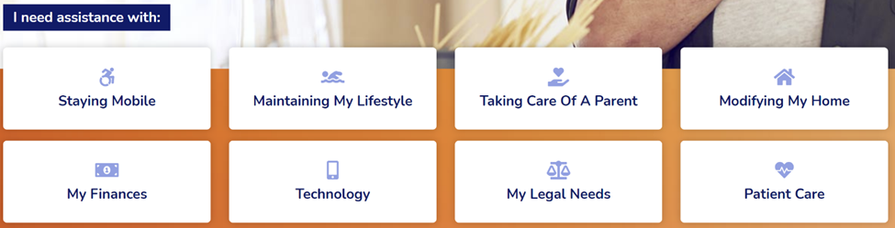
Figure 4 Categories of literature provided by AgingInPlace
Company website: https://aginginplace.org/
Scope of their services: Mobility, Healthcare, and Independent Living. Provides informational services.
Technology: Do not offer any technologies
Service: Assists older adults in guiding through different IADLs (refer to Figure 4)
Business model: (From their website) “Our reviews are intended to guide you in choosing the best home care services for you and your family, and we use an established rating process that is free of bias or influence. To keep these services free, we do accept affiliate commissions from some of the companies mentioned on this site.”

Comfort Keepers
Comfort Keepers’ philosophy is to provide high-level care to seniors through in-home caregiving. They have a variety of services including companion care, personal care, safety care, senior transportation (partner with Lyft), technology assistance, and interactive caregiving. On top of that, they provide specialized 24-Hour care, Alzheimer’s and dementia care, end-of-life care, in-facility care, post-hospital care, and private duty nursing (Figure 5).
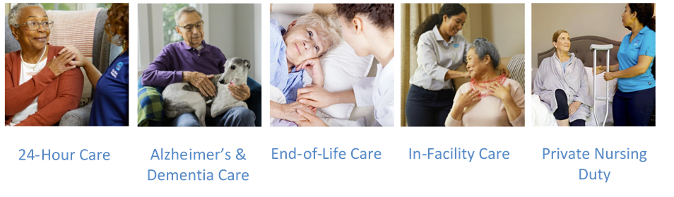
Figure 5 Specialized care provided by Comfort Keepers
Company Website: https://www.comfortkeepers.com/
Scope of their services: Transportation, healthcare, and independent living providing caregiving services to older adults
Technology: Personal emergency response system, medication safety and management, home monitoring system, and safety accessories
Service: In-home care for seniors so they can remain independent at home. “Our services focus on physical needs and total wellbeing. We believe that everyone should experience the best of life, no matter their age or the level of care that is needed.”
Business model: (From their website) “Our uplifting in-home care services begin with an in-home visit. Our professionals complete a comprehensive assessment and develop a care plan that is customized for each client.”

Elli Q
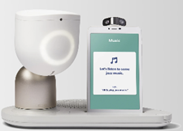
Elli Q is a tabletop intelligent assistant, Figure 6, that was created to interact, connect, and engage older adult users. As shown, it can do everything from conversing, play music, wellness, health reminders, etc.
Figure 6 Elli Q Assistant
Elli Q is said to be able to tailor its system to the user. The system can respond to a users’ voice, gaze, and touch. A user is provided the Elli Q body (moves with three degrees of freedom), base & charger (speaker, microphone, charging doc), and a screen. Figure 7 shows some of the features of the Elli Q.
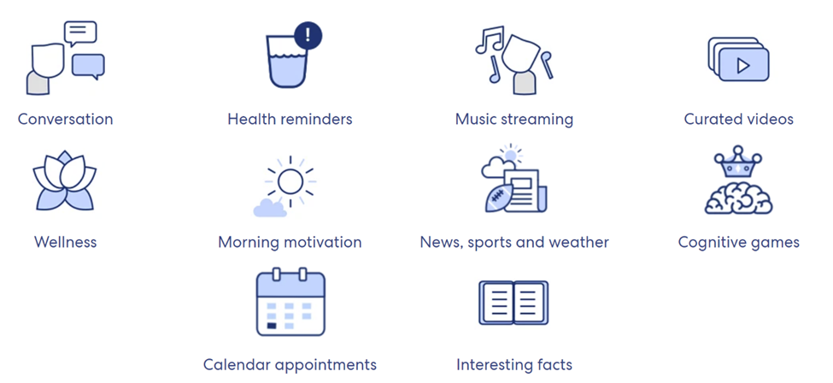
Figure 7 Functions of the Elli Q Assistants

Company Website: https://elliq.com/
Scope of their services: Cognition, communication and connectivity, healthcare, and independent living. Cognitive services mainly to avoid social isolation
Technology: AI-based robot
Service: Functionality seen above
Business model: Hardware sales

FirstLight Home Care
FirstLight Home Care provides non-medical in-home care (cooking, cleaning, laundry, bathing, etc.) for older adults with various types of care services (as shown in the figure below) - senior care, personal care, companion care, respite care, specialized dementia care, and family caregiver support. Under their Brain Health Services, they offer memory care training that is certified by the National Council of Certified Dementia Practitioners. Some of their other programs under improving brain health are Ageless Grace (fitness), Constant Therapy (speech, language, and cognitive exercise app), Elite Cruises and Vacation (dementia-friendly cruises), and Nymbl (application to improve balance). Additionally, FirstLight provides travel companion services where people help seniors throughout the whole trip, whether it be checking in, luggage, security, and transportation. For the family, they provide client-caregiver matching, personalized care plans, client care access, consistently follow through, client feedback, and 24/7 availability. Some of the services seen below in Figure 8.
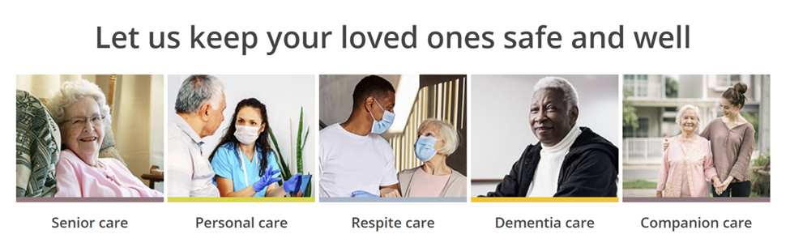
Figure 8 FirstLight care services
Company Website: (https://www.firstlighthomecare.com/)
Scope of their services: Cognition, healthcare, and independent living, in-home care for older adults, adults with disabilities, and busy families
Technology: Do not offer any technologies
Service: Providing a range of services to help older adults at home while also supporting the older adult’s family.
Business model: Charging for services based on location, family needs, and customized rate plan.
Latest news: In October 2020, FirstLight Home Care was recognized by Franchise Business Review as one of their top “Culture 100” companies

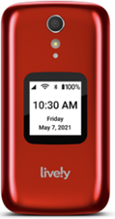
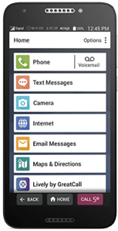
Lively (formerly Greatcall)
Figure 9 Lively's smartphone and flip phone
Lively is a company dedicated to providing older adults with mobile products so that they can live an independent life. They have two phones available: the Jitterbug Smart2 (smartphone) and the Lively Flip (flip phone) shown in Figure 9. With different packages, the phone can be compatible with Lively’s health and safety services. In addition to cell phone services, they offer their health and safety professionals linked to their mobile devices. Family caregivers have a Lively Link app that allows one to receive emergency alerts, check activities, retrieve location, and check on device status, along with caregiving support resources.

Company Website: https://www.lively.com/
Scope of their services: Communication and connectivity, independent living, cognition, transportation, mobility, and healthcare; allowing older adults to stay connected and safe through a combination of services with their cellphones.
Technology: Smartphone, flip phone, medical alert device, the wearable urgent response device
Service: Linked to the smartphone and external devices they have a connection to urgent care, an app that keeps family up to date, fall detection, partnership with Lyft, and Brain games.
Business model: Initial charge for phone or device then monthly charges depending on the package deal. There are deals for members of AARP.
Latest News: The new version of Lively is compatible with Amazon Alexa devices

TheKey (formerly Home Care Assistance)
TheKey is a company that is dedicated to creating customized long-term care plans for a senior in their home. They provide four different broad levels of care that can be tailored to the senior’s needs: hourly, full-time, hospital to home, and specialized care. The caregivers help patients implement the recommended changes so that the transition is stress-free. The four steps they use to create this plan are: calling to determine needs, hire caregivers that are matched to clients, assign a full-time care team to assist remotely 24/7, and using the Balanced Care Method™ to train their caregivers (Figure 10).
Figure 10 Balanced Care Method created by Home Care Assistance

The goal of this Balanced Care Method™ is to help reduce the negative effects of isolation and help seniors “live longer, happier, more balanced lives.”

Company website: https://www.thekey.com/
Scope of their services: Mobility, cognition, transportation, healthcare, communication and connectivity, and independent living. Work to create personalized care plans for seniors at home, live-in caregivers, or those requiring special care.
Technology: Do not offer any technologies
Service: Provide older adults and families a wide variety of caregiving methods to best suit the older adult’s needs.
Business model: Pricing depends on the care plan developed.

Home Instead ® Senior Care
Home Instead CAREGivers help provide individualized care to older adults. They provide everything from personal care, hospice care, respite care, Alzheimer’s care, dementia, and other conditions. Home Instead does provide different websites for their locations that detail their various offerings.

Company Website: https://www.homeinstead.com/
Scope of their services: Cognition, Transportation, Healthcare, Communication & Connectivity, and Independent Living. Using caregivers to help older adults complete activities.
Technology: Do not offer any technologies
Service: Sending CAREGivers to help older adults complete Activities of Daily Living (ADLs).
Business model: Price of care depends on location, amount or type of care, personalized plans, etc.
Latest News: Home Instead Senior Care has partnered with The National League of Nursing Foundation of Nursing Education (NLNFNE) to award a scholarship worth $10,000 to nursing students working towards serving the geriatric community

Seniors Helping Seniors ®
Seniors Helping Seniors® is a franchise that matches seniors with other seniors who are there to help them maintain an independent lifestyle. The seniors can help around the house (companionship, light housekeeping, cooking, groceries, pet care, etc.), out-and-about (escort to appointments, errands, outings), and support for family caregivers (dementia and Alzheimer’s care, long-distance check-ins, respite care, overnight stays, and 24-hour care).

Company Website: https://seniorshelpingseniors.com/
Scope of their services: Cognition, transportation, healthcare, communication and connectivity, Independent Living. Matching older adults with other older persons to help with small tasks.
Technology: Do not offer any technologies
Service: Assist with simple tasks such as housekeeping, cooking, errands, or specialized care.
Business model: Charge on an hourly basis.
Latest News: In August 2020, Seniors helping Seniors announced their partnership with the company Electronic Caregiver™. Electronic Caregiver is a service that provides remote patient monitoring devices catered to seniors

TeleCalm
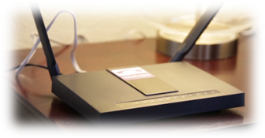
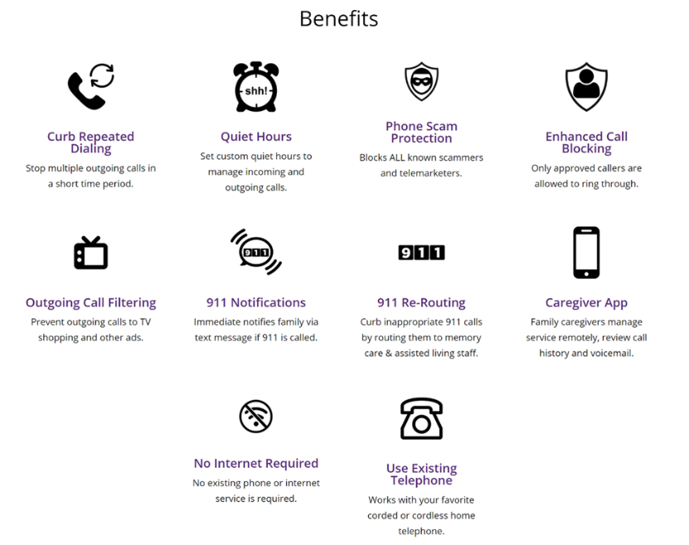
TeleCalm is a company aimed at protecting older adults with memory problems when using the phone. They help block scam calls, reroute inappropriate 911 calls to memory care, notify the family of 911 calls, connect family through the app, etc. (device seen in Figure 11). TeleCalm is also able to operate through an existing telephone system (Figure 12). They also provide users different monthly plans.
Figure 11 TeleCalm device to reroute calls
Figure 12 Benefits of using TeleCalm
Company Website: https://www.telecalmprotects.com/
Scope of their services: Cognition and communication and connectivity; protect seniors from scam calls by connecting caregiving family in the middle
Technology: Application to manage their phone service (probably have backend deal with the provider)
Service: Manage call screening and provide controls to the family caregivers
Business model: Monthly phone service ($50 or $40), installation fee ($60)

Tricella
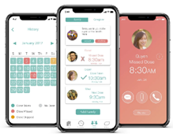
Tricella is a company that was founded with the mission of creating health and wellness products. Their team of engineers has created a digital pillbox that can alert the user and family members through an app. The Tricella Pillbox is embedded with sensors that detect whether the pills had been taken. The data connects to a smartphone through Bluetooth which can push notifications. In-app text, call, and audio recordings to track progress and history. The app can also connect multiple pillboxes for patients who need to take pills multiple times a day. App and pillbox see in Figure 13.
Figure 13 Tricella pillbox and corresponding app

Company Website: https://www.tricella.com/
Scope of their services: Healthcare and communication and connectivity; medication management for older adults, remote patient monitoring devices
Technology: Medicine dispensing device, RPM devices, and management console for doctors
Service: Patient health and wellness products
Business model: Sells the pillbox and corresponding app for $95.
Latest News: Tricella was noted by the website Reviewed as one of the 10 companies family members should use to keep track of their aging family

TytoCare
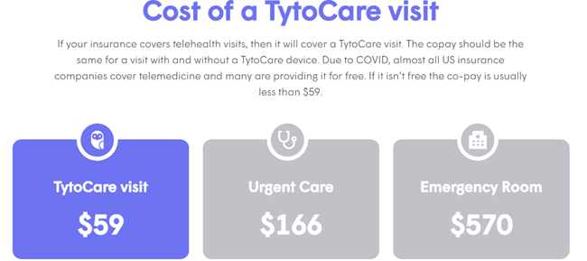
Tyto developed an FDA cleared handheld exam kit (Figure 16), and app, that allows the patient to perform certain exams from anywhere they choose. Their goal with this kit is to put the consumer's health into their own hands. The kit includes an exam camera and thermometer, otoscope adapter for ears, stethoscope for heart and lungs, tongue depressor adaptor for the throat, and the TytoApp™ for guided exams.
Figure 14 TytoCare prices

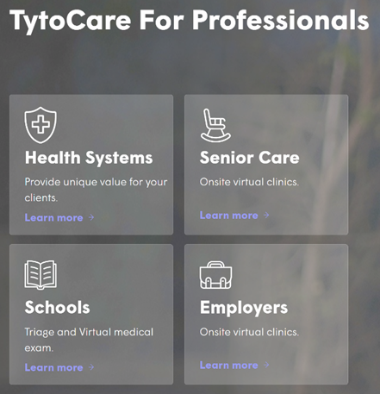
With this kit, they can conduct ear, lung, heart, throat, skin, temperature, and abdomen exams. Tyto also connects the patient to a remote physician (ideally your physician or someone in their physician network) to examine the results, diagnose the condition, and write a prescription (pricing in Figure 14). Tyto is diagnosing and treating more common conditions, such as ear infections, colds, flu, sore throat, etc. Tyto is currently only available for purchase through certain health systems and providers (some of those seen in Figure 15). They also require the patient to have a smartphone (last two versions of iOS or 4.4.4 and above for Android) or tablet and WiFi. Within the program, they not only have built-in training videos that help an easy transition but also during live telehealth visits the provider will also guide the patient/user through the exam. As for insurance, they note users can use their FSA (flexible spending account) to pay for the device and that exams/visits are often covered by insurance, however, this may not always be the case.
Figure 15 TytoCare for professionals

Company Website: https://www.tytocare.com/
Scope of their services: Healthcare and communication and connectivity; integrated medical devices for healthcare checks with TytoCare doctor network.
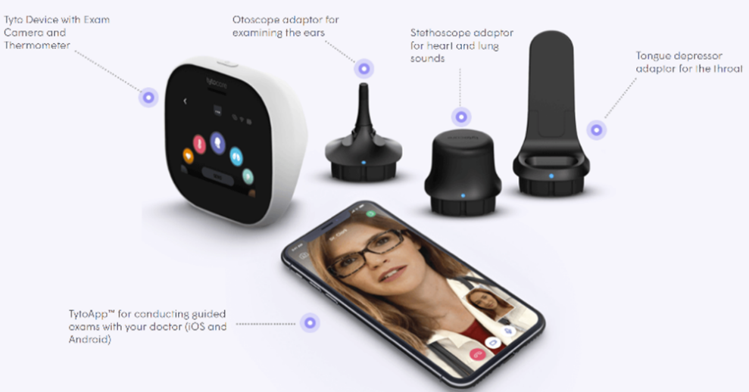
Technology: Medical device integration, remote monitoring, conference calls, doctor workflows
Figure 16 TytoCare devices
Service: Virtual doctor visits
Business model: Per visit charges, device sales, monthly service charges, EMR integration; Doctor network integrated into TytoCare
Latest News: TytoCare has partnered with Fletcher Technical Community College to provide students access to healthcare through their Virtual Wellness Center. Amwell has also recently (early October 2020) partnered with TytoCare to resell the TytoCare kit.

Visiting Angels
Visiting Angels are a company that performs in-home and older adult care services around the country. Visiting Angels also offer a free in-home assessment to determine what kind of care suits the client and match them to a caregiver best suited for them. Under their Life Care Navigation™ (Figure 17) program, they have home care services, companion care, personal care, respite care, palliative care, social care program, ready-set-go home (avoiding hospital readmission), dementia care, Alzheimer’s Care, end-of-life care, and safe & steady fall prevention program. The goal of this program is to meet the emotional, spiritual, and physical needs of the client to help restore hope.
Figure 17 Visiting Angel's Life Care Navigation provides personalized care
Company Website: https://www.visitingangels.com/
Scope of their services: Mobility, cognition, transportation, healthcare, communication and connectivity, and independent living; providing in-home personalized care so older adults can live at home independently.
Technology: Amazon Echo Dot ™ that can set reminders, read books, play games, etc. It is also connected to 24/7 urgent response agents.
Service: They provide care depending on the older adult's needs (home care services to Alzheimer’s care).
Business model: Cost changes based on location and type of care required.

Vayyar Home
Vayyar Home is a home monitoring solution that detects falls and calls for help when a fall does occur. When a fall does occur, the device connects the user to their caregiver or family member via mobile alerts and their app (Figure 18). The solution does not rely on cameras/visual data. The company also has opportunities for businesses to integrate their solutions (Figure 19).

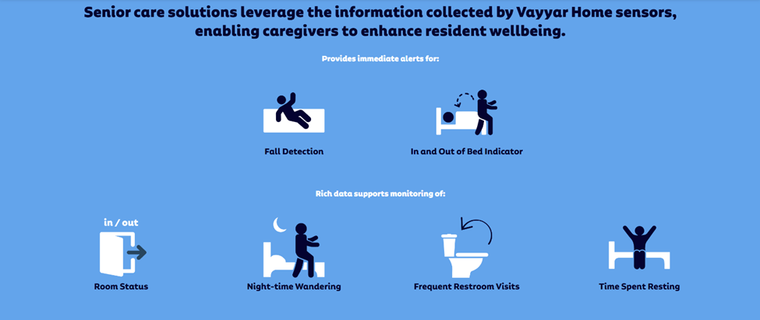
Figure 18 What Vayyar Home sensors detect
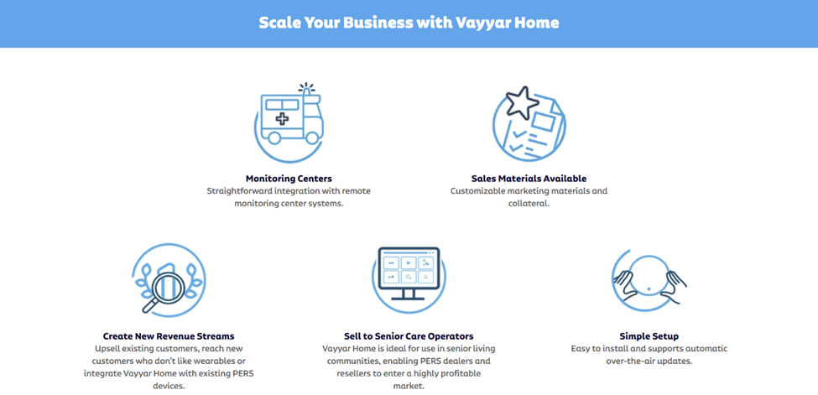
Figure 19 How businesses can use Vayyar Home

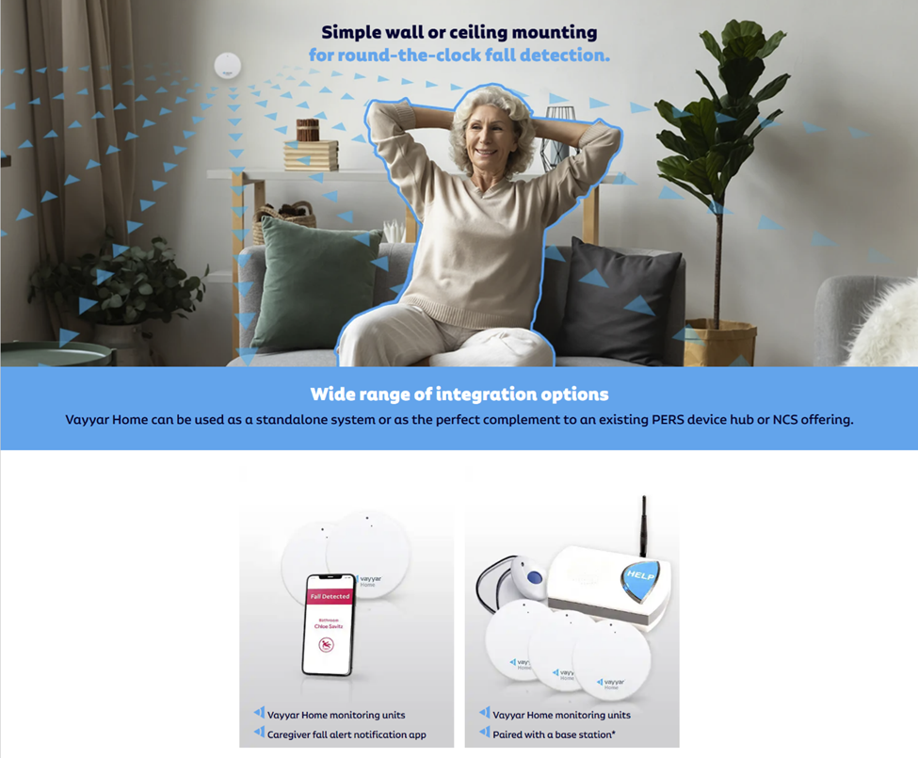
Figure 20 Vayyar Home devices

Company Website: https://vayyarhome.com/
Scope of their services: Mobility, communication and connectivity, and independent living
Technology: Sensor devices, fall detection analytics, caregiver integration
Service: Smart sensors around the house to monitor the safety of the older adult (Figure 20)
Business model: Device sales and services

International companies

Domalys
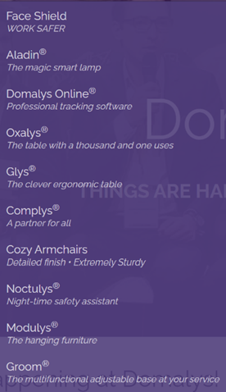
Domalys is a French company that designs and creates products for our vulnerable community. Their products include a smart lamp, tracking software, ergonomic tables, fun tables, armchairs, night-time safety assistants, hanging furniture, and an adjustable base (Figure 21). Their newest device is Aladin® a smart lamp created to detect early signs of illness and reduce falls. Beyond that, it can track sleep patterns that may be indicative of an underly condition. The Aladin® can be set up anywhere in the home and comes with a smart badge, team coaching, installation, and tech support.
Figure 21 Some of Domalys' products

Company Website: https://www.domalys.com/en/ (in French only)
Scope of their services: Mobility, communication and connectivity, and independent living; creating technology to improve individual care.
Technology: Wide array of technology, listed on the right, to assist with a variety of care points.
Service: Each product works in service of a different need.
Business model: Services, furniture, and devices

FocusCura
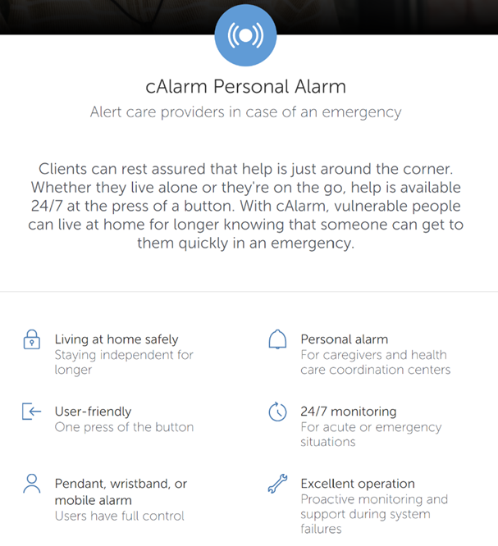
FocusCura is aimed to help older adult people stay independent in their own homes (focusing on virtual homecare and hospital at home) while keeping caregivers, family, doctors, etc. in the loop. They have developed three primary products to support their mission: cAlarm Personal Alarm, cKey Home Access, and cMed Medication Support. The cAlarm is available as a pendant, wristband, or mobile alarm. The alarm system can also connect to a patient’s at-home sensors (Figure 22). cKey assures clients that home care workers and healthcare professionals can enter their homes when necessary. cMed assists clients take their medication independently with correct dosage and timing.
Figure 22 cAlarm service provided by FocusCura

Company Website: https://www.focuscura.com/en
Scope of their services: Independent living, Communication and connectivity, and medication assistance
Technology: Pendants, in-home devices, backend monitoring, caregiver integration
Service: Device, installation, monitoring, and provider integration
Business model: Device sales and services charges
Latest News: Bought by ASSA ABLOY, a healthcare company located in the Netherlands

Kraydel
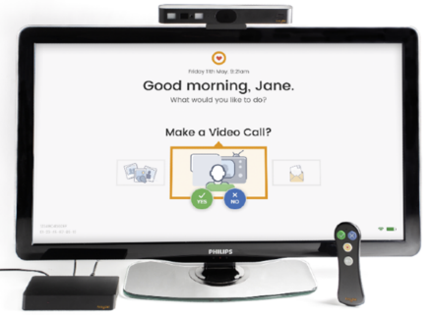
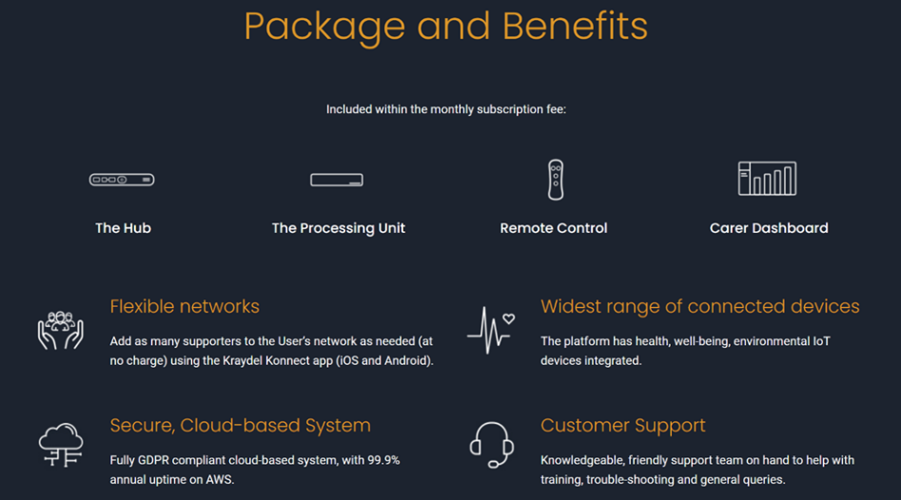
Kraydel is an Irish company that created their Konnect device which enables video calling via the TV (Figure 23). It mounts its hub on the TV, connects via HDMI, and operates using a simple (yes or no options only) remote. The device is targeted at both the older adults and the home care providers. Providers have access to a Konnect Dashboard that can send TV alerts and reminders (Figure 24).
Figure 23 Kraydel interface
Figure 24 Package and benefits for Konnect Device
Company Website: https://www.kraydel.com/)
Scope of their services: Communication and connectivity and independent living
Technology: Interact through a simple TV interface
Service: Customer support over the phone
Business model: Monthly subscription fee for the individuals and the care provider

SOFIHUB
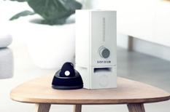
SOFIHUB home and beacon (Figure 25) are technologies created to help family members track their older adult members while they remain independent at home. The SOFIHUB home is an assistant that provides alerts, sends text-to-voice via the online portal, spoken reminders, and tracks falls via in-home motion sensors. SOFIHUB beacon is a device that functions as a panic alarm, personal assistant, and fall detector. The users' location can be tracked through the online portal.
Figure 25 SOFIHUB home and beacon assisted living device and safety pendant
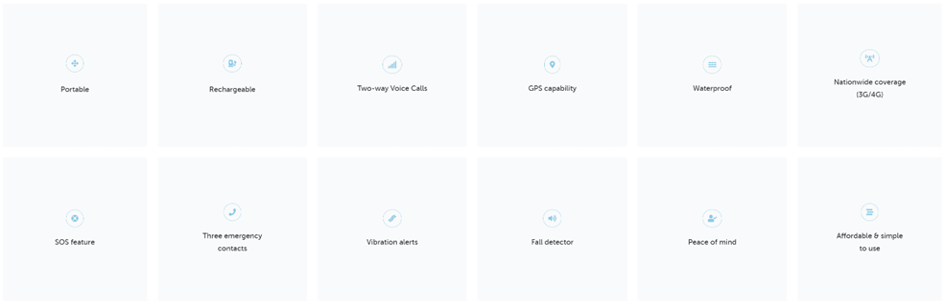
Figure 26 Functionalities of SOFIHUB
Company Website: https://www.sofihub.com/
Scope of their services: Mobility and independent living
Technology: Devices, two-way communication capabilities, manual fall detection
Service: Portal, alerting, wireless integration (Figure 26)
Business model: Device sales and services

AIP company summary
In the figure below, we present the summary of how all the companies are addressing the six-dimensional needs of the aging population. These needs are the areas of interest identified by the White House. These companies are evaluated on the level of solutions they are offering in five different capability dimensions. These capabilities are analyzed against:
- Caregiving: What emphasis is the company making in providing caregiving personnel? Is this an online support or boots on the ground? Do they have trained personnel assisting the older adults?
- Device support: What innovations have they made in creating devices to assist older adults in the areas where they claim their support?
- Backoffice support: Are they supporting the required back-office integration (such as Telecom operators, EMR systems, caregiving networks, etc.) to offer a comprehensive solution.
- Analytical support: How strong are they with their analytical support for the problems the older adults are facing in the categories they claim their expertise?
- Stakeholder Integration: Are they integrating the stakeholders such as the older adults, family, caregivers, providers, and payors into their solution?
Each cell in the matrix (Figure 27) represents the number of companies, that we surveyed, playing authentically in this area. By looking at the market map, we can make the following observations:
- There are significant gaps in turning the AIP offering into solutions. For example, cognition, mobility, and transportation are glaringly underserved. Even the most popular themes of AIP such as healthcare and independent living are underserved in the back office support and analytics.
- Independent living, connectivity, and avoidance of social isolation seem the target for many AIP companies. There is a significant proliferation of their frontend (devices) and back office (portals) by these companies. This is leading to significant fragmentation.
- Healthcare is mainly focused on device support rather than creating a sustainable service by integrating different existing systems and relevant stakeholders.
- Analytics seems the biggest missing feature in all of the AIP companies.
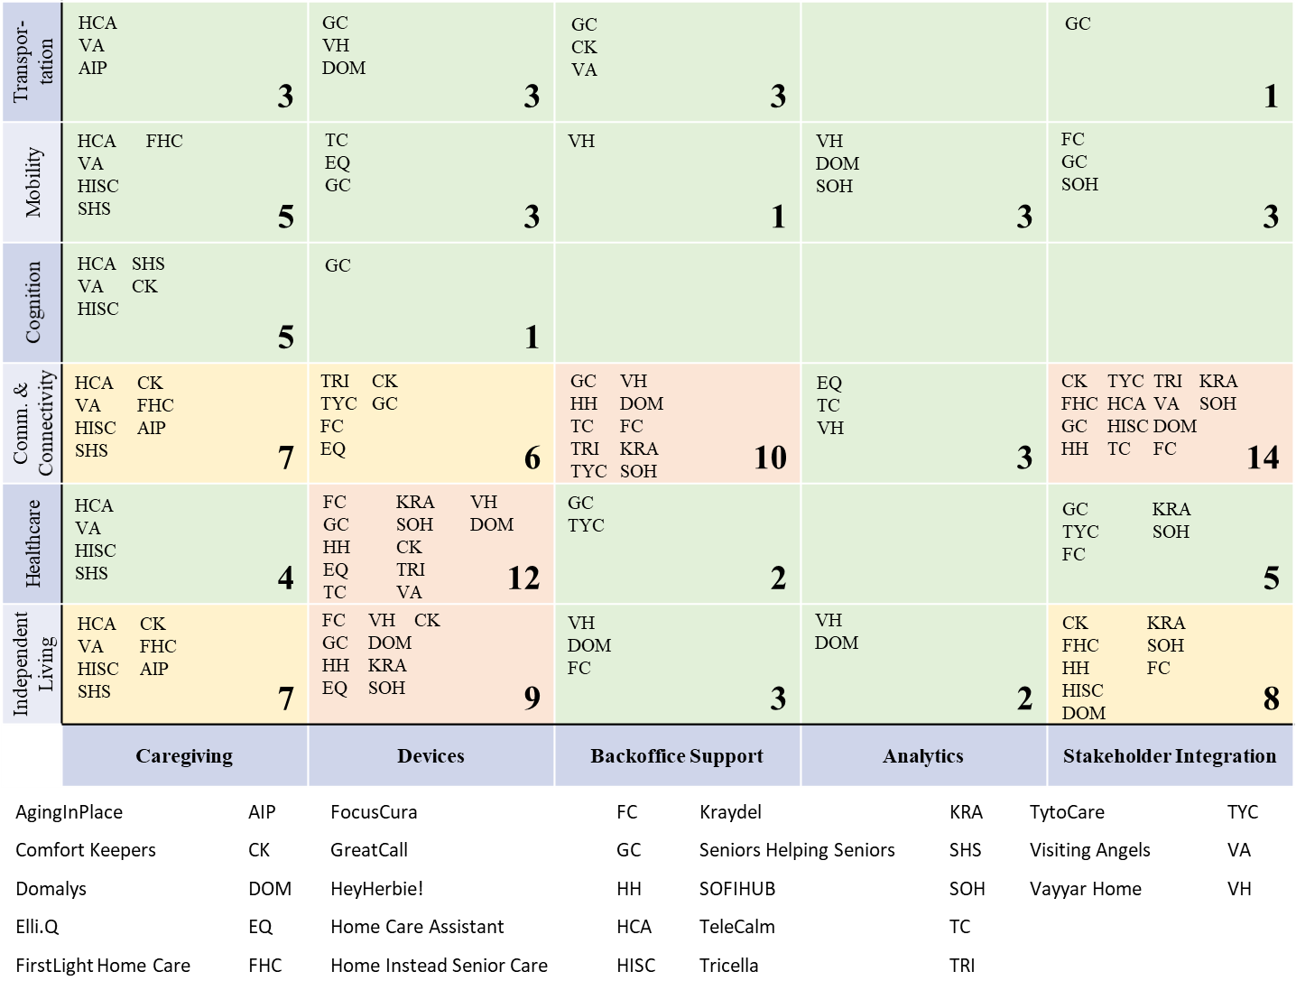
Figure 27 Breakdown of AIP companies based of White House Emerging Technologies paper

Telehealth company survey

U.S. companies

AMD Global Telemedicine
AMD Global Telemedicine focuses on providing solutions to organizations giving telehealth services while integrating into their current health IT system. The products and services AMD Global Telemedicine offers can be split into four main categories: diagnostic telemedicine solutions, direct-to-consumer platform, employee on-site healthcare, and customer use cases.

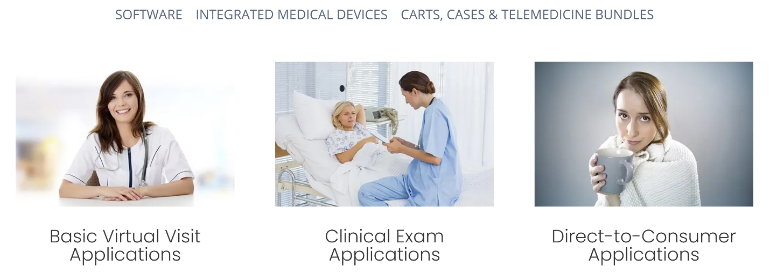
Figure 28 Product categories that AMD targets

Company Website: https://amdtelemedicine.com/
Technology: Software, integrated medical devices, carts, cases & Telemedicine bundles (Figure 28)
Area of Focus: Diagnostics, direct-to-consumer platform, on-site healthcare, and consumer use cases
Business model: Partnerships with American Telemedicine Association, International Society of Telemedicine and eHealth, EMR systems. Most likely to charge for hardware and software programs. Pricing dependent on the product or software.

Amwell
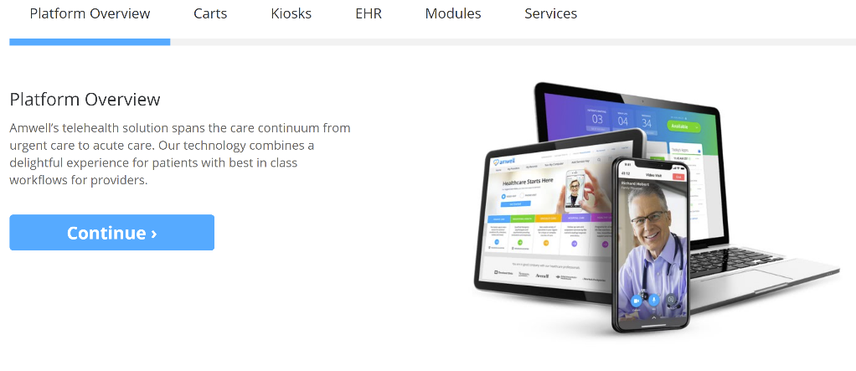
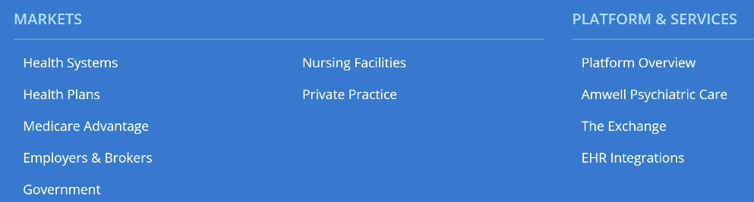
Amwell is one of the leading Telehealth providers within the US working with over 2,000 hospitals and health system partners. Amwell helps hospitals and health systems improve and expand their Telehealth program to offer more services to their patients. Amwell helps with telemedicine services throughout all of healthcare including Urgent Care to Telestroke. They also provide specialty aid to hospitals “reducing the time patients spend in the ER by nearly 70%. They have additionally implemented many of their services into inpatient and ambulatory care through the Wellstar Health system.
Figure 29 Amwell simulated platform and forms of technology
Figure 30 Market segments Amwell is currently working in

Company Website: https://business.amwell.com/

Technology: Software, telemedicine carts, Telemed Kiosks, modules, etc. (Figure 30)
Area of Focus: Wide array including basic consultations, professional services, developing medical equipment, etc. (Figure 30)
Business model: Partnerships with health systems, EMR companies, payors, employers, labs, etc. Charge based on solution: consultation fee, software charges, hardware charges, or boots-on-the-ground.

Arista MD
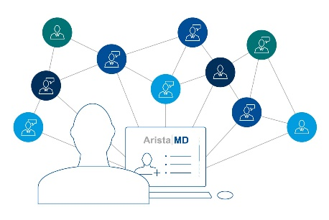
Arista MD works with various stakeholders in as e-consultants within the Telehealth field: payors, patients, health systems, and providers. They help providers expand their specialty network (Figure 31) which in-turn reduces healthcare spending from services such as duplicate diagnostics, unnecessary testing, or emergency department admissions. For patients, in addition to providing primary care, they give access to specialists. Arista MD helps health systems by improving their network management between patients, providers (primary care physicians (PCP) vs. specialist), and others. Providers are supported by Arista MD’s platform to ensure that patients are directed to the proper provider (PCP vs. specialist) while supporting PCPs.
Figure 31 Arista MD aims to expand the customers health network
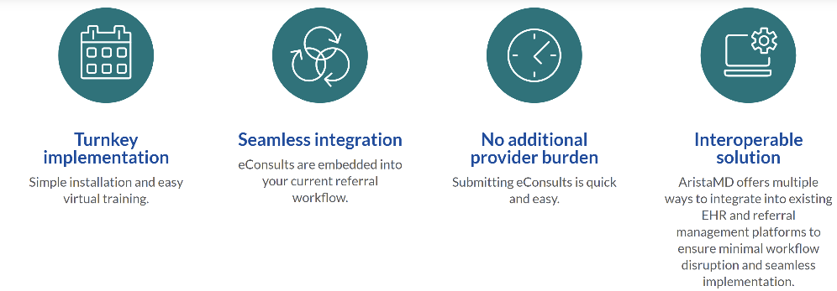
Figure 32 AristaMD's eConsults system
Company Website: https://www.aristamd.com/
Technology: Store-and-forward, asynchronous telehealth platform.
Area of Focus: Expanding eConsults between primary care and specialists (Figure 32)
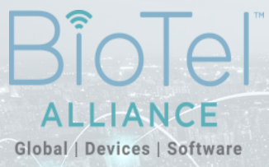
Business model: From website “At AristaMD, we envision a world where all patients have timely, cost-effective access to health care. Our mission is to use technology to facilitate collaboration between health care providers in order to expedite time to treatment, decrease costs and drive better patient outcomes.
Figure 33 Different sectors of BioTelemetry

BioTelemetry
BioTelemetry for the past 25 years has been focusing on providing cardiac and mobile blood-glucose monitoring, centralized medical imaging, and original equipment manufacturing. Their BioTel Heart sector provides remote cardiac monitoring diagnostic services and through their patient monitoring devices they have built the “world’s largest cardiac network while making care more accurate, comprehensive and efficient.” BioTel’s services are also able to fully integrate into a hospital system existing EMR software using unidirectional or bidirectional integration. They have also expanded into the sectors shown in Figure 33.
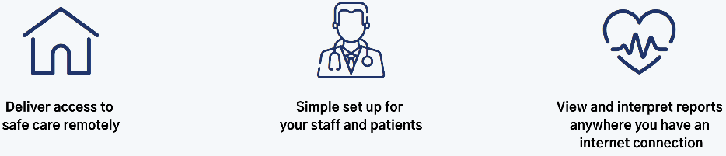
Figure 34 Telehealth arrhythmia monitoring
Company Website: https://www.gobio.com/
Technology: Mobile cardiac devices, corresponding software, remote INR
Area of Focus: Cardiac management through device monitoring (Figure 34)
Business model: Partnerships with Apple, Philips, and others. Revenue from device and software sales. Devices are covered by most insurances.
Latest News: Philips completes acquisition of BioTelemetry.

Bright.MD
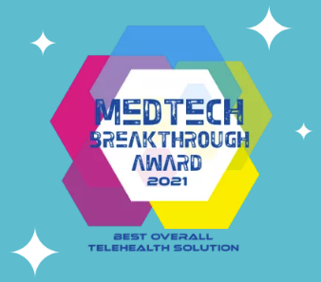
Bright.MD has created a platform to help hospital systems provide asynchronous care to their patients. Their SmartExam software connects the patients, health records, doctors, and status updates. They have also integrated physician SOAP notes, billing, communication, and prescription between SmartExam and EHR systems which is said to cut a company cost.
Figure 35 Medtech breakthrough award

Company Website: https://bright.md/
Technology: Bright.MD platform that connects to EMR systems
Area of Focus: Asynchronous care for patients
Business model: Partnerships with EMR companies and health systems Revenue coming in through software sales. Pricing could be per visit or dependent on insurance.
Latest News: Bright.MD names “Best Overall Telehealth Solution” in the 2021 MedTech Breakthrough Awards (Figure 35).

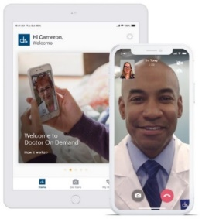
Doctors on Demand
Figure 36 Simulated Doctors on Demand platform
Doctors on Demand connects patients to certified physicians regardless of insurance coverage. They cover services under urgent care, behavioral health, preventative health, and chronic care. For the physicians, they have connected their own EHR system. Their services are also covered under many insurances including United Healthcare, Aetna, Humana and Cigna and is covered under the health plans of many companies such as Walmart, American Airlines, and Comcast.

Company Website: https://www.doctorondemand.com/
Technology: Telehealth software (Figure 36)
Area of Focus: Urgent care, behavioral health, preventive health, and chronic care.
Business model: Partner with employers, labs, and health plans. Pricing can be dependent on insurance.

Lemonaid Health
Lemonaid Health works in three main steps: online questionnaire, doctor review, and medicine delivery (shown in Figure 37). After filling out the online questionnaire about prior health information, the information is reviewed from a US licensed physician in one of the 50 states. Once working with the patient to identify the diagnosis (labs have an additional cost), the patient is given medication which is delivered to their home. The patient may pay decreased prices depending on their condition.
Figure 37 3 steps Lemonaid health follows

Company Website: https://www.lemonaidhealth.com/
Technology: Application or telehealth platform
Area of Focus: Cover a select list of conditions found on their website.
Business model: Partnership with pharmacies and labs. Cost of visits depend on reason for visit. Some conditions allow for a monthly subscription.

Livongo Health Inc.
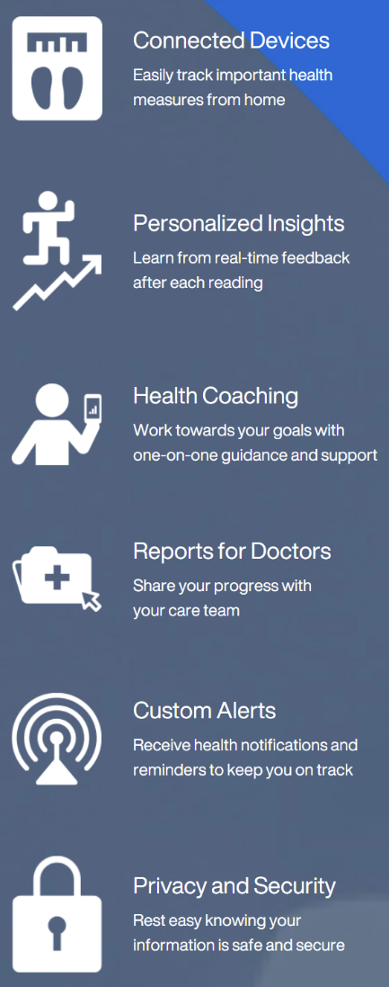
Livongo works to assist patients with chronic conditions to help sustain healthy behavior (Figure 38). Livongo also has done many clinical trials with all these conditions yielding better treatment methods and plans. Additionally, Livongo does data analysis on all of its patients of similar chronic conditions to continue improving on its procedure and care.
Figure 38 Services Livongo provides through their platform

Company Website: https://www.livongo.com/
Technology: Software and health management devices (i.e. scale or glucose monitor)
Area of Focus: Patients with chronic conditions (mainly Diabetes)
Business model: Partnerships with other companies such as Teledoc. Potential hardware charges.
Latest News: Livongo is now part of Teladoc.

NutriMedy
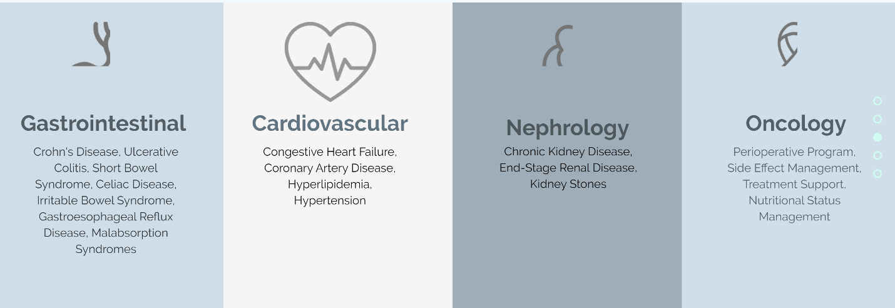
NutriMedy is an app that connects users to dieticians and nutritionist in order to support them with their condition. NutriMedy is said to have helped with gastrointestinal, cardiovascular, nephrological, and oncology related conditions (Figure 39). With the use of AI and ML they have been able to automate much of their process thus increasing efficiency.
Figure 39 Conditions NurtiMedy has targeted

Company Website: https://www.nutrimedy.com/
Technology: AI/ML software
Area of Focus: Individuals focusing on improving their nutritional health.
Business model: Bringing together dietitians, educational material, and personal care plans to help manage or prevent chronic conditions.

Philips
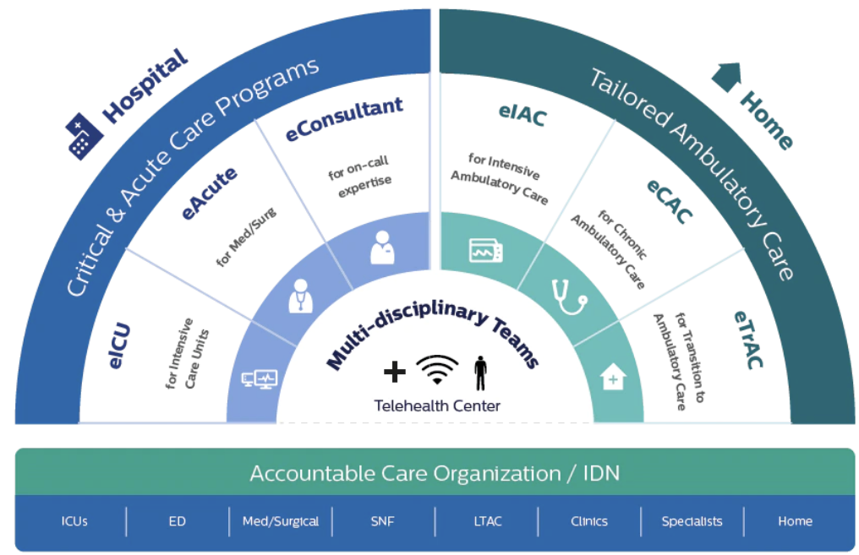
As a company with a large reach, Philips has touch in both the hospital and at-home sectors of telehealth. For hospitals, they have Intensive Care, Medical or Surgical, eICU Analytics and Research, Emergency Department, and Skilled Nursing Facility offerings. Their services are connected through Philips eCareManager. For patients, they offer remote patient monitoring services. Philips utilizes AI in many of their devices from many of their devices and patient monitoring technologies to even some of their simpler at-home appliances.
Figure 40 Philip’s enterprise telehealth guide for scaling their infrastructure

Company Website: https://www.usa.philips.com/healthcare/solutions/enterprise-telehealth
Technology: Different levels of technology depending on stakeholder. Hospital telehealth (ICU, Surgical, etc.) verses home telehealth (chronic disease management)
Area of Focus: Hospital and home telehealth services for companies (Figure 40)
Business model: Software, hardware, device sales for companies to develop their portfolio. They potentially also provide install and support for their partners.

Premier Health
Premier Health offers a video consultation, urgent care, social work, and stroke evaluations within their telehealth services. Patients are also able to use the MyChart account to set up appointments and connect with their provider.

Company Website: https://www.premierhealth.com/about-premier/about-us/what-is-premier-health/telehealth
Technology: Telehealth software
Area of Focus: Providers, urgent care, Telestroke, TeleSocialWork
Business model: Connecting patients to their physicians’ network. Pricing may depend on insurance.

Canadian companies

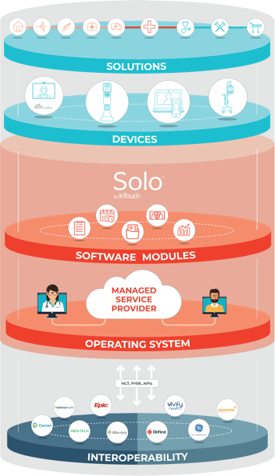
InTouch Health
Figure 41 InTouch Health's integrated platform called Solo™
Figure 42 InTouch Health's integrated platform called Solo™
Within InTouch Health’s telehealth solution, they have integrated their Solo™ software (Figure 41), medicine devices, and existing EMR systems into their platform. InTouch provides service covering behavior health, cardiology, convenient care, critical care, COVID-19/infectious disease, neonatology, operating room, specialty follow-up, and stroke. Additionally, for hospitals they provide implementation, consulting, and physician capacity management offerings.

Company Website: https://intouchhealth.com/
Technology: Platform (Solo™), Viewpoint cart, TV device, Xpress Cart, clinical carts, etc.
Area of Focus: Work with hospitals, health systems, and industry vendors
Business model: Charge could be based on level of integration, software installed, or hardware necessary. Work with various hospital systems.

Maple
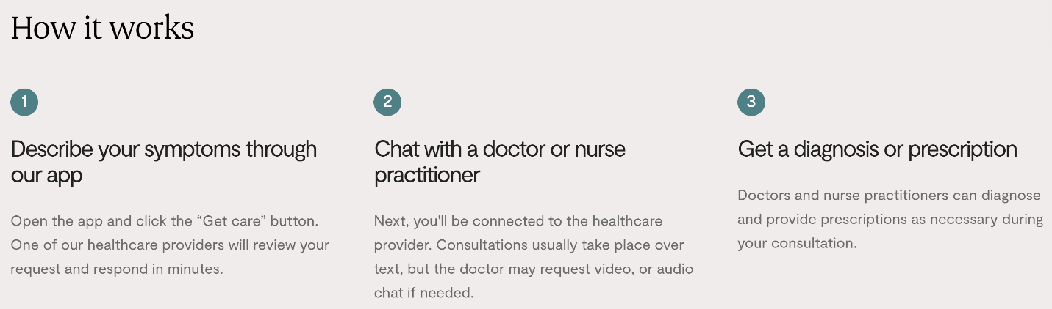
Maple is a telehealth company that links primary care or emergency medicine physicians to patients through their app. Patients are also able to request lab test for various different conditions for a flat fee of $49. On the hospital end, Maple has integrated their system into existing EMR software while creating a tele-hospitalist system.
Figure 43 Description of how Maple works

Company Website: https://www.getmaple.ca/
Technology: Virtual platform. Figure 43 above highlights how a patient interacts with their platform.
Area of Focus: Various kinds of specialists available on their network
Business model: Can pay per visit, membership plan, or credit packages. Work with businesses or hospitals.

International companies

Comarch
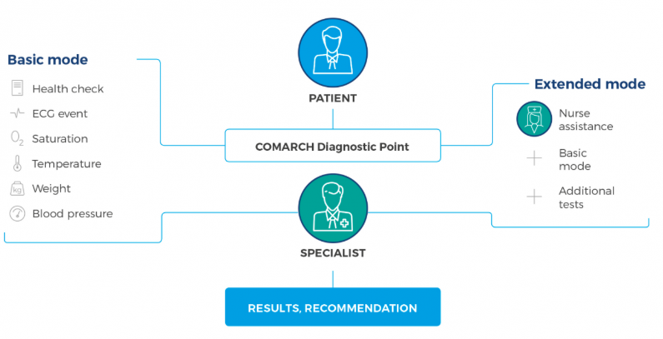
Comarch has established itself in other sectors of software development, including healthcare. They have created offerings under remote medical care covering remote medical center, remote medical care, remote cardiac care, remote maternity care, remote care services, medical teleconsultation, and diagnostic point (Figure 44). Comarch also employs the use of AI and cloud-based analysis within many of their healthcare solutions. Additionally, Comarch has developed their own electronic health record (EHR) system to document medical data.
Figure 44 Workflow of the diagnostic point
Company Website: https://www.comarch.com/healthcare/products/remote-medical-care/
Technology: Physical diagnostic points e-Care platform, heart monitoring software or devices, continuous cardiotocography (CTG) monitoring device, LifeWristband (security device for patients), etc.
Area of Focus: Diagnostics, cardiology, obstetrics, senior care, pulmonology
Business model: Selling ready-made solutions (equipment or software), leasing ready-made solutions, or service model

Focuscura
FocusCura is aimed to help older adult people stay independent in their own home (focusing on virtual homecare and hospital at home) while keeping caregiver, family, doctors, etc. in the loop. They have developed three primary products to support their mission: cAlarm Personal Alarm, cKey Home Access, and cMed Medication Support. The cAlarm is available as a pendant, wristband, or mobile alarm. The alarm system can also connect to a patient’s at-home sensors. cKey assures clients that home care workers and healthcare professionals can enter their home when necessary. cMed assists clients take their medication independently with correct dosage and timing.
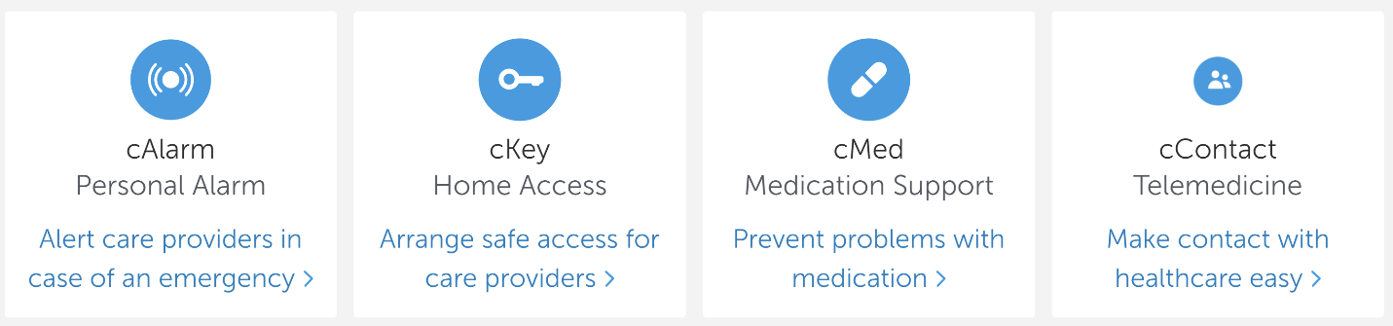
Figure 45 Focuscura services

Company Website: https://www.focuscura.com/en
Technology: Personal alarm, home access, medication support, telemedicine (services listed in Figure 45)
Area of Focus: Supporting aging adult in their home while keeping family, caregivers, and providers in the loop.
Business model: Sales through devices and software. Also provide installation and support services.

StethoMe
StethoMe is funded through the EU and based in Poland. StethoMe utilizes a smart stethoscope that can monitor respiratory and heart metrics (records beats per minute -BMP and resting rate -RR). Artificial intelligence (AI) and analytic software are used to accurately provide a diagnosis which is then reviewed by a doctor. The smart stethoscope has been clinically validated to be extremely effective in diagnosing conditions and can be used by patients at-home or even by doctors in conjunction with their own analysis. If used at-home with coordination with the app, the patient can send their results to a doctor who will determine what to do next.
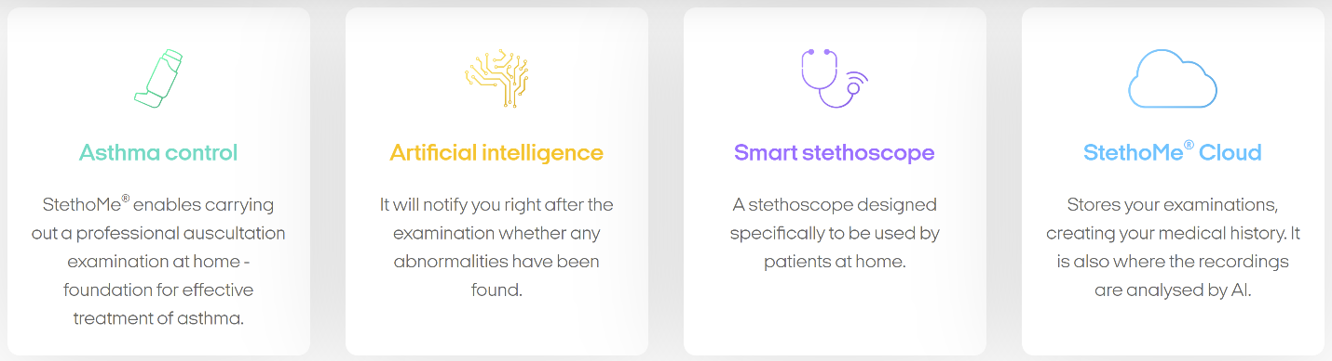
Figure 46 SthethoMe's technology incorporated into the stethoscope

Company Website: https://stethome.com/en

Technology: Monitoring device, software, cloud storage (shown above in Figure 46)
Area of Focus: Main focus is asthma monitoring
Business model: Selling devices to patients while the data is saved in the StethoMe AI cloud;
Their quality is confirmed by the CE medical certificate and scientific research.

Clear Arch Health (Formerly Resideo Life Care Solutions)
Clear Arch Health focusing on providing security, comfort, and care within someone’s home. The main product offered is its LifeStream Remote Patient Monitoring (RPM) Solution which connects video and peripherals, clinical dashboard, and the Genesis Touch Tablet.
Figure 47 Resideo Life Care Solution's platform components

Company Website: https://www.cleararchhealth.com/ Health
Technology: Remote patient monitoring software, integrated video communication, peripheral devices and accessories, integrated telemonitoring system.
Area of Focus: Monitoring patient condition in their home
Business model: Improving patient outcomes using genesis touch, LifeStream Software, and clinical services (Figure 47). They also provide clinical consulting, training, and support.

MyDoc
Figure 48 Best Practice Award given by Frost & Sullivan
MyDoc, a telehealth company based in Singapore, offers multiple services to help with chronic care management from health data tracking to digital health screenings, to a patient’s own personal team of doctors, physicians, and health coaches available 24/7 to integrated chronic disease programs. Their platform allows for case note recording, health diary entry, automated reminders, etc.

Company Website: https://my-doc.com/
Scope of their services:
Technology: Telehealth platform with a wide range of integrated features such as case notes to health concierge services.
Area of Focus: Acute, chronic and preventative medical services.
Business model: Integrated labs and physicians into the solution. Partnered with insurers and their brokers. Work with employers as well.
Latest News: MyDoc was named 2020 Singapore Telehealth Company of the Year by Frost & Sullivan (Figure 48).

Aerotel Medical System
Headquartered in Israel, Aerotel Medical Systems is a mobile and home-based company that focuses on ECG monitoring, medical parameters monitoring, telecare data hubs, and remote monitoring software. Their main focus is on the growing incident rate of heart related conditions.

Company Website: http://www.aerotel.com/index.php/en/
Technology: Remote ECG monitoring, medical parameter monitoring, telecare data hubs, remote monitoring software
Area of Focus: Telehealth and eco cardiogram (ECG) monitoring
Business model: Selling devices and software. They also have medical call centers and transtelephonic backup that transfers medical data.

Telehealth company summary
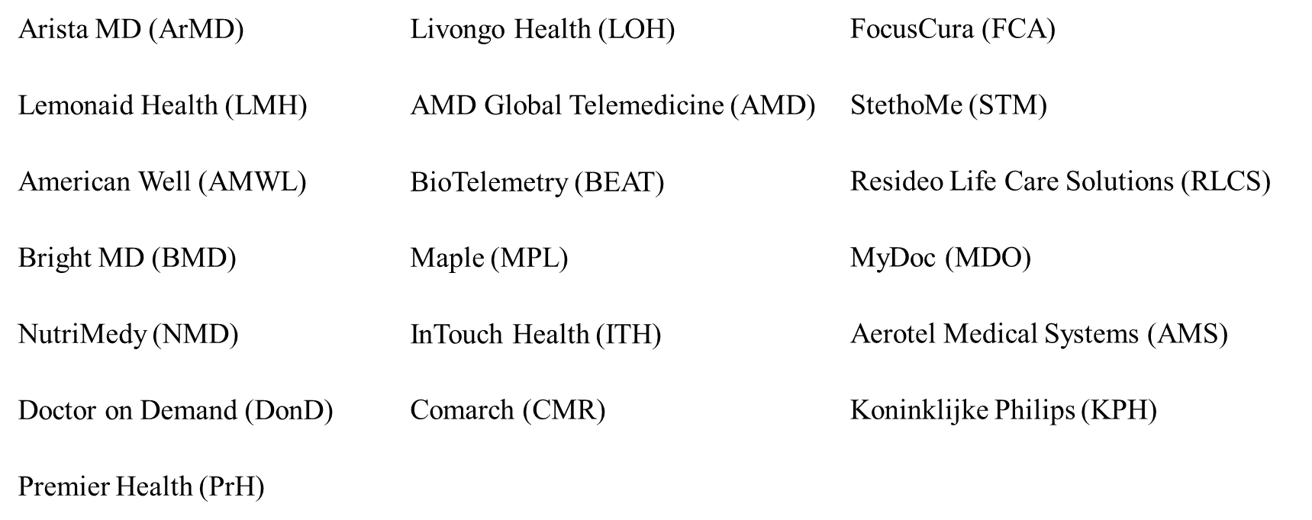
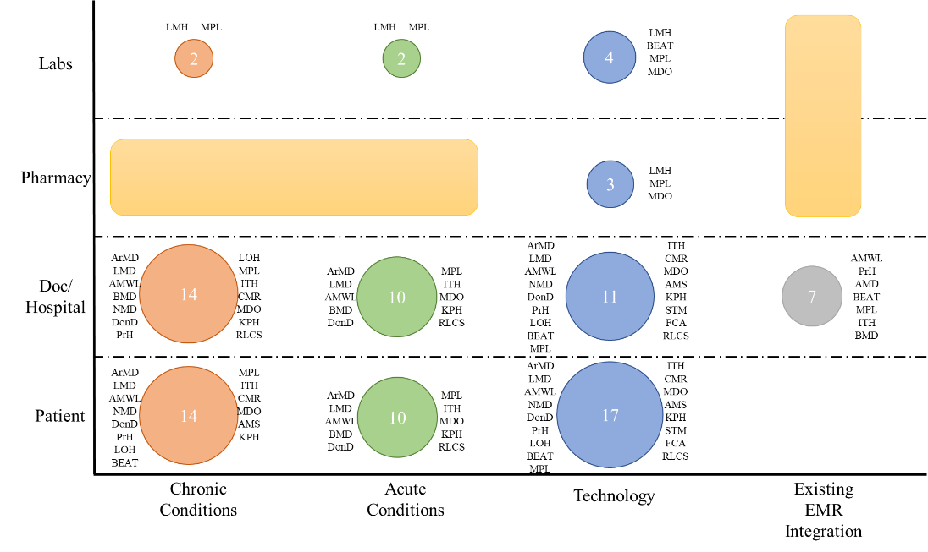
This summary looked at how companies we analyzed fit when compared against different stakeholders and a few elements of TH. The circles within each table cell represent box the size and number of companies within the ones analyzed that fit under that category. We have also listed the companies as reference. When looking at this chart, we designated the yellow square as the space where none of the companies we analyzed fit in.
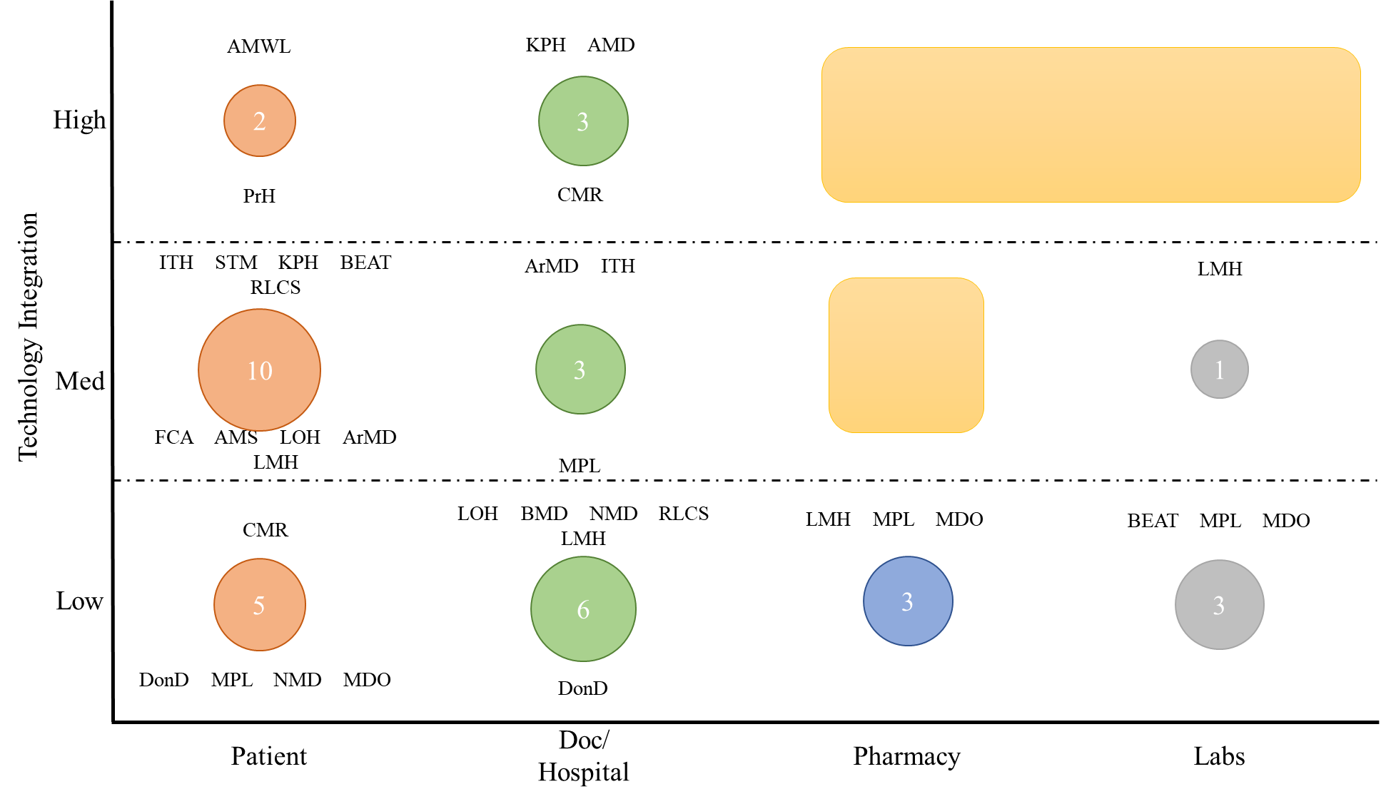
After looking at the table above, we created a summary only looking at the spectrum of technology for each company when compared against the same stakeholders as above. The scale recognizes which companies have taken steps to integrating various kinds of software or technology into their offering.

Recommendations for opportunities

AIP opportunities
Major innovations are happening in independent living, healthcare access, and connectivity services. Companies are focusing on their own devices and their platforms to integrate stakeholders. This is leading to very focused and fragmented solutions. In our opinion, none of these vendors (other than TytoCare to some extent) are focusing on valuable sustainable solutions.
Based on where the gaps are in the solutions, we recommend the following to the cable operators, who are entering into the AIP market-fresh:
- Follow an end-to-end solution approach: Address the fragmented solutions due to “my solution on my platform” syndrome with a fresh end-to-end solution approach. The cable operators are well versed with such solution delivery, which requires a scale of deployments, maintenance resources, and standardization.
- Bring your communication expertise to solve AIP problems: Social interactions are one of the main determinants of the success of AIP. Cable operators should repurpose their communication platforms to solve the needs of AIP.
- Be a device integrator: There are too many device manufacturers in play for every single healthcare, monitoring, and other older adult activity tracking needs. The cable operator should not work on device creation activities but rather should focus on certifying (or evaluating) different devices that can be deployed on their platform.
- Extend your existing back-office systems for AIP solutions: Extend your customer onboarding, management, service assurance, billing, and other platforms to support AIP solutions. This is a very valuable differentiator for the service provider. None of the smaller companies can replicate such capability.
- Partner with the caregiving teams to complement your technical solutions: Even though the service provider has boots on the ground for serving their customers, the AIP-specific services are quite different from managing broadband services. We recommend the service provider create a platform where the other more traditional AIP caregivers can participate.
- Emphasize analytics from the beginning: Develop purpose-driven analytics for maximizing the benefits of the technology-driven next-generation AIP solutions provided by service provider.
Aging in place is the next multi-trillion-dollar opportunity for cable operator. They are in the right place to make this inter-industry venture a win-win for both industries. In our opinion, the cable industry is well equipped to bring AIP solutions with a plethora of highly technical solutions they create and manage in their day-to-day activities.

Telehealth opportunities
With the sudden growth of telehealth companies during 2020, the TH market made way for different models; however, in turn the telehealth market became more fragmented. There are companies focusing solely on devices, platform, weight management, etc. The companies we highlighted above are but a fraction of the companies out in the market. After going through various types of telehealth companies, the charts above highlight some clear gaps within the current market. Overall, there seems to be less intentional integration with lab, pharmacies, electronic health record platforms, and other external entities. On the technology end, we see a similar trend of platforms focusing less on pharmacy and lab services. At a deeper level, there seems to be room for growth within chronic care management, connection between physicians, device integration, and data analytics.

Business requirements
To create the business requirements for telehealth and AIP, we took information we gathered from our previous research, talks with industry professionals, and current standards to set us on the right path. That initial period led us to choose eight stakeholders for telehealth and six stakeholders for AIP to focus on initially. For telehealth we identified the patient, provider, policy, payors, hospitals, support team, infrastructure, and serviceability. For AIP we focused on the older adult/patient, provider, payor, support team, infrastructure, and serviceability.
Each stakeholder has their own categories of considerations which are noted as classifications. These classifications are then divided into sub-classifications before detailing what the business requirement looks like. The requirements then are given a priority of either high, medium, low, or informative. High is any requirement that directly affects the stakeholder’s life safety. Medium involves any security or privacy considerations. Low would be the requirements dictating a stakeholder’s quality of experience. Informative is any requirement that is either an instruction or information that has no identified impact at that point in time.
The following section highlights some of the requirements for each of the identified stakeholders. To see the detailed requirements table, refer to Appendix B: Detailed business requirements:.

Aging in Place business requirements

Older adult/Patient needs
Ecosystem Support: For ecosystem support we looked at how independent living, cognition, and access to healthcare play a role in their AIP environment.
- Independent living is extensive, but one requirement identified was maintaining hygiene. Older adults should have safety measures in place to bathe so that they do not slip or fall (high priority).
- Cognition also plays a huge role in aging at home. Therefore, there should be baseline assessments of cognitive functions for future comparisons (medium priority).
- Access to healthcare is critical for everyone, especially for older adults who are at a higher risk.
Interactivity: Interactivity considers personal mobility, transportation, and communication and social connectivity.
- Personal mobility not only plays a role in the home, but also outside the home. Thus, older adults should have navigation tools to help move inside and outside the home (medium priority).
- Since many older adults have felt the extreme negative effects of social isolation throughout COVID-19, it is important to keep them interacting with others (high priority).
Condition Specific: Since an older adult’s age range can dictate their health condition, we felt it was important to consider different health conditions.
- The prevalence of chronic conditions significantly increases in older adults. Thus, it is important for older adults to have access to tools that help them manage their disease plan (high priority).
- Additionally, with more cognitive impairment seen in older adults, there needs to be an avenue open for patients or caregivers to voice their concerns to a healthcare provider (medium priority).
Distance: An individual’s distance from resources can change how they age at home; thus, it is important to consider where those resources are.
- Especially in rural areas, older adults and their caregivers should be given access to local resources they can use to navigate their community or needs (informative priority).
Cost Limits: Regardless of where a person wants to age, their financial situation needs to be considered. That could include income, coverage, housing, etc.
- Since there are many avenues to receive income, older adults should have a clear way to understand where that money is originating (informative priority).
- Based on the financial situation, older adults and/or their caregiver may decide if AIP or an alternative facility is suitable for their needs (informative priority).

Provider needs
How They Use: How they use considers how healthcare providers will interact with an older adult over a platform.
- Apart from the usual one-time encounter, with older adults it is important to consider chronic care management. Providers should have access to patient data so they can monitor their condition (high priority).
- Providers should also have the functionality to send their patient resources about their condition (informative priority).
Practice Needs: Each health practice will have different needs especially when considering different age groups. For older adult care, there is palliative care, hospice care, chronic care, etc.
- Palliative care would be providing older adults with care that addresses their illness while at home (medium priority).
- For hospice care, the hospice provider should also work with the older adult’s other caregivers to create a care plan for the older adult (high priority).
Cost Limits: The cost limits we considered were the training costs.
- Providers would need to consider costs of certified AIP specialists since these individuals are specially trained to help older adults live in their home (high priority).
- Staff should also be trained with basic skills to work with older adults. This could include bathing, feeding, communication, etc. (medium priority).
- On-going training costs should also be included that would highlight changes to best practices and to allow staff to refocus on the needs of the clients.
Technology Needs: Any technology needs the provider should consider when running their telehealth platform. Includes connection, medical devices, software, etc.
- A lower priority requirement would be making sure providers have a reliable connection to the telehealth platform.
- A requirement would be making sure there is seamless integration between the telehealth platform and existing provider systems (low priority).
Ecosystem Support: Ecosystem support gives providers any assistance they may need while using the telehealth platform.
- This could come in the form of device support. If the provider is having trouble with their medical device on the platform, they should have access to a support team (low priority).
- Additionally, if the patient is having trouble navigating the platform, providers should have access to a professional who can address the issue (low priority).
Health Insurance Portability and Accountability Act Compliance: With regulations around monitoring patient safety, it is important to highlight requirements that will address those regulations. Most prevalent is Health Insurance Portability and Accountability Act (HIPAA) compliance.
- If the telehealth platform stores patient sensitive data, they must make sure their platform is HIPAA compliant (Medium priority).

Payor needs
Cost Controls: We broke down the initial cost controls requirements into two categories: income related and housing.
- Insurance is an important part of understanding how older adults can cut their expenses of how to live at home. For example, older adults should be able to see what medical procedures are covered by their insurance policy (high priority).
- As for housing, older adults should also have a chance to explore affordable housing options based on their income (medium priority).
Policy Adherence: For policy we looked at medical treatment and transportation.
- Payors should inform older adults on the different medical treatment prices and how they would impact their medical care (informative priority).
- Older adults should also be given some financial assistance if they have difficulty travelling in their community (high priority).
Care Improvements: Care improvement requirements discusses how payors can provide assistance to older adults living at home. This could be done through housing or transportation updates.
- In the home, older adults could add medical equipment to their home so that medical professionals can provide care in the older adult’s home (medium priority).
- Transportation modes should allow older adults to easily navigate the system (low priority).
Adoption: Adoption of AIP can involve different groups, but at a large scale it involves the community in which they live.
- There should be plans to invest in ways older adults can integrate into community culture (informative priority).

Support Team
Medical Support: Medical support entails any medical issues different parties have. This could include medical questions or issues that a patient may have. What is important to consider is how the issue flows through the system.
- A chain of command should be established so that different levels of issues are sent to the appropriate individual (informative priority).
- Additionally, when there is a medical anomaly noted in the system, a trained support staff should be notified while notifying the other individuals effected (medium priority).
Technical Support: Technical support is a support team dedicated to assisting with any platform, device, hardware, etc. issues that arise.
- Similar to medical support, there needs to be a chain of command that dictates how an issue moves up the support process (informative priority)
- Technical support also picks of extra responsibilities when it comes to issues such as system failure. For example, there should be a special notation created when there is a failure in a technical system (medium priority).
Financial Support: Financial support provides stakeholders with support in any financial related issues. Insurance or reimbursement issues would fall under this support team.
- Again, there should be a chain of command for financial issues created in the system (informative priority).
- Support staff should also follow a chain of resolution when issues, such as insurance or reimbursement, arise so that the user is aware of what’s ongoing with their issue (informative priority).
Peripheral Support: Peripheral support refers to supporting those who may be involved in a patient’s care journey [family or friends] (high Priority).
- The same chain of command is created or integrated into the system to help peripheral support systems (informative priority).
- Additionally, if a medical system or device is activated [fall detection, house sensor] the appropriate individuals should be notified (informative priority).
Customer Journey: We also wanted to consider a primary customers journey through the support system. Apart from the usual chain of command, we considered installations, monitoring, and responses.
- One requirement necessary is making note of any issues during monitoring (informative priority).
- If there needs to be action taken for this issue, there should be a response team sent out to resolve the problem (low priority).

Infrastructure
Physical Interface: Physical interface looks at what an interface needs to operate.
- Creating a gateway to allow data transfer between different healthcare networks is crucial for continuum of care (informative priority).
- A stable connection to the interface is key to smooth visits or interaction (low priority).
Terms of Service: Clearly written out Terms of Service should be made early on to avoid any future confusion on roles.
- An SLA (Service-Level Agreement) should be created between the service provider and the healthcare client on how services will be split between the two (informative priority).
- On top of an SLA, if there is a system failure, there should be backup system in place to retrieve data (medium priority).
Customer Service: Similar to support teams, customer services support user issues.
- There should be a chain of command that establishes a hierarchy of which personnel should address issues at different levels (informative priority).
- The company should also decide on the method in which they will address these issues [bot, ticket system, etc.] (informative priority).
Operations: Operations note on platform activity. This could involve incidents, reporting, platform traffic, etc.
- Early on there should be an established process on how to log platform incidents (informative priority).
- After logging those incidents, a method for reporting those incidents must be in place (informative priority).
Security Monitoring: Security monitoring can be extensive especially with sensitive medical data, so we cover a few basic considerations.
- One basic security measure would be to ensure each user has their own unique username and password to access the designated platform (medium priority).
- Denial-of-Service (DOS) attacks disrupts a user’s access to their machine. One requirement would be to monitor for such attacks (medium priority).
Content Management System: For content management systems (CMS) we initially considered two requirements: housing and delivery.
- Housing constitutes that there is a unique location for all data to be stored (informative priority).
- Delivery would mean converting the CMS data into a standard format for users to use (informative priority).
Alerts: Alerts could include a wide variety of requirements, but we discuss both user and company alerts.
- User alerts could come from analytical results. Based on the data results it can recommend action to be taken by older adults or other stakeholders (informative priority).
- Company analytics would work in a similar way as user alerts, but the data would inform company decision makers (informative priority).
Accessibility: Accessibility considers how platforms can adjust to a user’s physical needs: sight, mobility, hearing, etc.
- The platform could provide a way to account for sight impairment (i.e. adjusting font size) (low priority).
- For physical locations, the company should account for those with mobility challenges by including structures such as ramps (low priority).
Caregivers: Since caregivers can be an integral part in an older adult’s AIP journey, they should be given a certain level of access to their care recipient’s records that conform to HIPAA regulations (informative priority).

Serviceability needs
Support: Support falls into two categories: proactive and reactive.
- Proactive support entails talking to users or analyzing data to identify any issues that may arise (low priority).
- Reactive support can happen in different ways. For example, a ticketing method can be used to address user issues as they come about (informative priority).
Content or Conversation Flow: Content or conversation flow involves the user’s interaction with the platform.
- The company should decide if the first interaction the user has is with an automated system or a live employee (informative priority).
- There should also be a line of questioning created to help delve into the customers issues (informative priority).
Customer Journey: A customer’s journey through service support involves four different phases - activation, maintenance, deactivation, and logistics.
- Activation is the stage where customer service personnel are notified that there is a user service claim (low priority).
- Maintenance is following up with the user’s claim (low priority).
- Deactivation is making note of or closing the user’s claim once the issue has been addressed (low priority).
- Logistics involves any action that needs to be taken after the claim has been resolved. This could be distribution, return, or refurbishment (informative priority).
Proxy: Proxy involves being in contact with a secondary user if the primary is not available. If there is a secondary user, they should have consent to speak on behalf of the primary (medium priority).
Audit: These requirements looked at auditing of accounts.
- One such audit would be to track the number of accounts on the platform (informative priority).
- It is also important to make note of the state of the account: active, not active, etc. (informative priority).
- Account traffic is another auditing tool (informative priority).
Revenue Insurance: In order to charge for revenue insurance, we built requirements relative to the number of users.
- Tracking the number of active users is one metric for insurance (informative priority).
- Based on the level of activity of an account, the user will be charged accordingly (informative priority).
Security: Maintaining security is important to maintain the integrity of the platform.
- Making sure users have the appropriate credentials to access the platform is the first line of defense (medium priority).
- If there is any suspicious activity, there should be a special notation for these incidents (medium priority).
- Hand-in-hand with the notation is a method to address these security concerns (medium priority).
Customer Supply Management: Customer supply management can touch many different aspects of supply management. The ones we talk about in requirements involve transportation, delivery, and devices.
- Transportation could be providing older adults with reliable transportation services (food, appointments, etc.) (informative priority).
- The delivery requirement would make sure stakeholders get their items in a timely matter and without damage (low priority).
- As for devices, they need to have uniform quality amongst the devices produced (low priority).

Telehealth business requirements

Patient needs
Ecosystem Support: Ecosystem support involves supporting the patient with any user facing systems such as telehealth platforms, electronic medical records (EMR), medical devices, etc.
- For example, a low priority requirement falling under the platform sub-class. we identified was ease-of-use. Since there is a varying level of technical abilities, the platform should be intuitive to accommodate for those differences.
- An informative requirement falling under medical devices notes the select medical devices compatible with the platform, those devices should have the capability to upload information to the platform.
Interactivity: Interactivity covers any considerations that need to be taken when the patient is talking to a healthcare provider.
- A low priority requirement created fell under the physician sub-classification. This requirement highlighted the need for audio capable devices so that the patient can communicate with the physician.
- A medium priority requirement took note of consent. The patient/guardian should give their consent to use the telehealth service platform.
Condition Specific: Condition specific requirements follows different concerns for either an acute, chronic, or behavioral condition.
- An informative priority requirement for a chronic condition involves the patient’s treatment coordination. The patient should be able to contact any of their care providers in case of any health questions they may have.
- For behavioral health, a low priority requirement would be referral to another provider. The patient should be able to schedule an appointment with a new provider if they deem necessary.
Age Specific: We had 3 categories for a patient’s age: <18 years, 18-55 years, and >55 years. Depending on their age, the requirements change to reflect the care they’re receiving at that age.
- For pediatric care (<18 years of age), it is important to have guardian consent. Before a physician’s encounter, the patient’s guardian should give consent to using the telehealth services.
- For older adult care (>55 years of age), a medium priority requirement would be patient monitoring. If the patient consents to device monitoring, the provider will have access to the data collected.
Distance Specific: Distance specifics was broken down into care location and pharmacy, mostly considering individuals in a rural location.
- With telehealth providing care to individuals regardless of their location, we saw the need to include a requirement where there are designated community sites to which patients can refer if they need to send or receive any information. This could come in the form of sending medical information via a community pharmacy. We designated this as a low priority requirement.
Cost Limits: Cost requirements can consider everything from medical insurance to medical devices.
- During the pandemic, more insurers have begun to cover certain telehealth services; however, patients should be aware of the extent of their coverage (informative priority).
- On the other end, if a patient needs to purchase a medical device to use for their telehealth visit or otherwise, there should be clear options of how they can purchase that device.

Provider needs
How they Use: How they (providers) use highlights some important features of a telehealth platform that healthcare providers should have. This includes integration of EMR systems and the actual telehealth space.
- A low priority requirement would be the ability for providers to record their patient encounter in their EMR system.
- Along that same line would be providers being able to view a patient’s past records (informative priority).
Practice Needs: Each type of provider practice will require a different level of telehealth technology. For example, certain types of specialties or during telehealth expansion, the providers practice need will change.
- Certain specialties may require unique equipment to conduct the visit. Hence, these specialists should have access to those pieces of equipment during their visit (low priority).
- Staff should also be trained on how to navigate the telehealth platform (informative priority).
Cost Limits: Cost limits would be any considerations providers need to take when using telehealth solutions. This could relate to expanding their telehealth needs or device additions.
- One consideration would be breaking down how money would be spent to expand the services (informative priority).
- If devices are being integrated into the telehealth platform, providers should have a voice on whether or not it would serve their needs (informative priority).
Technology Needs: Is any technology needs the provider should consider when running their telehealth platform. This includes connection, medical devices, software, etc.
- A low priority requirement would be making sure providers have reliable connection to the telehealth platform.
- A requirement would be making sure there is seamless integration between the telehealth platform and existing provider systems (low priority).
Ecosystem Support: Ecosystem support gives providers any assistance they may need while using the telehealth platform.
- This could come in the form of device support. If the provider is having trouble with their medical device on the platform, they should have access to a support team (low priority).
- Additionally, if the patient is having trouble navigating the platform, providers should have access to a professional who can address the issue (low priority).
HIPAA Compliance: With regulations monitoring patient safety, it is important to highlight requirements that will address those regulations. Most prevalent is HIPAA compliance.
- If the telehealth platform stores patient sensitive data, they must make sure their platform is HIPAA compliant (medium priority).

Policy needs
Licensing: Proper user licensing is a key component for telehealth platform use. After COVID, certain licensing regulations were changed.
- Previously physicians could not practice across state lines, but now physicians with a valid medical license can practice across state lines with certain exceptions (high priority).
- There is also the nursing licensure compact (NLC). NLC allows nurses to have one license valid across multiple states (high priority).
Prescribing: Online prescriptions are also highly regulated and need to be addressed in the platform.
- The Ryan Haight Online Pharmacy Consumer Protection Act 2008 allows for dispensing of controlled substances via the internet only for a valid medical purpose after a physician’s visit (high priority).
- The Special Registration for Telemedicine Clarification Act of 2018 states that the DEA needs to communicate special registration allowing providers to prescribe controlled substances via telemedicine without an in-person exam (high priority).
Medical Record: Maintaining a medical record is an important component of a provider visit. We have identified some guidelines to be followed.
- One medium priority guideline would be to make sure the platform adheres to a hospital’s or clinic’s guidelines on how to maintain patient medical records.
Reimbursement/Parity: Being reimbursed for telehealth care is a key change that happened in 2020. Medicaid and other insurance plans have begun to cover telemedicine services in almost every state (informative priority).
HIPAA (Health Insurance Portability and Accountability Act): Since HIPAA is a key component to health security used to protect patient information. Because providers will be collecting data during patient visits, there are guidelines in place to protect that info.
- One such guideline is making sure only the authorized physicians or healthcare worker is accessing the health information (medium priority).
- These authorized personals should also be provided with unique ID for tracking user identity (medium priority).
HITECH (Health Information Technology for Economic and Clinical Health): The HITECH Act is aimed to prompt the use of health information technology including Electronic Health Records (EHRs).
- HITECH includes more rigorous enforcements of HIPAA with penalties as much as $250,000 (medium priority).
- Under HITECH, business associates are also required to comply with HIPAA security rules (medium priority).
Informed Consent: Patient consent is another necessary component to conduct telehealth business. Consent involves explaining the risks and benefits of the service to the patient, guardian, and/or caregiver (medium priority).

Payors needs
Cost Controls: Cost control for payors involves how insurance will address telehealth services.
- Telehealth services have recently been equally reimbursed compared to in-person care (informative priority).
- Users of telehealth should also be aware of what kind of tele-visits are covered under insurance (informative priority).
Policy Adherence: Since there are continuous changes to healthcare policy, it is important to keep up to date on how those changes effect telehealth initiatives. These changes may also change during the course of COVID-19 (informative priority).
Care Improvements: Care improvement looks at how either employers or insurance can improve Telehealth access.
- Employers can offer employees different packages depending on a user’s healthcare needs (informative priority).
- Additionally, insurance groups can expand their services as time goes on to provide more comparable coverage to in-person services (informative priority).
Adoption: As telehealth grows, there are more chances to expand into more nuanced areas of healthcare.
- Payors may end up covering more specialties as they become available on the platform (low priority).
- Some payors may also require physicians to be in their network in order to be reimbursed for their service (informative priority).

Hospitals needs
Specialty: Hospitals need to consider what kind of special employees they need to hire in order to work in the telehealth space.
- This means making sure physicians are eligible to work across state-boarders (informative priority).
- Hospitals should also be supported on the telehealth regulations to consider when hiring healthcare providers (informative priority).
Cost: There are also various kinds of costs that need to be considered: expansion, medical devices, software, etc.
- When a hospital expands their telehealth offering, there should be a breakdown on how money is being spent to grow their service (informative priority).
- Hospitals should also be given a chance to explore the addition of new medical devices in their telehealth service (informative priority).
Technology: With telehealth heavily relying on technology, there should be a clear path of integration.
- For example, if the hospital is using an EHR system, it should easily integrate into the telehealth service (low priority).
- Devices should also be able to integrate into the telehealth platform (low priority).
Service Availability: Each healthcare worker will interact with a telehealth platform in different ways.
- Nurses and providers will have their own unique workflows to consider on the platform (informative priority).
- Other entities such as labs, imaging, admin, insurance have additional workflows (informative priority).
Hospital Information System: Health Information Systems involves patient, clinical, and management information.
- One requirement would be to compile a master patient index which would combine patient data from different hospital systems (informative priority).
- On another end, hospitals can use analytics to inform better clinical decisions (informative priority).
Support: Throughout a hospital use of the telehealth platform, they should be supported by trained professionals when issues arise (low priority). The same goes for device support (low priority).
Security: There are multiple sectors that require security measures to be in place.
- One would be to makes sure the software being used is HIPAA compliant (medium priority).
- Another is making sure that when data is collected it is secure from unauthorized access (medium priority).
Software: Hospitals also need to ensure their software fits their needs whether it be in secure access or filling claims.
- The software should only be accessible to those with appropriate ID access (medium priority).
- Some software may also integrate claims or billing functions into the platform (low priority).

Support team needs
Medical Support: Medical support would be any medical issues different parties have. This could include medical questions or issues that a patient may have. What is important to consider is how the issue flows through the system.
- A chain of command should be established so that different levels of issues are sent to the appropriate individual (informative priority).
- Additionally, when there is a medical anomaly noted in the system, a trained support staff should be notified while notifying the other individuals affected (medium priority).
Technical Support: Technical support is a support team dedicated to assisting with any platform, device, hardware, etc. issues that arise.
- Similar to medical support, there needs to be a chain of command that dictates how an issue moves up the support process (informative priority)
- Technical support also takes extra responsibilities when it comes to issues such as system failure. For example, there should be a special notation created when there is a failure in a technical system (medium priority).
Financial Support: Financial support provides stakeholders with support for any financial related issues. Insurance or reimbursement issues would fall under this team.
- Again, there should be a chain of command for financial issues created in the system (informative priority).
- Support staff should also follow a chain of resolution when issues, such as insurance or reimbursement, arise so that the user is aware of what’s ongoing with their issues (informative priority).
Peripheral Support: Peripheral support refers to supporting those who may be involved in a patient’s care journey (family or friends).
- The same chain of command is created or integrated into the system to help peripheral support systems (informative priority).
- Additionally, if a medical system or device is activated (fall detection, house sensor) the appropriate individuals should be notified (informative priority).
Customer Journey: We also want to consider a primary customer’s journey through the support system. Apart from the usual chain of command, we consider installations, monitoring, and responses.
- One requirement necessary is making note of any issues during monitoring (informative priority).
- If there needs to be action taken for this issue, there should be a response team sent out to resolve the problem (low priority).

Infrastructure needs
Physical Interface: Physical interface looks at what an interface needs to operate.
- Creating a gateway to allow data transfer between different healthcare networks is crucial for continuum of care (informative priority).
- A stable connection to the interface is key for smooth visits or interaction (low priority).
Terms of Service: Clearly written out terms of service should be made early on to avoid any future confusion on roles.
- A service level agreement (SLA) should be created between the service provider and the healthcare client on how services will be split between the two (informative priority).
- On top of an SLA, if there is a system failure, there should be backup system in place to retrieve data (medium priority).
Customer Service: Similar to support teams, customer services support a user issue.
- There should be a chain of command that establishes a hierarchy of which personnel should address issues at different levels (informative priority).
- The company should also decide on the method in which they will address these issues (Bot, ticket system, etc.) (informative priority).
Operations: Operations takes note on platform activity. This could involve incidents, reporting, platform traffic, etc.
- Early on there should be an established way on how to log platform incidents (informative priority).
- After logging those incidents, a method for reporting those incidents must be in place (informative priority).
Security Monitoring: Security monitoring can be extensive especially with sensitive medical data, so we cover a few basic considerations.
- One basic security measure would be to ensure each user has their own unique username and password to access the designated platform (medium priority).
- Denial of service (DOS) attacks disrupt a user’s access to their machine. One requirement would be to monitor such attacks (medium priority).
Content Management System: For CMS we initially considered two requirements: housing and delivery.
- Housing constitutes that there is a unique location for all data to be stored (informative priority).
- Delivery would mean converting the CMS data into a platform format for users to use (informative priority).

Serviceability needs
Support: Support falls into two categories: proactive and reactive.
- Proactive support entails talking to users to identify any issues that may arise (low priority).
- Reactive support can happen in different ways. For example, a ticketing method can be used to solve user issues as the come about (informative priority).
Content or Conversation Flow: Content or conversation flow involves the user’s interaction with the platform.
- The company should decide whether the first interaction the user has is with an automated system or a live employee (informative priority).
- There should also be a line of questioning created to help delve into the customers issues (informative priority).
Customer Journey: A customer’s journey through service support involves four different phases activation, maintenance, deactivation, and logistics.
- Activation is the stage where customer service personnel are notified that there is a user service claim (low priority). Maintenance is following up with the user’s claim (low priority). Deactivation is making note of or closing up the user claim once the issues has been addressed (low priority).
- Logistics involves any action that needs to be taken after the claim has been resolved (informative priority). This could be distribution, return, or refurbishment.
Proxy: Proxy involves being in contact with a secondary user if the primary is not available. If there is a secondary user, they should have consent to speak on behalf of the primary (medium priority).
Audit: These requirements look at auditing of accounts.
- One such audit would be to track the number of accounts on the platform (informative priority).
- It is also important to make note of the state of the account: active, not active, etc. (informative priority).
- Account traffic is another auditing tool (informative priority).
Revenue Insurance: In order to charge for revenue insurance, we built requirements relative to the number of users.
- Tracking the number of active users is one metric for insurance (informative priority).
- Based on the level of activity of an account, the user will be charged accordingly (informative priority).
Security: Maintaining security is important to maintain the integrity of the platform.
- Making sure users have the appropriate credentials to access the platform is the first line of defense (medium priority).
- If there is any suspicious activity, there should be a special notation for these incidents (medium priority). Hand-in-hand with the notation is a method to address these security concerns (medium priority).

Use Cases

Introduction
The COVID-19 pandemic required people to discover new ways to do things from home over a home network. One area where this has become obvious is wellness. While many healthcare providers have scrambled to provide remote visits, this only solved part of the problem. What people need is a support infrastructure at home that gives wellness providers the information they need as well as the ability to provide remote assistance. This requires a secure reliable home network with connected devices to do the observing and controlling. Additionally, connected services beyond the home are needed to log measurements, connect families and wellness providers, and provide notification of significant events.
Cable operators are well-positioned to provide these services. They can extend their traditional offerings of bandwidth and television service to include aging in place (AIP), telehealth, in home care, and safer alternatives to surgery. This can unleash many inter-industry, revenue-generating opportunities in healthcare by linking healthcare devices, families, and wellness providers into coordinated health communities. In-home care solutions over 10G, highly available access networks can both improve the wellness experience and provide new cable operator revenue streams while fully satisfying stringent HIPAA data security and privacy requirements. Cable operators already have the core technology and the consumer relationships to naturally provide this type of solution.
This section explores use cases in this space and points out the key areas where cable operators can provide a collaborative in-home wellness solution., It introduces several use cases that SCTE standards working groups are considering with respect to the aging in place and telehealth spaces in the wellness industry. It also considers use cases common to both areas such as connectivity and analytics infrastructure, as well as use cases specific to AIP and telehealth.

The Opportunity
US healthcare costs are increasing at 5.4% year over year and are estimated to reach $5.5 trillion by 2026 . The US healthcare industry is huge, and policymakers have been concerned by its growth relative to total GDP. The criticism is sometimes characterized by the idea that the US healthcare system is a sick-care system and that boundaries must be broadened to effect positive change on national healthcare. Wellness and social determinants of health are important items for discussion within the healthcare industry. This represents an interesting opportunity for cable operators with a strong residential franchise presence.
The healthcare industry has been modernizing its infrastructure intending to control costs and improve the quality of care. Telehealth is one such mechanism that has been gaining adoption. Telehealth played a critical role in virtualizing care during the COVID pandemic. Telehealth has been growing at a yearly rate of ~15% with 2020 seeing a 175x increase in telehealth adoption mainly due to COVID-19. This Telehealth infusion is driven by increased patient and provider adoption, better reimbursements, and relaxed regulations. Although adoption may slow after COVID, telehealth benefits are recognized and are here to stay. Telehealth is not just video communications, but it also touches on different technological solutions that cable operators have mastered and been deploying. Healthcare has lagged most industries regarding the virtualization of services. Consider how the retail, finance, and entertainment industries have been transformed by digital technology over the last decade. The potential disruption to healthcare is inevitable. The cable industry not only brings technology but also leadership in building standards-based platforms that can deliver critical cost reductions required to assist the healthcare industry.
Center for Medicare and Medicaid Services (CMS) projects up to $5.5T healthcare spend in 2026. Duke Tech Solutions (DTS) projects, of the total spend, $3T can be better addressed by virtualizing the care models with telehealth and better connecting the existing wellness and housing sectors to the healthcare industry. Out of which, $1.3T can be addressed by telecom operators. In this report, we demonstrate some of the needs that telecom operators can support using their developing capabilities such as in-home technologies, IoT, broadband communication enhancements, consumer service development, platform standardization expertise, back-office capabilities, and installation and support resources.
Different services are driving healthcare costs that can be addressed by telehealth initiatives³⁴. These services include perpetual wellness, aging in place (AIP), communication-enabled medical encounters (CEME), virtual pharmacy, hospital at home (HAH), and remote specialty services. A very conservative analysis in these six segments shows that a U.S. telecom operator can recognize ~$27 billion per year Figure 49.
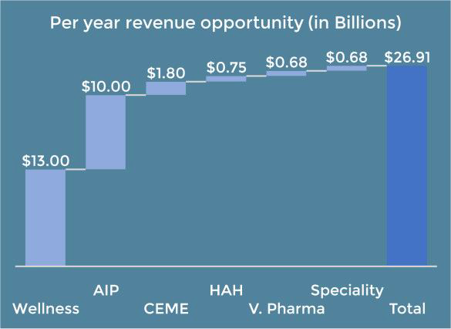
Figure 49 A conservative estimation of US telecom for wellness opportunity from DTS³⁴
In this section, we will concentrate on three use cases: aging in place; CEME for independent living; and hospital at home. Each of the use cases considered is analyzed from the wellness stakeholders’ points of view with clear definition of the problems, how stakeholders interact with one another, how and what to sell to the stakeholders, what is involved in the solutions, what are the opportunities for the stakeholders, and what are the opportunities for the cable operators.
All these opportunities are analyzed against the framework shown in Figure 50³⁴ . The cable operator can use this framework to realize their telecom for healthcare (T4H) solutions. The framework includes telehealth patient/consumer home components, the Telehealth sensor network infrastructure, and the telehealth hosting back-office infrastructure.

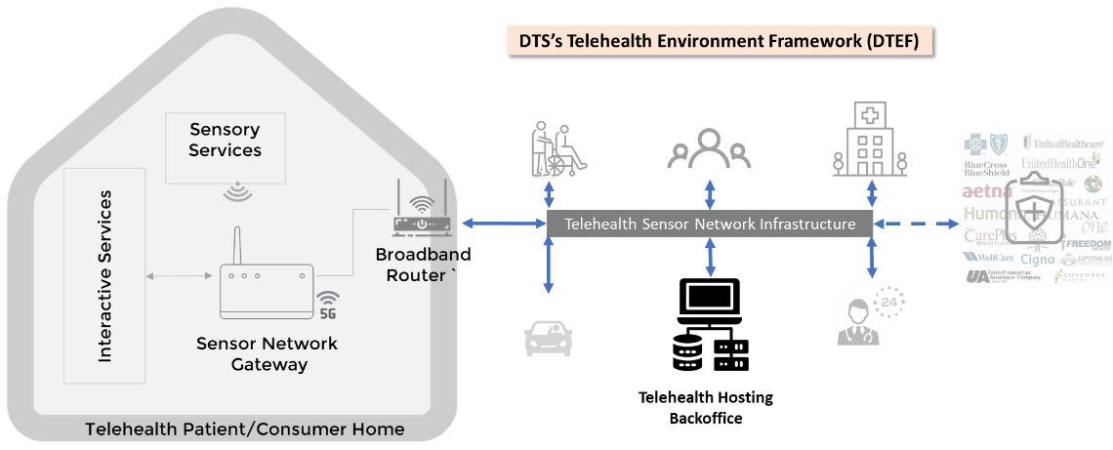
Figure 50 A telehealth environment framework
COVID-19 has accelerated the rollout of telehealth from an experimental new service to a necessity. It has uncovered a powerful new wellness delivery model that could fundamentally change the cost structure of the entire wellness industry. Because of this, the transition to a virtualized wellness service model is at the top of the wellness strategy stack. We believe the wellness industry transformation goals can be addressed by the cable operators, making this inter-industry collaboration a success. As mentioned previously, it has the potential to mold into a $1.3 trillion opportunity for U.S. telecom operators by 2026³⁴.

The Stakeholders
Every patient ages uniquely and has unique needs. The solution to effectively address the needs of patients will need to be tailored to those requirements. However, there is a sort of continuum of aging that is common. A patient moves from a position of relative independence toward more dependence on a team of supporting stakeholders.
The patient is the focus of this support. Stakeholders in the process of caring for the patient include a community of family and friends such as the patient advocate/power of attorney (POA) and neighbors, and a collection of caregivers including primary care doctors, medical specialists, nurses, therapists, personal care assistants, housekeepers, meal providers, etc. There are also insurance companies, Medicare, and other payers. Many patients want to remain in their own homes with relative autonomy as long as possible. COVID has pushed the limits of some of these ideas. Technology has demonstrated that telecommunications, networking, and automation can fill in gaps that previously required manual or higher-level assistance. Technology solutions can be more convenient, more effective, and less expensive. This is an opportunity for cable operators .
Patient or User: The primary stakeholder is the patient. Proper care of the patient is the primary goal. Proper care includes providing that care in compliance with the patient’s preferences as far as possible. The stakeholders must have a common plan of care. They must be able to communicate that plan and execute it effectively. Clear means of measuring the effectiveness of the care and communicating that information with all the stakeholders is key.
Community: Perhaps the most important group of stakeholders in the patient's circle are their friends and family. These are the people with the most direct and personal relationships with the patient. In many cases, they are responsible for making decisions about the patient’s care. They should be notified of significant events and be in regular communication with the patient and other caregivers.
Caregiver: Caregivers include those responsible for providing patient care. Caregivers include physicians, nurses, therapists, specialists, and other healthcare providers, but also include cleaning services, personal hygiene providers, and meal providers. They will interact with the patient on a scheduled or routine basis but may also be required to respond to emergency needs. Also, it is important to note that the location of the service could be at home, an independent living facility, or an assisted living facility. Providing the continuum of care for a given user throughout their transitions is very rewarding and increases the stickiness of the user.
Payor or Insurance: Except for the patient’s community of family and friends, most stakeholders will need to be paid. Depending on circumstances, this can include personal funds, insurance coverage, and government resources. This stakeholder service can be highly automated to simplify interactions and ensure that caregivers and service providers are promptly compensated while the patient and their designated care advocate(s) clearly understand the process, costs, and expected benefits.

Infrastructure
Infrastructure is the most important aspect of a remotely-delivered integrated wellness care system. This is what ties all the component pieces together. At the most basic level this includes installing sensors, actuators, and monitoring equipment. At the higher levels it involves keeping track of all the stakeholders, providing them with the information they need, and providing the tools so they can act on that information.
Wellness-related infrastructure: Wellness infrastructure is the glue that alerts families and caregivers when the patient needs attention. It communicates when care is rendered so the insurance company can pay for the service. It reminds the patient to take medications and schedules visits. This would be a new area for cable operators so it may make sense to partner with or acquire a company that has expertise in this area already.
Technical: Technical infrastructure is where the cable operators have an incumbent advantage. Providing networking to the home is a core competency. Connecting in-home devices (such as Wi-Fi infrastructure, sensor devices, television, and other equipment) inside the home is also routine for cable operators. Extending the connectivity to networked health and monitoring devices is certainly within current skill sets. Setting these monitoring systems up may require wellness care partnerships or additional training. There will be additional security regulatory requirements for the type of traffic transported. There may be an opportunity to provide monitoring, data collection, and data analytics services on behalf of the wellness care stakeholders.

Key Use Cases
Use cases in wellness care are as unique as the patients themselves, so flexibility is very important. However, there are some key categories of service that are common across most use cases. This paper examines three use cases that cover the spectrum from simple assistance for daily living to acute hospital care from home.

Aging in Place
Aging in place involves passive monitoring with selective assistance for daily tasks. The best aging in place technologies do little or nothing to disrupt a patient’s normal activities. For example, a connected pillbox can report which medications a patient takes and when. Falls can be detected by a watch or other item that is worn or can be detected passively by a floor-mounted impact sensor. The point is to provide technical tools and assistance to help the patient do simply what might otherwise be difficult.
The table below maps several services that might be required for a patient aging-in-place mapped against the various stakeholders who might be involved in delivering that service.
Table 1 Aging-in-place Services
Service | Community | Caregiver | Payor | Infrastructure
Connectivity | H | L | L | M
Installation | M | L | N/A | M
Communication | M | M | L | M
Monitoring | M | L | N/A | M
Analytics | L | L | L | L
Cable operator opportunity: (L)ow, (M)edium, (H)igh, (N/A) not applicable
The in-home architecture illustrated in Figure 50 outlines an infrastructure that can provide AIP services. The data network in the home connects all the relevant devices. It also allows for remote communication with the patient’s community and healthcare providers. Information from the sensors can be logged and analyzed and can be shared during remote visits. All this information travels over the network protected by the highest reasonable levels of data and transport security. The status of each connected device can be monitored with deviations from expected norms reported. Defective equipment can be not only be detected but also proactively determined for immediate service or replacement.
To be sure, the data collected has HIPAA security and privacy implications for it to be carefully secured and managed throughout its lifetime. It is expected that the health infrastructure provider will manage this, and the physical security of the network will be the responsibility of the technical service provider. The ultimate success of the system will be indicated by positive health outcomes at a lower total capital and operational cost than current alternatives. With lower costs and improved patient outcomes, this system can be attractive to all stakeholders.

Independent Living
The next level of use case is independent living. In this circumstance, patients are not able to do some daily living activities without assistance. Patients may have mobility issues around the home, or they may have cognitive impairments that require personal assistance. It may be important to have professional home visits scheduled and audio or other reminders provided. Physical access to the home may need to be controlled through a video camera interface and verified credentials. Automated locks can secure the home but allow access for verified visitors. The table below illustrates some of the differences between aging in place and independent living patients.
Table 2 Independent living Services
Service | Community | Caregiver | Payor | Infrastructure
Connectivity | H | L | L | M
Installation | H | M | N/A | H
Communication | H | M | L | H
Monitoring | M | M | N/A | M
Analytics | M | L | L | M
Cable operator opportunity: (L)ow, (M)edium, (H)igh, (N/A) not applicable
Some of the stakeholder roles may be different, but they fall into the same general categories. Independent living still requires connectivity, infrastructure, and security. While aging in place can get away with mostly passive monitoring, assisted living use cases may require more direct monitoring and intervention. This might include blood, urine, and other sample collection that may need to be performed by a professional with data collection, storage, and analysis capabilities provided by the envisioned system.

Hospital at Home
At the end of the spectrum is the hospital at home use case. In this instance, acute care is needed. The patient may be bedridden or otherwise be mobility limited. Maybe complicated procedures need to be regularly performed. If constant in-person professional monitoring is not required, though, the patient will often prefer in-home care where they can be in familiar surroundings and with family more frequently. This alternative when possible, also drastically reduces the provider costs. Assistance with meal preparation and personal hygiene may be required. The table below shows how hospital at home services differ from aging in place or independent living use cases.
Table 3 Hospital-at-home Services
Service | Community | Caregiver | Payor | Infrastructure
Connectivity | H | L | L | H
Installation | H | H | N/A | H
Communication | H | H | M | H
Monitoring | H | H | N/A | H
Analytics | H | H | M | H
Cable operator opportunity: (L)ow, (M)edium, (H)igh, (N/A) not applicable
Again, the technical infrastructure is the same. Just the level of service is increased.

Services
Now let’s look in a little more detail at the technical service categories required by patients in these various use cases.
Secure Connectivity: At the most basic level, any sort of in-home care requires a secure, reliable network. This is already the core service that cable operators provide to homes. What is new is the extension of networking to devices within the home. In general, this has been the responsibility of the homeowner. Any device being managed within the home will have to be verified to work on the network and the security of the data traveling or at rest while under the control of the operator will need to be guaranteed. A service level agreement (SLA) for network availability and quality as well as a detailed HIPAA conformance test will likely be required. Secure connectivity is also required by the other stakeholders on the business side. Depending on the markets addressed by the cable operators, there may be connectivity opportunities here as well.
Accessible Communications: Beyond the basic network, applications will be required for communication. This will include video conferencing to communicate with the community and with caregivers. During COVID, many people became quite familiar with this technology, but older patients will likely need drop/moisture-proof and cleanable equipment design, simpler user interfaces, and pre-populated call lists. Patients may find it easier and more convenient to do video conferencing on the television from their couch.
Communications will also need to extend beyond video conferencing. During medical visits, it may be important to share output from devices like networked blood pressure cuffs or pulse oximeters. This information becomes even more useful if it has been logged over time with significant readings/events highlighted and commented. A video conference may be initiated by sensors noting events that need to be evaluated by medical professionals.
An important part of this communication network is the notification infrastructure. In certain cases a caregiver, doctor, or nurse may need to be notified that conditions have exceeded a certain threshold. Other less critical circumstances (like a change of routine or elapsed time since the bathroom was used or a refrigerator door opened) might trigger an alert to a family member who may discuss the change with the patient. A complex set of rules for guiding who gets notified and when the information is collected, becomes a feature set that cable operator’s home care makes apart from more traditional medicine. Monitoring, informing, and control happen automatically and immediately so nobody needs to remember anything, and events are logged for analysis. This information collection is generally inexpensive or even free, decreasing the cost for everyone while improving the level of patient care.
Monitoring: Connecting equipment to a secure network enables remote monitoring. On a basic level, this can be door and motion sensors that record when the patient uses the bathroom. Other instruments may monitor sleep conditions or measure parameters from more involved medical instruments. Authorized caregivers or family might be alerted to a fall or a failure to take medications. Equipment can notify technicians if it fails calibration or needs service. Alerts can be generated if the equipment becomes disconnected or fails to call in on a specified schedule. Data can be securely logged so the circumstances of any event can be placed in context even after it occurs.
Analytics: Collecting accurate time-stamped data is critically important, but often isolated data yields little insight. Predictive and proactive analytics must take information from all sources, look at it in context, and extract the important information. Big data analytics techniques can evaluate massive amounts of unstructured data and determine correlations that might be impossible for humans to discover. More information with better insights obtained more immediately at lower costs means more efficient healthcare and better care for the patient.

Cable Operator Solutions
This section examines how this business might make sense for cable operators. COVID forced many people to utilize remote healthcare much sooner than they might have done otherwise. While remote doctor appointments are just one feature of home health care, they introduced people to the concept.
Integration: From the start of the cable industry, cable providers have been involved in integrating and packaging services for simpler consumer consumption. Cable providers collect content from several services and sell it as a single service to consumers. The idea of aggregating wellness services from several stakeholders into a single home service is a natural evolution. The networks that connect stakeholders are provided by cable operators with billing, operations, installation, management, customer service, and other cable skills critical for a successful home wellness care service.
Connectivity Provider: Connectivity is a primary cable product. Cable operators are premium providers of networking services for consumers and businesses. A secure network is a basic infrastructure required for any home wellness care service. Customers already trust this service and are comfortable paying for it every month. Regardless of who provides home healthcare, there is a good chance based on home service penetrations that cable networks underly that service. It is not much of a stretch to think that cable operators can create viable and secure home healthcare services.
Installation Services: Cable operators have fleets of service vehicles and trained installers who regularly install equipment in customer homes. There are few industries more capable of installing networked residential devices. Given the HIPAA requirements, additional training and certification will be required for technicians with this responsibility, but several business models could be used to manage qualified technicians.
Monitoring Services: Monitoring equipment is necessary to keep the network running optimally. Remote monitoring is required to do this at scale. For cable operators, this is business as usual. Extending this service to wellness equipment in the home will require expansion, but it is expanding an existing service rather than introducing a new one. Data collected from equipment can be used to diagnose both individual hardware devices and the network in general. A wellness portfolio would require many more data models, increased storage capacity, and an improved analytics capability.
Analytics: Analytics involves making sense of data. The cable industry has tremendous storage and computational resources capable of performing these complex analytics. When cable companies don’t own the technical and human resources outright, they can get these services through many cloud service providers.

Conclusions
These use cases provide some insight into how a common cable operator infrastructure might be leveraged to provide a common home wellness care service that is flexible enough to support a range of use cases from assistive services to the management of complex hospital-at-home healthcare services. Cable operators can leverage their existing competencies in providing network services, installation, managing monthly subscriptions, monitoring systems, analyzing data, and providing customer service to make a legitimate case for operating home healthcare services like aging in place, independent living, and hospital at home. Business conditions, and especially the presence of standards to drive the industry to common and cost-effective solutions, will determine whether cable operators could more successfully offer these services by building their services, partnering with companies in this space, or acquisitions. As pricing pressures move basic networking services towards commoditization, cable operators need to evaluate new business opportunities that maintain and increase profit margins. Home healthcare services offer a promising opportunity.

Business case for operators

Aging in Place business case

Market sizing
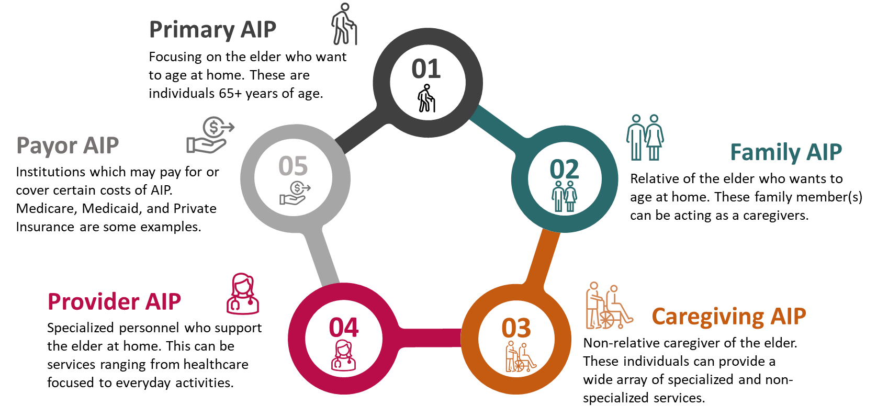
When trying to understand the AIP market we took a look at the key players: older adults, family caregivers, third party caregivers, providers, and payors. An offering to each of these players can be the potential market for the operators, as shown in Figure 51.
Figure 51 Different stakeholders an operator can address with their AIP solutions
Primary AIP: Older adults (65+ years), being the main target stakeholder for AIP solutions, we categorize them as primary AIP. Between 2017 and 2060 the older adult population is expected to double from 45M to 95M. As this population grows so does the healthcare spend will increase on this market segment. Some of this healthcare spending can be addressed by primary AIP through various means as discussed later in this paper. With a constant rise in average life expectancy, the age which is considered “old” has gone up to 65 years of age compared to in the 1920s when 55 was thought of as “old.” Additionally, in the US men and women tend to retire around 65 and 63 years of age, respectively. Social Security benefits are also set to be released to an individual who is at a minimum of 65 years of age. AARP has identified that 90% of this 65+ age group is aiming to age at home as long as possible.
Family AIP: Family caregivers are also a large market to consider for AIP. In 2020, as shown in Figure 52, AARP forecasted the family-based US caregivers (who acted like caregivers over the last 12 months) be 21.3% (53M) of the US population. Of those caregivers, they spend on average 23.7 hrs per week. 50% of those caregivers are children of the care recipient. This large market is necessary to consider since a large number of older adults will need some level of support from a family caregiver.
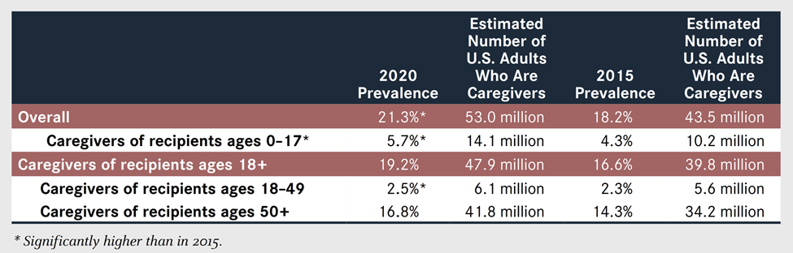
Caregiver AIP: Professional caregivers that are not related to the older adults are considered in this category. Although AARP reports ~10% of caregivers are non-relatives, it is important to consider how these caregivers can support older adults. If a relative is far away or the caregiver needs respite care, non-relative caregivers provide a chance for specialized care. There are caregiving organizations that can provide everything from healthcare support to companionship. In general, caregivers (family or non-family) can help with services such as healthcare, cognition, mobility, ADLs, etc. Many of these caregivers assist the care recipient with on average 4.4 IADLs.
Figure 52 2020 AARP report forecasts that 53 million acted as caregivers to older adults
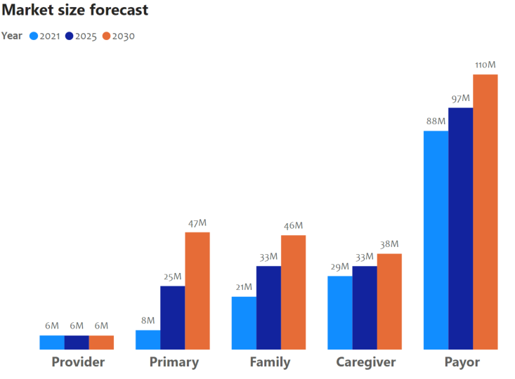
Provider AIP: For the provider AIP, we considered both healthcare and non-healthcare providers. Providers here are specialized personnel providing some level of care to the older adults – such as healthcare providers, home health agencies (HHA), residential care communities, adult day service centers etc. Apart from caregivers, there are multiple types of individuals helping older adults age at home. We want to highlight the importance of managing one’s health by including healthcare providers and HHA. Healthcare providers can do everything from home visits to telehealth visits. HHA can provide skilled nursing services or therapeutic services. Adult day services, similar to some caregiver services, can provide supervision, social activities, meals, and some medical services. To derive a market size for each of these providers, we took a percentage of the total number of home health agencies, nursing homes, adult day services, and residential care communities and separated it into healthcare/non-healthcare providers. In total, we estimate around 5.7 million agencies in 2021 providing care to older adults. As we go through this paper, we will see how the portion of providers changes based on the potential telecom offerings.
Figure 53 Projected AIP market size for different stakeholders
Payor AIP: This category accounts for institutions such as Medicaid, Medicare, private insurance etc. While some older adults, or their families, may finance their own AIP journey, certain institutions will cover certain aspects of AIP. For example, Medicare can partially cover the cost of durable medical equipment or cover certain home health services. Each private insurance will act differently, but most will cover some level of health visits (virtual or in-person), home care services, etc. Medicaid will provide their level of health services and long-term care to the older adult who has limited income or assets. The payor market reflects the size of the Medicare, Medicaid, private insurance, and the uninsured market who have an interest in AIP. In 2021 we project that around 87.6M individuals would fall into one of the identified insurance categories. When we look at Figure 53, it shows that in both 2025 and 2030 payors still carry the largest market size. However, it is important to also note that while payor size is still the largest in 2030 their share of the AIP market decreases as the number of older adults, family caregivers, and third-party caregivers grows.
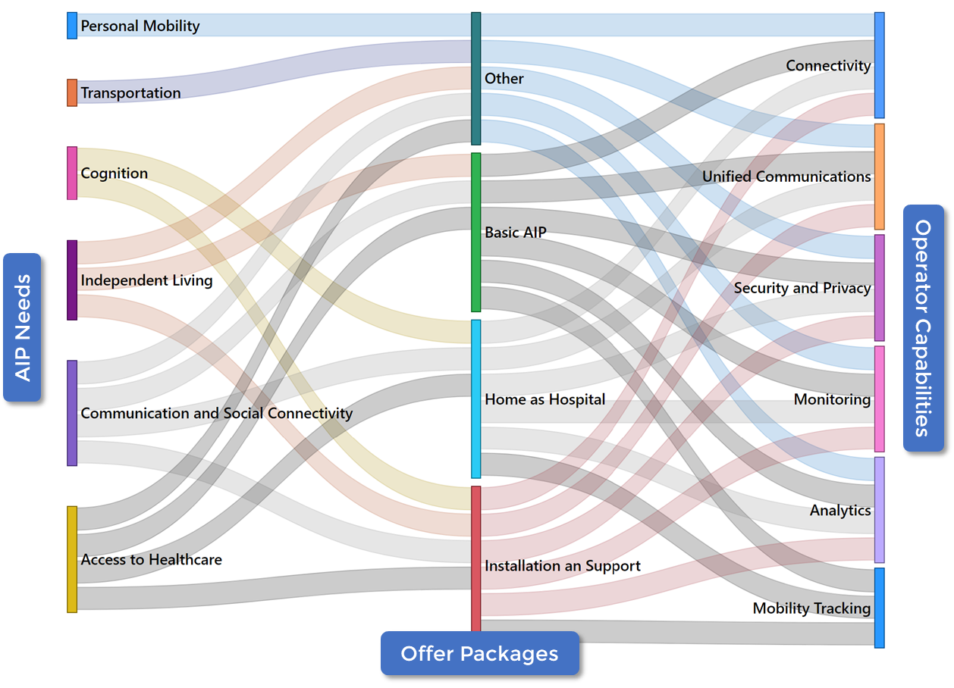
Figure 53 provides an overall AIP market size over the next ten years per market segment. Overall, there is steady market growth in market size from 2021 to 2030. We forecast that primary AIP will see the largest year-over-year growth primarily because of the increase in the older adult population and those willing to age at home. With an increase in the number of older adults, there is also an increase in the need for family caregivers. Since family members are typically a large portion of caregivers, as the older adult population increases, more family members will identify as caregivers. On the payor end, as AIP becomes more commonplace, we predict there will be more coverage for AIP services.
Figure 54 Mapping aging population needs to offer which in turn mapped to the operator capabilities

Business model

Telecom offering for AIP
Before devising different offers, we need to understand the requirements for older adults. Since requirement analysis is not the main focus of this article, we present a summary of the needs conducted by a task force from the White House in the insert “Emerging Technologies to Support an Aging Population”.
Emerging technologies to support an aging population
This report identifies a range of emerging technologies that have significant potential to assist older adults, and it is offered as a guide for both public and private sector research and development (R&D) to improve the quality of life, enhance individual choice, reduce caregiver stress, and cut healthcare costs. The Task Force identified six primary functional capabilities as being critical to individuals who wish to maintain their independence as they age and for which technology may have a positive impact.
1.Key Activities of Independent Living. Living independently requires the ability to perform of a range of activities that impact our daily lives. Many of these activities can be assisted through technology, including those that support good nutrition, hygiene, and medication management.
2.Cognition. Cognitive changes are common during aging, with increasing prevalence at older ages—varying in severity and impact. These changes can affect the ability to live independently as well as personal safety. Technology holds the promise to help older adults monitor changes in their cognition, provide mental training to reduce the impact of these changes, and create systems that assist individuals and families to maintain financial security.
3.Communication and Social Connectivity. Older adults may face communication challenges as the result of hearing loss, social isolation, and loneliness, especially in economically distressed and rural communities. Technology can improve hearing and strengthen connections to larger communities.
4.Personal Mobility. Mobility is a key factor in successful aging. To live independently, an individual must have the ability to move around the home comfortably and safely and throughout the larger community. Technology can assist older adults in staying mobile and able to safely perform key activities necessary for day-to-day life as well as interact with their communities.
5.Transportation. True independence requires mobility outside of the home and neighborhood. Transportation needs and limitations are dictated to an extent by the changes to individual physical and cognitive abilities that come with age. While some older adults remain completely independent and continue to drive without assistance, others may be able to drive but require vehicle modification and/or advanced technologies to assist them while operating a vehicle. New technologies could also help older adults more safely and easily use public transportation.
6.Access to Healthcare. Access to healthcare plays a critical role in helping older adults stay active and independent as they age. Activities and strategies that support the maintenance of function and independence with age are multifaceted. Alignment and coordination of these efforts through technology can increase the effectiveness and efficiency of these services.
In the process of identifying primary capabilities and focus areas on which technological advances can have a positive impact in enabling older adults to age in place, several areas emerged that are associated with a number of technological solutions and were therefore not specific to individual R&D recommendations. These areas are included in the final section of the report, Cross-Cutting Themes.
This insert provides six major categories of the needs of the aging population. As shown in Figure 54, a service offering for the cable operators is the exercise of mapping the needs to the capabilities of the service provider. As presented in, the cable operator has significant technical capabilities that they are offering to their current broadband customers such as, connectivity, unified communication platforms, commitment to security and privacy on all their services, different in-home and network monitoring capabilities, burgeoning analytical capabilities, and different mobility-based services. In the figure, we show how to map the requirements to the capabilities through offers. The offers that an operator can provide to address the problems are - basic AIP, hospital at home (HAH), install and support (IandS), and other services.
Basic AIP: This basic offer, as shown in Figure 54, can address many of the older adults’ needs such as access to healthcare, communication, and social connectivity (to reduce social isolation), basic cognition and more importantly enable them for independent living. This offer constitutes the operator capabilities such as providing broadband and in-home connectivity, extending the unified communications that are offered to the business customers to the AIP stakeholders, guaranteeing the security and privacy offering (which the operators are well versed with) as part of the offering, extending their current service assurance infrastructure to the AIP offers, and provide metrics-driven basic analytics to the AIP offering.
Home as a Hospital (HAH): HAH takes the basic offer to the next level of complexity. This service, bringing hospital-level services to the older adult’s home, is typically driven by the cost, inconvenience, and risks (such as exposure to the diseases) of staying longer time at the hospital. While at home, the patient would ideally have access to a physician 24/7 and could receive at-home visits. Patients can also receive diagnostic tests such as ECGs, oxygen levels, echocardiograms, and treatments like oxygen therapy, IV fluids, antibiotics etc. However, these exams are dependent on the devices available in the home. The main requirements that HAH can support include access to healthcare, communication with the older adult's support team (family, caregivers, and providers), and a higher level of cognition support. As shown in Figure 54, these can be offered through the cable operator's current portfolio of services. The additional challenge to solve would be the integration of medical devices into their solution. Many business models can be adopted between the device manufacturers and the operators, which are not discussed in this paper.
Installation and Service (IandS): This would include any installation and support AIP solutions would require. For example, an older adult or their family member may want to install monitoring or security systems in the house to observe the older adult’s behavioral changes in the home. Others could include health systems that can record falls, changes in sleep patterns, medication systems, etc. Depending on the devices or service there are different levels of training and servicing required. Certain medical devices may need to be serviced or updated more often since they could directly impact the health of the older adult. This service could be offered as an upsell package by the operators. As shown in Figure 54, the operator can support many of the requirements older adults have in their daily life. These services enhance the service offering that they are providing for their AIP portfolio.
Other Enhanced Services: These services include a wide array of services that fall outside of instrumental activities of daily living (IADLs) such as sensors, management tools, analytical support, advanced cognition support, social isolation tools etc. These services may be ones that telecom operators may not have a direct influence in but can repurpose their offerings to fill in AIP needs. For example, to fulfill the needs of transportation for the older adults through an integrated communication platform where the operators can link the elder requesting the service with the local transportation company who is part of the operator's ecosystem.
In the following sections, we provide the telecom operator market size for the above product offerings, the revenue opportunities and the costs, and their profitability analysis.

Operators market size
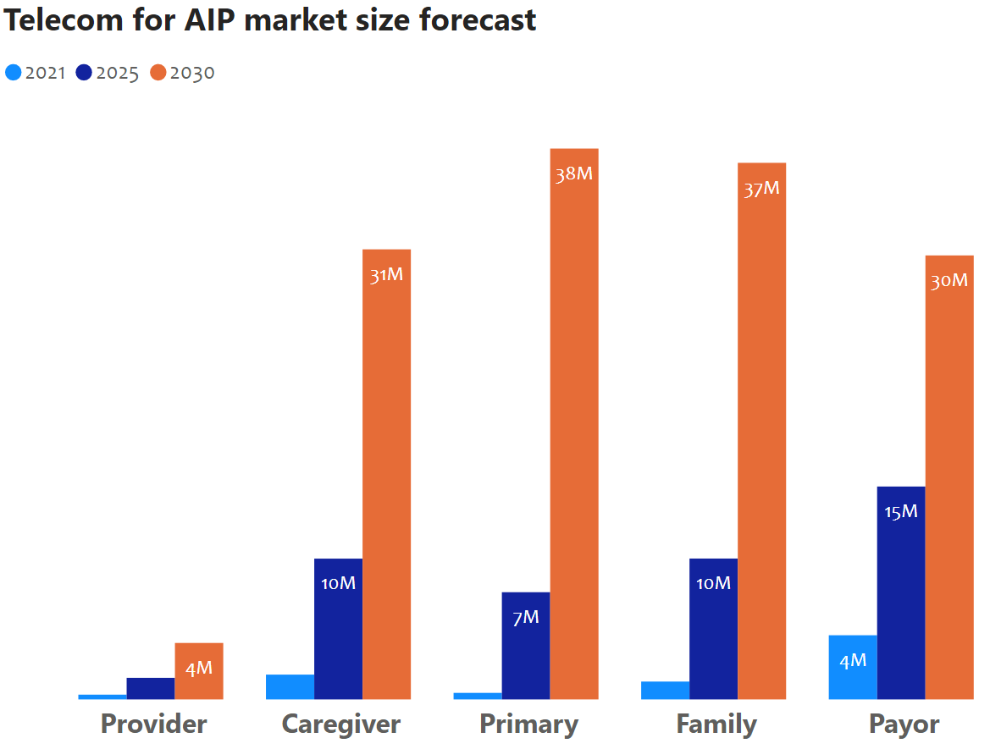
With very conservative initial and growth assumptions per market segment (primary, family, caregiver, provider, and payor) and a detailed breakdown of these segments into subsegments for an accurate forecast, we derived the next 10-year telecom operators AIP forecast.
When looking at how the AIP market is projected to grow, as shown in Figure 55, it is clear that there is consistent growth in most segments. The market segment seeing the most growth is the primary stakeholder. We can attribute this amount of growth to the increasing rate of our aging population growth and increased desire to age in one’s own home. With this desire to age at home, there inherently comes a need for an increased level of service offerings.
Figure 55 Telecom operators projected market size by the offers
Additionally, those individuals caring for the older adult (family or caregivers) will increase as a result of the need for older adults to have additional care. The growth in primary AIP will drive the growth in the HAH, the other, and IandS offering. One potential reason for this is the need for more hands-on attention with these offerings.

Potential business models
Healthcare and care provider industries are mature industries. Entering into these markets requires a portfolio of strong differentiators and a mindset to collaborate with the incumbents. In Figure 56, we highlight the business models on how operators can extend their capabilities in the four offers that were discussed in the previous sections.
Basic AIP Offering: Since the basic AIP package deals with many of the strongholds of the operators such as communication and at-home activities, stakeholders such as the primary (older adult), family, and caregiver will directly be subscribing to the MSOs solutions. However, with healthcare and care services that are being offered on the MSOs platform, they would have to share some of their revenue with providers.
HAH Offering: For a HAH offering there may not be any direct revenue from the older adult, but it may happen through their healthcare provider. MSOs could work with providers to create services to fit the needs of the older adult and take rent from those solutions. Through these solutions, operators can create services that family members or caregivers can opt into and thus receive direct revenue from those stakeholders.
IandS Offering: Each stakeholder will require different levels of installation and support services. Primary, family, and caregivers may have some one-time install with few support needs, while providers may need more services based on the level of care they provide. These are direct revenue streams for the operators.
Other Offering: The other offering encompasses some of the IADLs, advanced analytics, and additional more involved device integrations. Also, here we assume more complex use cases are addressed and metrics are monitored.
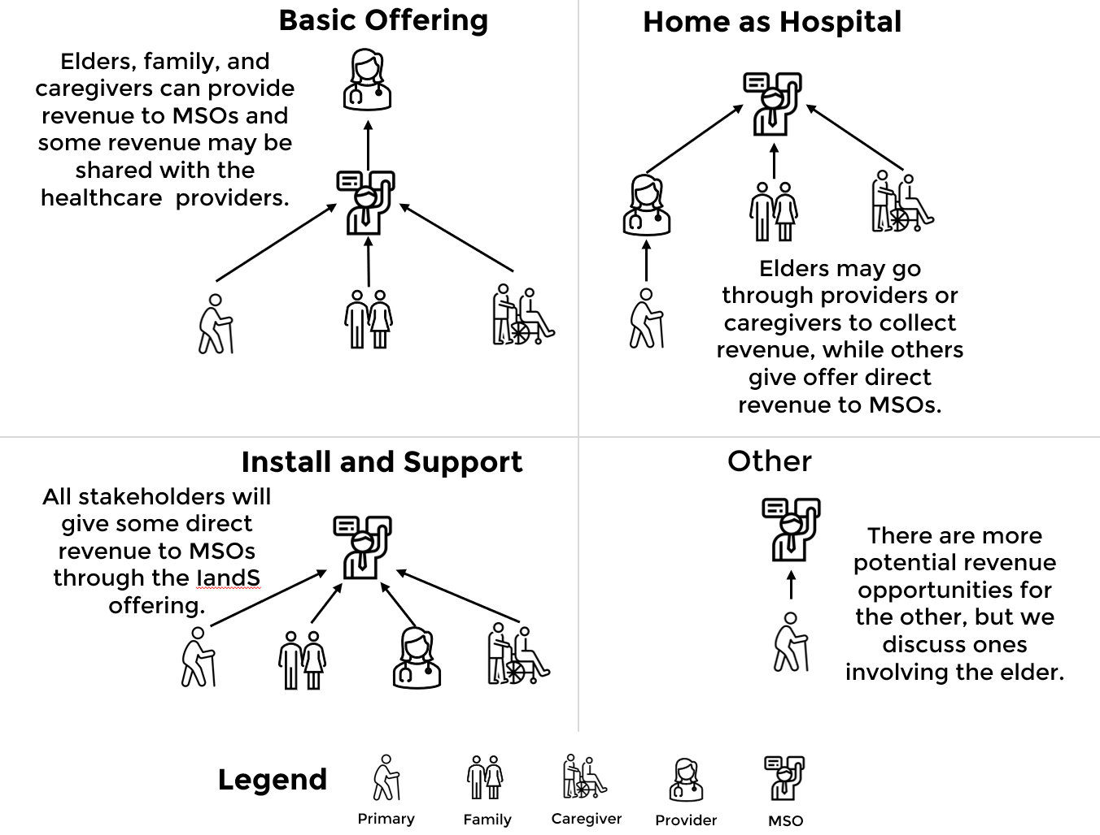
These revenue options are just a few of the possible ways cable providers can interact with certain AIP stakeholders. As operators grow their AIP presence, they can expand their business models on how they reach the stakeholders.
Figure 56 High level business models assumed in the revenue, cost and profitability analysis

Business case analysis

AIP revenue forecast for operators
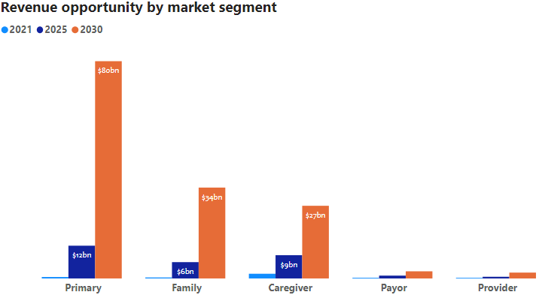
In this section, we provide some of the analyses in forecasting the operator’s AIP revenue opportunities. We have done extensive stakeholder business cases and analyzed business models used by different vendors to identify the operator revenue opportunities. The summary of this analysis is presented by market segments in Figure 57 and by offers in Figure 58.
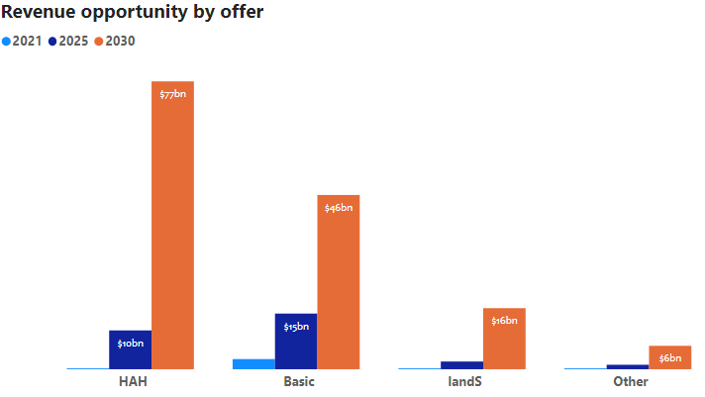
Basic AIP: With the basic AIP offering, operators can derive revenue from the basic services that they can offer related to the enhanced unified communication services, video-capable devices, offering highly secure communications, smart medical devices rental, TV subscriptions for the interactive communications, and basic analytics to support some of the monitored data. For the primary AIP, operators can be between the older adult and the caregiver (or provider). Hence, the operators would collect the revenue and distribute it to the other parties in the values chain. In the same basic AIP realm, primary AIP, family AIP, caregiving AIP can all go through operators directly. The stakeholder’s business case includes - for older adults and their support team savings from the fuel, loss of wages and other family expenses that range up to $150 per visit per family caregiver, and the overall reduction of cost up to $75 per visit due to virtual nature of it. In addition, the operator can cross-sell those compatible video devices and AIP TV subscriptions that can be mainly attributed to the operator. Additional medical devices (such as pill dispensers from companies like Hero Medication, Tricella) can add additional revenue to the operators.
Figure 57 10-year revenue forecast for different market segments
Figure 58 10-year revenue forecast by different offers
Home as a Hospital: Home as a hospital (HAH) saves on an order of $2.5k per day to the patient compared to the in-hospital patient care. In a HAH offering the operators can take revenue from cost savings due to virtual visits, medical devices support, any monthly rental etc. The patients in HAH typically pays for durable medical devices (DMDs) such as hospital beds or infusion pumps. Operators can make revenue from integrating DMDs to their platform and could take up to at least 50% revenue for monitoring services per month. In addition to monitoring, operators can take revenue from office visits to diagnostics. Many of these revenue opportunities for HAH can be found in health concierge services. These services can potentially integrate with family or caregivers depending on the extent of the HAH model thus creating other revenue opportunities (such as monitoring, on-call medical alerts etc.).
Install and Support (IandS): In-home networking is complicated. Added to that the scare of handling healthcare devices takes this technology paranoia to the next level. Who is best suited to manage (install and service) these complex technologies better than the operators?! The operators have been doing this forever. Adding the AIP devices at home to their IandS portfolio there is significant revenue in security, monitoring, health systems installation, and servicing. These installations can range from $500 - $1000, and service charges can be as high as $150 - $300 per month.
Other: Since the other offerings capture a wide range of possible services, we only focused on a few services to project nominal revenues. One of them is the addition of more involved sensors in the home and hence different pricing models depending on the function of the sensors.
Revenue projection summary: When comparing how these different stakeholders change with the identified offerings, it is apparent that there are some clear trends. In terms of relative revenue size, revenue from the primary stakeholder in 2030 is taking up a larger portion of the total revenue compared to 2025 (39% in 2025 vs 55% in 2030). Another point to note is the growth of the HAH offering with all stakeholders, especially primary AIP. One potential reason for this is the increasing availability, acceptance, and understanding of virtual health services. The COVID-19 pandemic did open many doors for virtual health services and that trend does not seem to be going away anytime soon.

AIP solution cost projection
End-to-end AIP costs are grouped into 5 main categories: premise equipment, service offering, operations and support, training, and overhead. For the cost model, each of these costs is further categorized into:
- Initial one-time costs: These are the costs of building the initial AIP infrastructure. This typically scales based on aggregation points and the scaling of the modular architecture per volume of customers (such as per thousand, per million customers, etc.)
- Net new customer costs: These are the cost of adding a new customer to the platform. This typically depends on the type of service a customer is subscribing for.
- Per subscriber costs: These per subscriber maintenance costs.
- Installation and support costs: These costs include per customer installation and support costs.
- Overhead costs: these are the additional management. Marketing, sales, etc. support organizational overhead. These scale on the number of markets and the number of resources per manager.
Each of the cost categories will be reviewed in more detail in the following sections.

Premise equipment costs:
Premise equipment is considered as any premise cost beyond the demarcation point at the customer’s home. The demarcation point is being defined as the AIP hub (could be a logical or a physical device). For any of the five market segments identified there will be a hub cost. The hub cost is expected to be different for the different market segments. For primary and family needs the hubs and other relevant basic devices are costed between $80 to $100, and for other stakeholders between $150 to $200. Subscribers are assumed to either pay for their premise equipment or rent it for the time that they have the service. For this reason, no net new subscriber cost is applied for the premise equipment in the business case model.
The cost to support unified communications at the premise is projected to be the same on a per-user basis. Each user would have a licensing cost and be required to download a communication application. The cost of the associated application and license is expected to decrease significantly over time. These starting costs are expected (mainly due to revenue share models) to be less than $10 per month.
Premise sensor costs will vary based on the offering, market segment, and the specific conditions targeted to be addressed by the AIP solutions. Some of the sensor packages for the older adults in the basic offering could be around $750 while in the HAH case they can go as high as $10K for purchasing (and $1300 per month for rental). Typical costs for the IandS can be up to $300 per month. On top of this, an additional monitoring cost of up to $10 per month may also occur per customer. Like the premise equipment, the sensor packages would also be purchased or leased by the customer for at least the time that they have the service. For this reason, no cost is applied for the senior packages in the business case model. Equipment installation and maintenance costs are being covered under operations and support costs.

Service offering costs:
The most significant impact to operators in supporting the AIP market will be felt in providing the services. Most of the changes will be one-time costs with some ongoing support and maintenance costs. Initial costs will be high as they are investing in the initial infrastructure, but these costs will come down over time significantly. Time to market is very important to obtain market share, so where justified, forming partnerships or outsourcing necessary service offering requirements is recommended. Below is a list of the primary service offering support requirements.
- Unified communications for individual households
- Personal or electronic health record (PHR or EMR) integration
- Platform compliance to Health Insurance Portability and Accountability Act (HIPAA)
- Security (not considered unique to the AIP offering) and privacy support
- Data hosting services, and
- Analytical services
Note that these service offering costs are expected to decrease over time as systems and processes are put in place to address the offerings.

Operations and support costs:
Operations and support costs are the costs to cover order fulfillment and customer service. These costs tend to have the biggest impact on the cost model. By operators leveraging their existing order fulfillment and customer support organizations, they have a significant competitive advantage in the early stage of this developing market. They will also be better equipped to be more accurate at estimating and controlling these costs. In the operating costs, we considered order fulfillment costs such as order entry and installation and customer services such as customer care and in-home service team costs.
Employee training will be critical to have a fast and smooth introduction of AIP service offering. Training is considered a one-time cost. However, additional training will need to be provided for onboarding new employees. Although the entire enterprise would need so form of training, primary training would be focused on five distinct areas of the organization.
- Installation and provisioning
- Customer care
- Field service and support
- Inter-industry sales and marketing support
- Other enterprise support
Training will include understanding the product offerings, which is key for all areas of the organization. Each organization will need to understand how these new offerings impact their job functions and any associated process changes that are made.
Overhead costs:
To cover the costs that are shared an additional overhead charge has been assumed. These costs account for personnel responsible for the sales, marketing, and dedicated engineering personnel for the AIP solution support. An estimated headcount has been applied to the model. These overhead costs will be incurred year over year to support the product offerings.
Summarized cost projections:
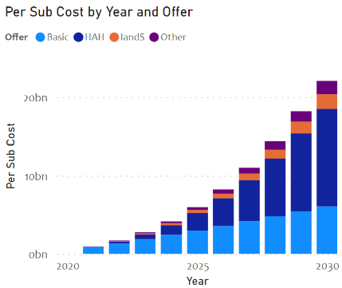
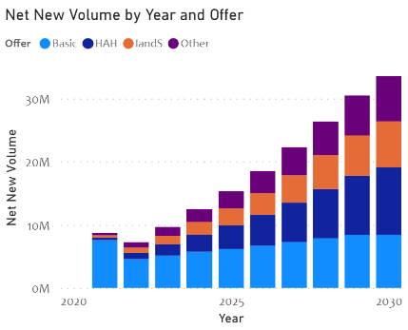
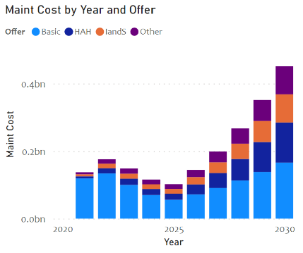
As stated earlier, each of these cost categories is further classified for the AIP offers. Figure 59 shows a high-level estimation of the costs per sub, net new subscribers addition, and support.
Figure 59 High level estimated cost breakdown by AIP product offering
Per sub monthly costs are the highest due to revenue share agreements with the other solution component providers such as unified communications platform, PHR or EMR services, and specialized analytical services. Maintenance is the next major cost driver due to increased services. One can argue thar return on investment (ROI) of IandS is not high enough to offer these services. But IandS being the key differentiator for the operators, they drive higher revenues through gaining more customers for other services. Incremental cost for adding newer customers will diminish after the initial solution creation.

Profitability analysis
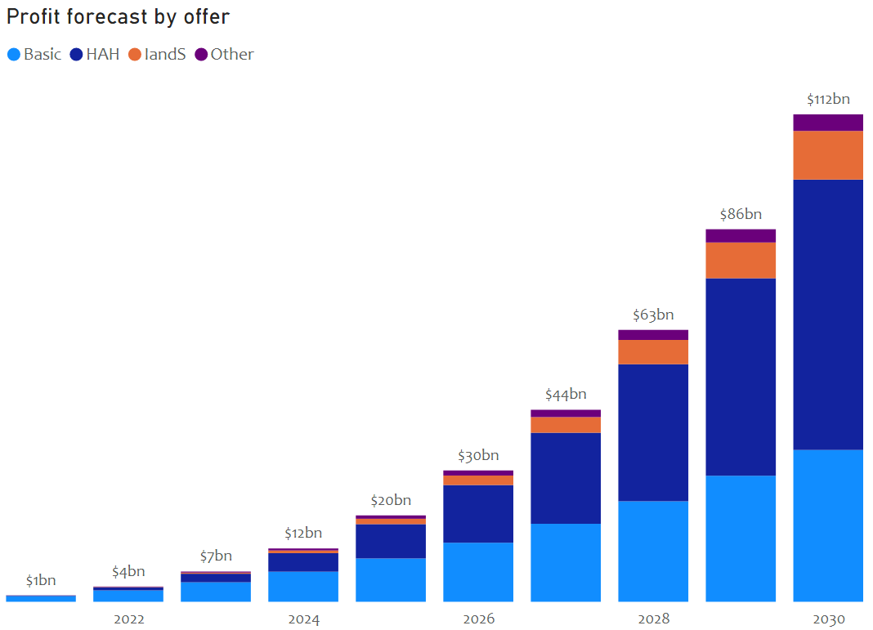
A shown in Figure 60, the AIP opportunity for operators is going to reach 100s of billions in the US alone. We made a very conservative take rate assumption of 5% year-over-year (YOY) growth in the market capture for the operators. There is a significant upside to the profitability depending on the level of involvement an operator wants to have with the healthcare industry. We believe as both industries learn to trust each other, they will take more risks of solving complex AIP problems and hence open doors for higher rewards than projected here.
Figure 60 AIP 10-year profitability forecast by offer

Telehealth business case

Market sizing
To understand the telehealth market, we looked at a few key stakeholders: individuals, primary house, primary AIP, secondary AIP, and provider adoption.
Figure 61 shows a variety of markets operators can tap into to provide telehealth services.
Figure 61 Different stakeholders an operator can address with their Telehealth solutions
Individual: Single encounters are the main target for stakeholders for telehealth solutions, we identified this as individual. Prior to COVID-19, Centers for Disease Control (CDC) reported the number of telehealth visits were increasing at an average compound growth rate of 50% per year; however, during COVID-19 there was an increase in need to shift to virtual care for safety and convenience’s sake. This shift pushed telehealth visits up 154% (approximately 1.6M telehealth encounters) by the end up March 2020 when compared to that same time period in 2019. The number of individual patients that said they use telehealth went up from 11% in 2019 to 46% in 2020. While the number of overall telehealth visits are declining, many walls have been knocked down because of the pandemic. It opened the door for other markets/stakeholder to benefit from telehealth services. Some of the stakeholders we address are household families, older adults, older adult caregivers, and providers.
Primary House: Primary house addresses how family households will use telehealth services. The 2020 census reported a total of 83.7M households in the US with an average age of 50 years. Since encounters typically involve just the individual, we expect that only a fraction (estimated ~10-15%) of households will initially aim for a family telehealth plan.
Primary Aging In Place (AIP): Older adults (65+ years) and their caregivers (secondary AIP) also have a large stake in the progress of telehealth solutions. More and more older adults are turning towards aging in their own home or AIP. With AIP comes technologies such as telehealth to make their stay at home safer and more convenient. As the older adult population grows (2017 older adult population 45M to 2060 older adult population 95M) and 90% reporting wanting to age at home, telehealth will become a prime service for AIP⁴⁷.
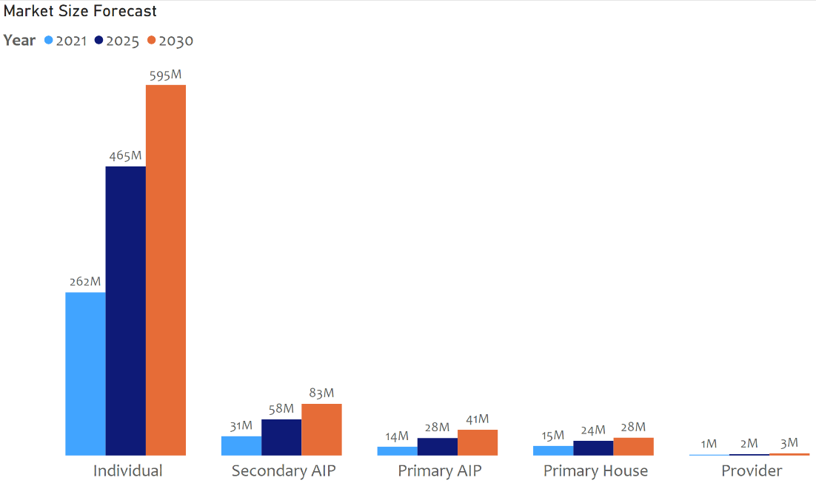
Secondary AIP: Caregivers are also a big part of an older adult’s care journey. The 2020 AARP Caregiver Report noted that 53M Americans acted as a caregiver sometime in the past 12 months⁴⁷. 89% of those people were relatives and spend on average 23.7 hours per week caring for their older adult family member⁴⁷. Since caregivers are providing significant care for older adults, it is important for them to be inside the loop of the older adult’s health care journey, including telehealth visits.
Figure 62 Projected Telehealth market size for different stakeholders
Provider Adoption: Physicians and other healthcare providers (categorized as provider adoption) are also growing more accustomed to using telehealth, with 80% of physicians who have used telehealth plan to continue using it after the pandemic. Since restrictions have eased and clearer reimbursement pathways for telehealth have been made, more physicians will likely continue adding it to their practice. Physicians (from all types of specialties and locations) will be able open their services to users of telehealth. A survey done by Amwell found that 96% of physicians would be willing to use telehealth for their practice and 93% said they would use if for chronic care management. As such, telehealth is trending towards becoming an additional health tool for healthcare.

Business model

Broadband Telecommunications offering for telehealth
Before going into telehealth offerings, we need some issues our identified stakeholders have with the current healthcare system.
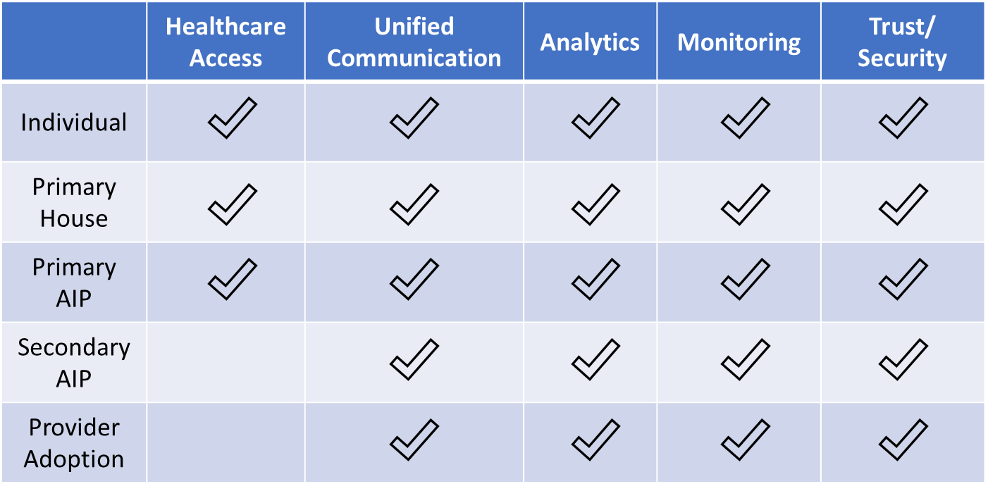
Table 4 Common problems in healthcare industry and which stakeholders face them
The table above describes some common problems the stakeholders above have faced with our health system. Derived from these problems, we have created offerings that cable operators can offer to address those problems: Basic telehealth, security, analytics, and install and support (IandS).
Basic Telehealth: Basic telehealth offerings would address the basics of a medical encounter between patient and provider. This offering would include simple audio or video communication between the different parties. Hence it would address the need of making sure services are provided to anyone as long as they have a reliable connection. Operators have a chance to utilize their strength in broadband, in-home connectivity, and unified communications to offer services to telehealth stakeholders. By extending their current services they can add infrastructure to support telehealth services and address the needs of the consumer.
Security: The offering is mainly dependent on the level of data security required in the service. If the service operators want to offer simply video or audio communication, it may not need to be HIPAA (Health Insurance Portability and Accountability Act) compliant. However, if the service is more integrated with the patient data (personal information or other patient data), then having HIPAA and PHI (protected health information) compliance is necessary. Depending on the amount of risk operators want to take on, building that trust in the service is essential. Cable operators have the capability to provide secure connections and data transfer making it easier to delve into the security offering. The challenge with moving the healthcare security would be to maintain services according to established regulation.
Analytics: Analytical services would involve both analysis and visualization of different forms of patient or hospital data. It can help inform providers of lab trends, correlations that may help with diagnosis, or chronic care management. Visualizations assists with understanding telehealth trends in the home as a hospital, whether it be for telehealth management, device operations, etc. With a wide range of analytical services that can be derived from hospital data, operators have a chance to work with healthcare experts to provide metric-driven changes to the industry.
Installation and Support (IandS): IandS involves any form of install and support telehealth services may require; each stakeholder will require different levels of support. For providers this may involve restructuring their infrastructure to support telehealth, for example, repurposing their devices, installing software/hardware, new telehealth devices, servicing devices, software, etc. For the patients there may not be as many devices to install, but there is potential for servicing devices. Depending on the level of IandS, technicians will have to be specially trained to support the telehealth infrastructure. This service could be offered as an upsell package by the operators. Since operators have already been integrated into telehealth since the beginning, IandS is another chance to enhance their telehealth portfolio.
In the following sections, we provide the cable operator market size for the above product offerings, the revenue opportunities and cost, and a profitability analysis.

Operator market size
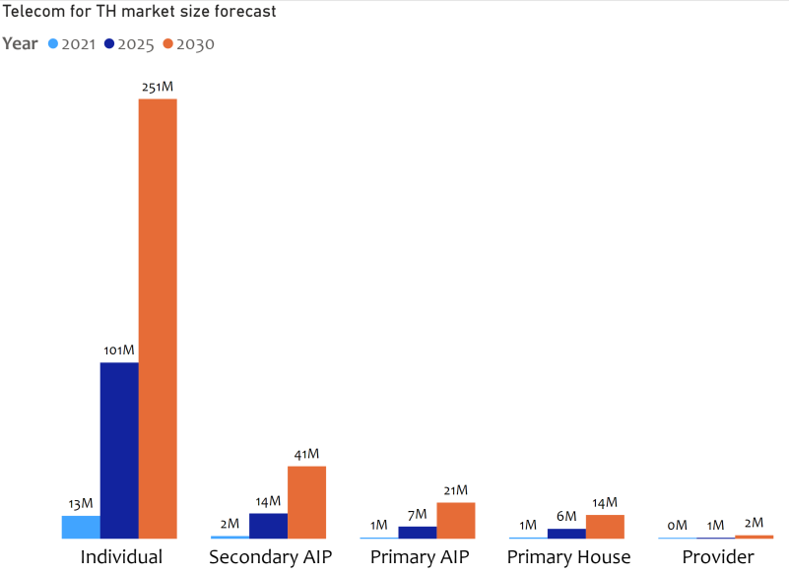
With a very conservative initial and growth assumption per market segment (individual, primary house, secondary AIP, primary AIP, and provider) and a detailed breakdown of these segments into subsegments for an accurate forecast, we derived the next 10-year cable operators telehealth forecast.
Figure 63 Cable operators projected market size by the stakeholder
When looking at how the telehealth market is projected to grow, as shown in Figure 63, it is clear that there is consistent growth in most segments. The market segment seeing the most growth is the individual. We can attribute this amount of growth to increased acceptance of telehealth services. As telehealth builds its reputation as a reliable mode of healthcare, more individuals will turn to it for primary care visits, specialized treatment, chronic care management, etc.
Additionally, with primary AIP and secondary AIP the growth can link back to this move towards older adults wanting to age in their own home. As an increasing number of older adults shift to AIP, there is a need for older adults to receive healthcare services in their own home. Together with that, the older adult’s caregiver(s) will also increase as a result of a need for additional care.

Potential business models
While the healthcare is a mature industry, telehealth has just begun to receive heavy attraction; however, due to the pandemic many companies have made a push to enter the market. This means operators need to utilize their strengths to create strong differentiators and portfolios. Figure 64 below highlights business models to which operators can refer to extend their capabilities within the realm of the four offerings.
Basic Telehealth Offering: Since the basic telehealth offering only deals with the essential video/audio communication cable operators will be working closely with healthcare provider. Other stakeholders (individual, primary house, primary AIP, and secondary AIP) will more often than not engage with a provider rather than cable operators in the basic offering. By nature of this pathway, cable operators will mostly be receiving revenue directly from healthcare providers.
Security Offering: A majority of telehealth security efforts are incorporated into the telehealth platform, and for that reason revenue generated from a security offering would primarily involve the healthcare provider. The other stakeholders would have security provided to them when the login to the platform, but cable operators would not be gaining any direct revenue from them.
Analytics Offering: Like the security offering, providers would be the main stakeholder for an analytics offering. While patients/caregivers may have access to certain pieces of data, the provider would be actively be using/paying for the analytics. Cable operators may take on a proactive approach to creating dashboards or analytical tools for providers to use in their practice. Hence, operators will receive revenue from the providers that use their analytical tools or services.
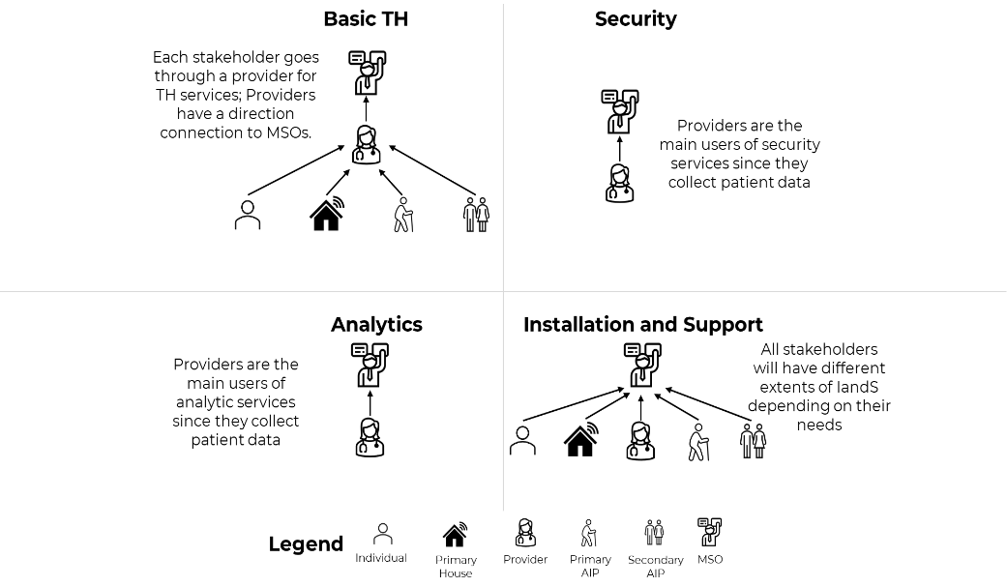
IandS Offering: Depending on the condition of the patient or active role medicine plays in their daily lives, stakeholders may require more install and support of medical device. We do, however, expect that majority of the revenue will be taken from provider because of the variety of medical devices they already have. While other stakeholder may have closer to a one-time cost or less frequent monthly IandS devices, providers need more active device support.
Figure 64 High level business model assumed in the revenue, cost, and profitability analysis
These pathways are just a few of the possible ways cable operators can interact with certain telehealth stakeholders. As operators grow their telehealth presence, they can expand their business models and how they reach out to stakeholders.

Business case analysis

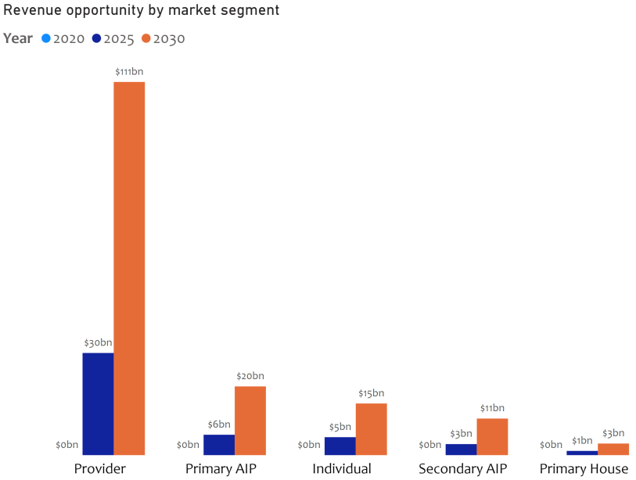
Telehealth revenue forecast for operators
Figure 65 10-year revenue forecast for different market segments
In this section, we provide an analysis of different telehealth revenue opportunities for operators. We have done extensive stakeholder business cases and analyzed business models used by different vendors to identify the operator revenue opportunities. The summary of this analysis is presented by market segments in Figure 65 and Figure 66.
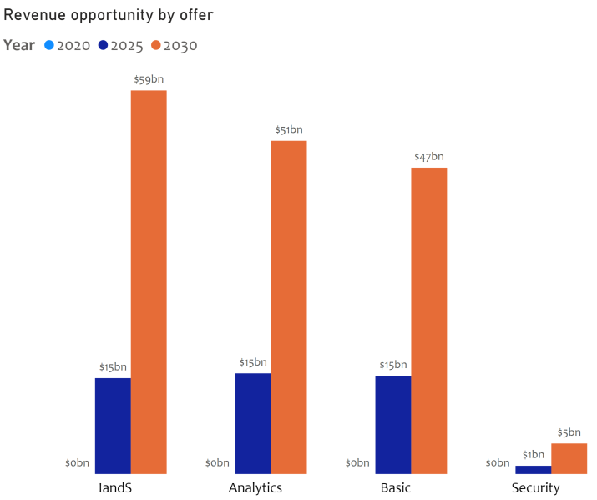
Basic Telehealth: With the basic telehealth offering above, cable operators can derive revenue from either telehealth visits, monthly revenue from package deals, or users/license charges. For the individual telehealth visit the revenue would go from the provider to the cable operator. For their pricing model, operators can consider that patients are gaining significant saving (from fuel expense, lost wages, and other family expenses). Cable operators can make money in a few ways with primary house such as taking revenue from the monthly and/or per visit charges. As a reference we have seen two types of package deals: a) straight monthly charge and b) a reduced month charge with an additional per visit charge. With providers, revenue can be derived from monthly user charges, software license charges, etc. The stakeholder business case includes saving money on fuel expenses, wages, and travel time. Per visit patients can save roughly $280. In addition, the operator can partner with providers to create an integrated platform where operators would take a majority of the revenue for running the back end. Monthly packages for homes (such as HealthTap or OurDoctor) are another revenue pathway for operators.
Figure 66 10-year revenue forecast by different offers
Security: Since security will mainly focus on the provider end, operators can charge through various pricing models such as licensing, number of users etc. Security is also provided through EHR systems, thus there may be some revenue split with EHR systems or other partners. License charges can vary depending on the level of protection provided. Some estimate it to between $1000-2000 per year. A per user charge can also change depending on the size of the institution.
Analytics: Pricing for analytics and visualizations can be dependent on, a) number of hospital claims or b) other metrics chosen by the operator. Because there is a wide range on types of visualizations and analytical services that can fall under this offer, we focused on conservative numbers to project the revenue. One such as service was analyzing hospitals claims.
Install and Support: IandS can become more complicated for certain stakeholders, but operators already have an infrastructure to handle the complexity! In the IandS models, operators can make revenue from installing technology for providers with monthly servicing costs; however, for an individual or primary house service there may be little revenue from installations and servicing depending on the type of devices used. Provider installations can be upwards of $10,000/devices with a fraction of that going to per month servicing.
Revenue Projection Summary: When comparing how different offering revenues are changing between stakeholders from 2025 to 2030, there are some clear trends that emerge. In terms of revenue portion size, each stakeholder has relatively the same portion of the total revenue. The two largest segments in both 2025 and 2030 are the individual and primary AIP. With individuals holding the largest market segment (~76% in 2025 and 2030) and most revenue generated through basic telehealth offerings, it is not a surprise that it is one of the larger revenues generating stakeholder. As for primary AIP, while its market is not larger than secondary AIP, this group will directly be interacting with the offerings. For example, an older adult will be the primary user for a basic telehealth solution while a caregiver may require pared down functionality to monitor the older adult. As MSOs continue to explore telehealth, more revenue opportunities will emerge beyond just the stakeholders/offerings we have suggested.

Telehealth solution cost projections
End-to-end telehealth costs are grouped into 5 main categories: new subscriber, service offering, operations and support, training, and overhead. For the cost model, each of these costs is further categorized into:
- Initial one-time costs: These are the costs of building the initial telehealth infrastructure. This typically scales based on aggregation points and the scaling of the modular architecture per volume of customers (such as per thousand, per million customers, etc.)
- Net new customer costs: These are the cost of adding a new customer to the platform. This typically depends on the type of service a customer is subscribing for.
- Per subscriber costs: These are per subscriber maintenance costs.
- Installation and support costs: These costs include per customer installation and support costs.
- Overhead costs: these are for the additional management. Marketing, sales, etc. support organizational overhead. These scales on the number of markets and the number of resources per manager.
Each of the cost categories will be reviewed in more detail in the following sections.
New subscriber costs:
New subscriber cost is considered cost specific to adding a new customer. The demarcation point of the telehealth service is being defined as the telehealth hub (could be a logical or a physical device). For any of the five market segments identified there will be a hub cost. The hub cost is expected to be different for the different market segments. For individuals, primary home, and primary AIP needs the hubs and other relevant basic devices are around $80. A secondary AIP hub is ~$150 while a provider hub is ~$750. Subscribers are assumed to either pay for their premise equipment or rent it for the time that they have the service. For this reason, no net new subscriber cost is applied for the premise equipment in the business case model.
The cost to support unified communications at the premise is projected to be the same on a per user basis. Each user would have a licensing cost and be required to download a communication application. The cost of the associated application and license is expected to decrease significantly over time. Initial costs are being estimated at $2 to $4 per month per subscriber, however lower cost maybe achievable assuming volume discounts.
Premise sensor costs will vary based on offering, market segment, and the specific condition targeted to be addressed by the telehealth solutions. Some of the sensor packages for individuals with a basic package could be around $750 while a basic package for primary AIP is ~$6,750. On top of this, a monitoring service charge of ~$1 - $5 per subscriber per month is also likely to be incurred. Like the premise equipment, the sensor packages would also be purchased or leased by the customer for at least the time that they have the service. For this reason, no cost is applied for the sensor packages in the business case model. Equipment installation and maintenance costs are being covered under operations and support costs.
Service offering costs:
The most significant impact to operators in supporting the telehealth market will be felt in providing the services. Most of the changes will be one-time costs with some ongoing support and maintenance costs. Initial costs will be high as they are investing in the initial infrastructure, but these costs will come down significantly over time. Time to market is very important to obtain market share, so where justified, forming partnerships or outsourcing necessary service offering requirements is recommended. Below is a list of the primary service offering support requirements.
- Unified communications for individual households
- Personal or electronic health record (PHR or EMR) integration
- Platform compliance to HIPAA
- Security (not considered unique to the AIP offering) and privacy support
- Data hosting services and partitioning
- Analytical services
Note that these service offering costs are expected to decrease over time as systems and processes are put in place to address the offerings.

Operations and support costs:
Operations and support costs are the costs to cover order fulfillment and customer service. These costs tend to have the biggest impact on the cost model. By operators leveraging their existing order fulfillment and customer support organizations, they have a significant competitive advantage in the early stage of this developing market. They will also be better equipped to be more accurate at estimating and controlling these costs. In the operating costs, we considered order fulfillment costs such as order entry and installation and customer services such as customer care and in-home service team costs.
Employee training will be critical to have a fast and smooth introduction of telehealth service offerings. Training is considered a one-time cost. However, additional training will need to be provided for onboarding new employees. Although the entire enterprise would need some form of training, primary training would be focused on five distinct areas of the organization.
- Sales
- Installation and provisioning
- Customer care
- Field service and support
- Enterprise
Enterprise training will include understanding the product offerings, which is key for all areas of the organization. Each organization will need to understand how these new offerings impact their job functions and any associated process changes that are made.
Overhead costs:
To cover the costs that are shared an additional overhead charge has been assumed. These costs account for personnel responsible for the sales, marketing, and dedicated engineering personnel for the Telehealth solution support. An estimated headcount has been applied to the model. These overhead costs will be incurred year over year to support the product offerings and would be scaled based on the number of subscribers.
Summarized cost projections:
As stated earlier, each of these cost categories are further classified for the business case model. Figure 66 shows a high-level estimation of the costs per sub, net new subscribers addition, and support.
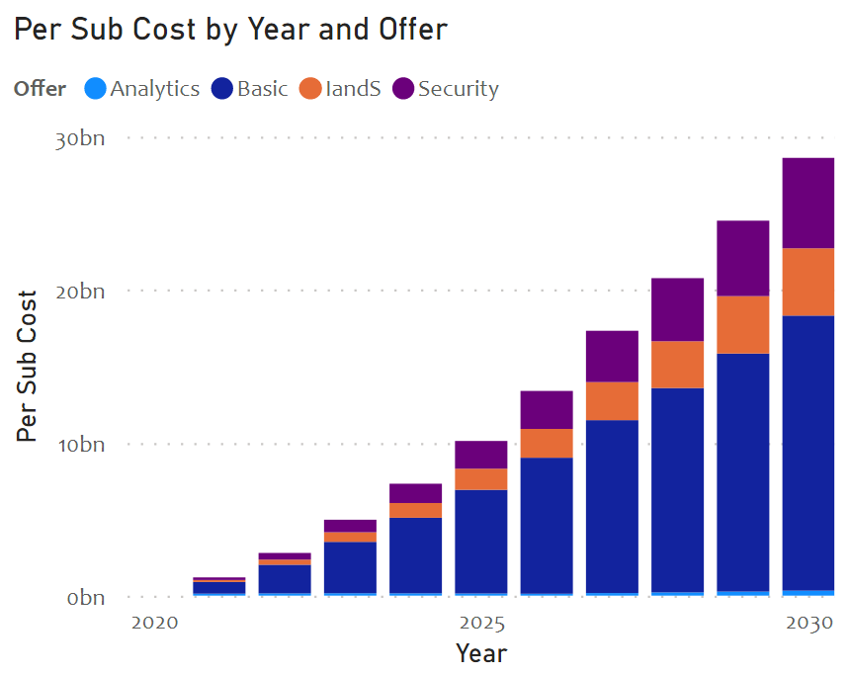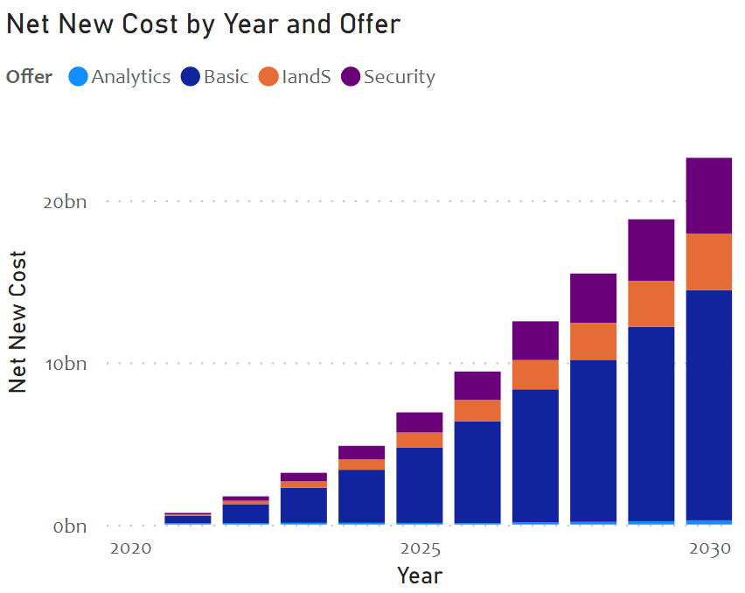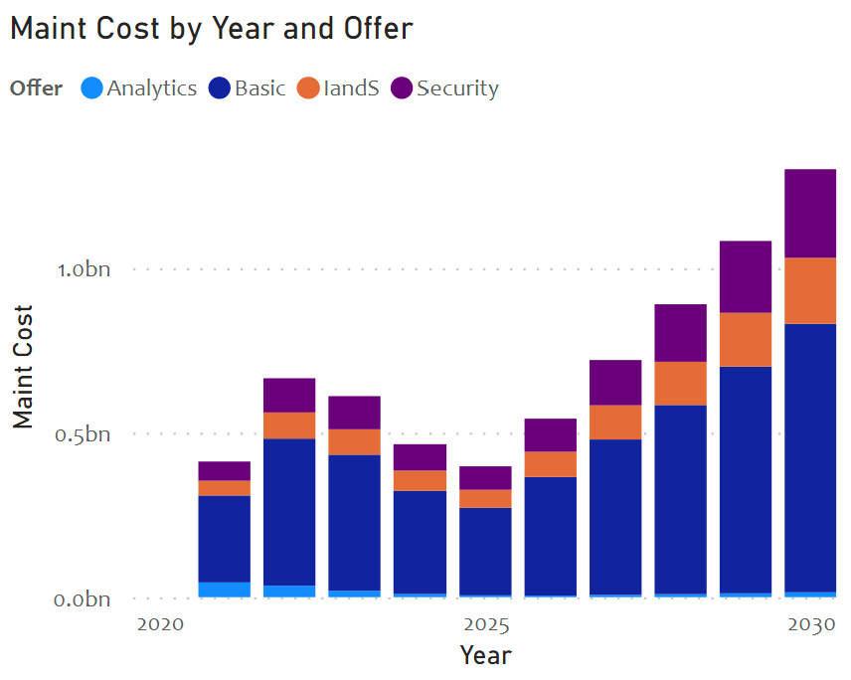
Figure 67 High level estimated cost breakdown by AIP product offering
Per sub monthly costs are the highest due to revenue share agreements with the other solution component providers such as unified communications platform, PHR or EMR services, and specialized analytical services. Maintenance is the next major cost driver due to increased services. One can argue that the ROI of IandS is not high enough to offer these services. But IandS being the key differentiator for the operators, they drive higher revenues through gaining more customers for other services. The incremental cost for adding newer customers will diminish after the initial solution creation.

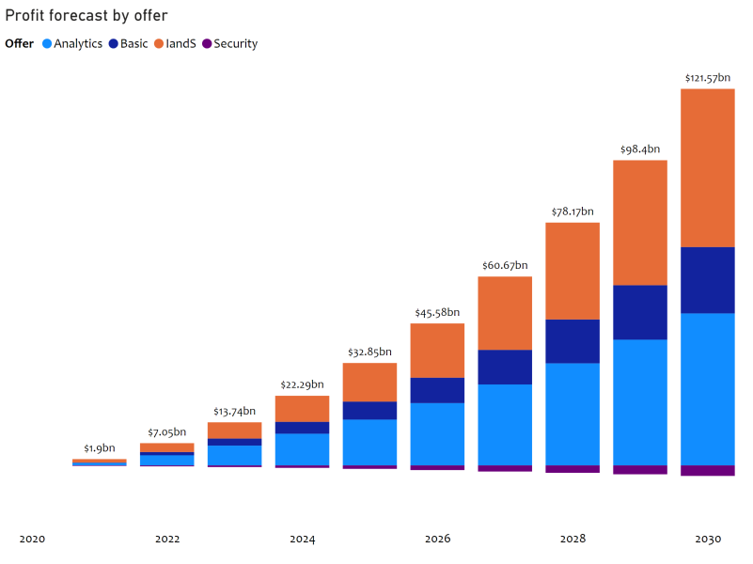
Profitability analysis
Figure 68 Telehealth 10-year profitability forecast by offer
A shown in Figure 68, the Telehealth opportunity for operators is going to reach 100s of billions of dollars in the US alone. We made a very conservative take rate assumption of 5% YOY growth in the market capture for operators. There is a significant upside to the profitability depending on the level of involvement an operator wants to have with the healthcare industry. We believe as both industries learn to trust each other, they will take more risks in solving complex telehealth problems and hence open doors for higher rewards than projected here

Conclusions and recommendations

Aging in Place conclusion and recommendations
This paper outlines our research of the AIP market size and identified product offerings that are needed to fill the demand of a growing AIP market. The result of our analysis reveals a compelling opportunity for cable operators to play a key role in fulfilling this market need by growing their product offerings and enabling end-to-end AIP solutions.
As this paper points out, the healthcare industry is looking for innovations to help control exploding costs and address changing market needs. The operators are uniquely positioned to help address this AIP market need. Cable operators have a competitive advantage in several key areas:
- Established relationships with target customer base
- Communication infrastructure ownership and control
- Data hosting and analytics capabilities
- Consolidated billing
- Service provisioning and management experience
- Customer service and support (boots on the ground) organizations in place
The key will be to use these competitive advantages to quickly capture market share and grow operating profits while the market is still fragmented. This market discontinuity is the optimum time to enter this expanding market.
To be most competitive, the operators will need to address their weaknesses in this inter-industry venture. Healthcare is a new area for cable operators with some unique challenges. You not only need to support patients (i.e., subscribers), but also the assortment of care providers and institutions. HIPAA regulations will also need to be addressed. From our market research and analysis, we were able to estimate the broadband telecommunications market size, the projected revenue, and the estimated cost to support making these AIP offerings available. By modeling this data, we can calculate the projected profit. This model can be used by the cable operators and other telecommunication operators developing their AIP business case.
Based on our extensive analysis, we make the following recommendations to the cable operators:
- AIP gives a way for cable operators to enter the lucrative inter-industry collaboration with the healthcare industry. The cable industry is uniquely positioned with its current capabilities.
- Develop partnerships with the caregivers, providers, and payors to integrate different stakeholders.
- The AIP is not just for the older adults but for the family, caregiver, provider, and payor communities.
- The development of integration partnerships and purchasing key technology will be crucial to bringing these offerings to the market quickly. The product offering strategy should focus on providing end-to-end AIP solutions.
- The offers presented here take into consideration the level of risk an operator is willing to take. We highly recommend exploring these during their internal strategic discussions.
AIP is not only a huge opportunity for operators, but it is becoming the new direction for aging in America. It gives older adults, family, and caregivers a chance to take advantage of the fast-changing technology for some peace of mind and will be a change in behavior that continues for the foreseeable future.

Telehealth conclusions and recommendations
This paper outlines our research of the telehealth market size and identified product offerings that are needed to fill the demand of a growing telehealth market. The result of our analysis reveals a compelling opportunity for cable operators to play a key role in fulfilling this market need by growing their product offerings and enabling end-to-end telehealth solutions.
As this paper points out, the healthcare industry is looking for innovations to help control exploding costs and address changing market needs. Cable operators are uniquely positioned to help address this telehealth market need. The cable operators have a competitive advantage in several key areas:
- Established relationships with target customer base
- Communication infrastructure ownership and control
- Data hosting and analytics capabilities
- Consolidated billing
- Service provisioning and management experience
- Customer service and support (feet on the ground) organizations in place
The key will be to use these competitive advantages to quickly capture market share and grow operating profits quickly while the market is still fragmented. This market discontinuity is the optimum time to enter this expanding market.
To be most competitive, operators will also need to address their weaknesses. Healthcare is a new area for cable operators with some unique challenges. You not only need to support patients (i.e., subscribers), but also the assortment of healthcare providers and institutions. HIPAA regulations will also need to be addressed. From the market research and analysis, we were able to estimate the broadband telecommunications market size, the projected revenue and the estimated cost to support making these telehealth offerings available. By modeling this data, we are able to calculate the projected profit. This model can be used by cable operators and other telecommunication operators in developing their telehealth business case.
Based on our extensive analysis, we provide the following observations and recommendations to cable operators:
- Telehealth gives way for cable operators to enter the lucrative inter-industry collaboration with the healthcare industry. The cable industry is uniquely positioned with its current capabilities (unified communication, broadband, and IoT devices).
- Develop partnerships with individuals, caregivers, and various healthcare providers to integrate different stakeholders.
- The development of integration partnerships and purchasing key technology will be crucial bringing these offerings to the market quickly. The product offering strategy should focus on providing end-to-end telehealth solutions.
- Repurpose infrastructure to support telehealth offerings and HIPAA considerations.
- The offers presented here take into consideration the level of risk an operator is willing to take. We highly recommended exploring these during their internal strategic discussion.
Telehealth is not only a huge opportunity for operators to seize, but it is becoming a new addition to the ever-changing healthcare field around the world.

Overall recommendation to Cable Operators
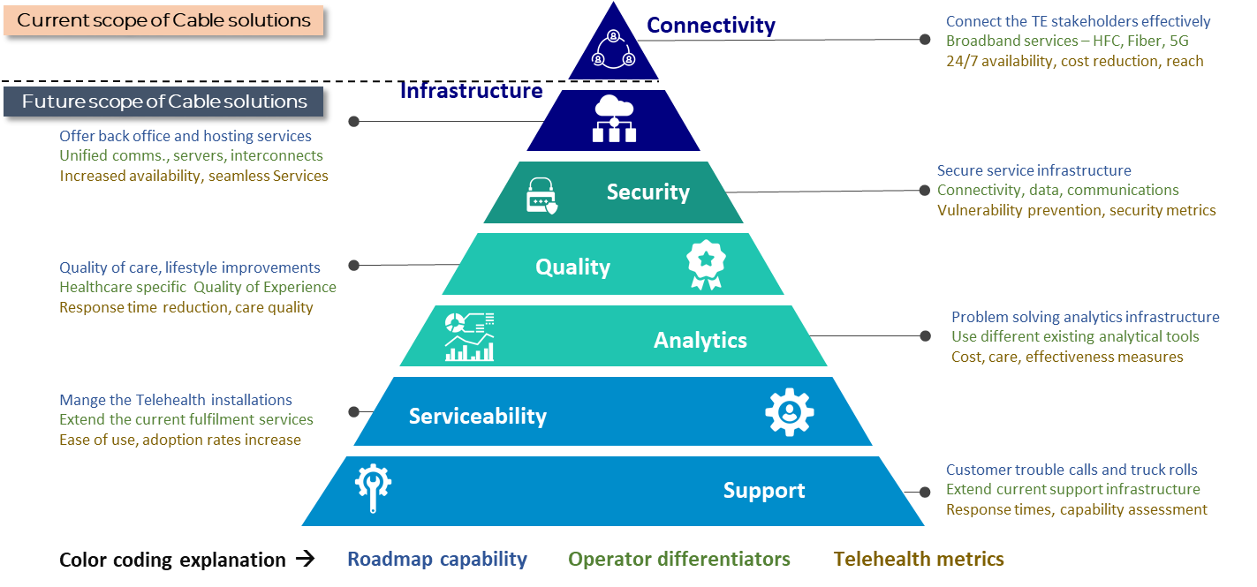
Bringing all the concepts, metrics, and capabilities together, in Figure 69, we propose a potential roadmap for the cable operators to successfully offer a Telecom for Wellness (both for Telehealth and AIP) environment.
Figure 69 Overall recommendations to address Telecom for Wellness by the cable operators
- Offer your existing capabilities to wellness industry:
  - We propose the operators to play to their strength to start with. This includes the ubiquity of reach and relations through connectivity. It is observed that the biggest challenge for the wellness customers is still the broadband connectivity. This is certainly understandable in the rural areas. Even in the urban and suburban areas, this seem to be one of the main concerns. The lowest hanging fruit for the cable operators is to bundle these connectivity services in the wellness language to address the customer needs. The wireline services such as hybrid fiber coax (HFC) and fiber based solutions, along with the wireline services with the future 5G etc., can solve these basic needs. Some of the metrics the wellness industry understand related to connectivity are the 24/7 availability, cost reduction through efficient use of time and increased reach of the patients.
  - Extend the existing service-oriented infrastructure to meet the wellness needs. These include the managed back office and hosting services – specifically focused on the supporting the above mentioned communication relations. This also includes services such as unified communication services. Assist the wellness providers in hosting their important data (such as EMR data, patient specific data, billing information etc.) and a portfolio of seamless interconnection (between the stakeholders) services. These services can be measured through the availability and seamless access metrics.
  - Offer a state-of-the-art secure platform. The wellness industry is longing for the day-to-day security infrastructure that the cable operators offer for connectivity, data, and communications. Working with their security infrastructure, the providers, by solving the security related issues will be welcome by the wellness industry. Such an infrastructure’s effectiveness can be measured through vulnerability prevention and other security metrics.
- Adapt your capabilities to the wellness needs:
  - Adopt the service quality metrics that the cable operators are using to monitoring to the wellness services. Develop wellness specific quality of care and lifestyle improving service – like what we call the quality of experience metrics for the services we offer for the triple play services. Metrics such as response time improvements, cost reduction, quality of care improvements etc. need to be measured on the data that is mined for these wellness services. This increases the adoption of the telehealth services and hence the cable operator supported wellness services.
  - Use your service oriented analytical platform to assist the complex wellness issues. Put the complex digital infrastructure that cable operators have developed to solve telehealth related problems. These metrics will be in cost of care reduction, quality of care improvements, telehealth effectiveness etc. This, in our opinion, is a simple redirection of the analytical infrastructure to the wellness industry.
- Increase the capabilities of the operators to meet the future needs of the wellness industry:
  - Develop telehealth installation services as a first step to turn the telehealth as a standard portfolio service. Extend the fulfilment PPTs (people, processes, and tools) to offer telehealth installation services. Implement different fulfillment learning that you have, such as self-service and assisted service combinations, to make the customer’s life easy when deploying these services. Measure your stakeholders and your successes through metrics such as ease of use and adoption increase.
  - Offer telehealth support services to turn the fragmented market to your advantage. Use your customer’s support infrastructure through care centers, truck rolls to address their wellness needs. This comes at the expense of mobilizing your support organizations to gain wellness expertise. The size of the telehealth opportunity foreshadows the complexities reshaping your service organization. The reward for the operators is significant enough that this is a necessary step to gain the full control of your inter-industry opportunities. Success can be measured by response time, and problem solving capability assessment metrics.
In addition to the step-by-step telehealth services, the cable operators have to make the appropriate decisions to develop a go-to-market strategy either through partnerships, building some of the solutions, or by applying the BOT (build, operate and transfer) model. For such a solution they need a clear roadmap for execution, deciding which market they are after: B2B, B2C or B2B2C. For additional information reach out to the authors.

Appendix A: Terminology

Aging in Place terminology
ADLs - are routine activities people do every day without assistance. There are six basic ADLs: eating, bathing, getting dressed, toileting, mobility, and continence. The performance of these ADLs is important in determining what type of long-term care and health coverage, such as Medicare, Medicaid, or long-term care, a person will need as they age.
Assisted Living: Housing for older adults or disabled people that provides (some) nursing care, housekeeping, and prepared meals as needed. It can be considered long-term care, depending on the person and their needs. Assisted living facilities can also be called residential care, congregate housing, adult congregate care or domiciliary care. Most would be considered appropriate for someone who only needs a little care each day. Some of that assistance might be with dressing, bathing, eating, and toileting, but do not require the intensive medical and nursing care.
Congregate Care Facility - a facility for long-term residence exclusively by persons sixty years of age or older, and which shall include, without limitation, common dining and social and recreational features, special safety and convenience features designed for the needs of older adults, such as emergency call systems, grab bars and handrails, special door hardware, cabinets, appliances, passageways, and doorways designed to accommodate wheelchairs, and the provision of social services for residents which must include at least two of the following: meal services, transportation, housekeeping, linen, and organized social activities.
HCBS: types of person-centered care delivered in the home and community. A variety of health and human services can be provided. HCBS programs address the needs of people with functional limitations who need assistance with everyday activities, like getting dressed or bathing. HCBS are often designed to enable people to stay in their homes, rather than moving to a facility for care. HCBS programs generally fall into two categories: health services and human services. HCBS programs may offer a combination of both types of services and do not necessarily offer all services from either category.
Independent Living Facility - a facility that provides residential accommodations for senior adults. These residences may include common areas, a common dining facility, and space for provision of social, psychological, and educational programs. Home health care or other community-based services may be used on an individual basis. Meals, linen, and housekeeping services may be offered. There may be a maintenance staff, but there is no medical or supervisory staff.
Long Term Care: A collection of personal and health services dedicated to enabling people to live safely and as independently as possible when a gradual or sudden illness, injury or other condition doesn’t allow them to perform everyday tasks on their own. Long term care can last months or years and is based on each individual’s abilities and condition. Care can include from family and friends or paid professionals and may be provided in their home or at day programs, assisted living facilities or nursing homes.
Memory Care - long-term care option for patients who have been diagnosed with such conditions or have problems with at least two areas of ADLs. A memory care environment is designed for persons with a level of impairment making it unsafe for him or her to continue to stay at home, but who does not require the intensive care of a skilled nursing facility. Memory care allows a person experiencing memory loss to maintain a level of independence while relying on the safety and security of being in a residential facility with a professional staff.
National Aging in Place Council: NAIPC is an association of businesses that provide services to people who are aging in place.
NCAL: serves the needs of the assisted living community as a branch of the American Health Care Association (AHCA). NCAL provides national advocacy, education, networking, professional development, and quality initiatives. Also, NCAL focuses on legislation that can affect long term care. NCAL has state affiliates, which help with education, support assisted living members and advocate for those members.
NCOA: is a nonprofit organization that which has the goal of improving the lives of seniors and older adults across the nation by helping them find benefits, improve their quality of life and health, live independently, and stay active and involved in their communities. The NCOA works with organizations across the United States to help seniors maintain their quality of life in the local community and is headquarters in Washington, DC.
Non-Medical In-Home Care: Non-medical in-home care is a service that helps people continue to live independently at home, by assisting the individuals in the home with their ADLs. It is designed to help individuals, as well as family caregivers. This type of caregiving is typically provided by people who do not have formal medical training.
Skilled Nursing Facility: an in-patient rehabilitation and medical treatment center staffed with trained medical professionals. They provide the medically necessary services of licensed nurses, physical and occupational therapists, speech pathologists, and audiologists. Skilled nursing facilities give patients round-the-clock assistance with healthcare and activities of daily living (ADLs). There are numerous federal regulations regarding what skilled nursing facilities can and cannot do.
Universal Design: This term refers simply to the design of something, whether it be a building, home or product, that can be used by anyone, regardless of physical abilities. In the case of aging in place, the principles of universal design are used to create an accessible home environment, geared towards the safety and comfort of seniors.

Telehealth terminology
AI: the ability of a digital computer or computer-controlled robot to perform tasks commonly associated with intelligent beings. The term is frequently applied to the project of developing systems endowed with the intellectual processes characteristic of humans, such as the ability to reason, discover meaning, generalize, or learn from past experience.
AMR: An electronic or paper-based medical record used in the outpatient or ambulatory care setting.
Appointment: An appointment represents a booked slot or group of slots on a schedule, relating to one or more services or resources. Two examples might include a patient visit scheduled at a clinic, and a reservation for a piece of equipment.
ARRA: An economic stimulus bill enacted by the 111th United States Congress and signed into law by President Barack Obama created the Health Information Technology for Economic and Clinical Health (HITECH) Act, which provided $30 billion for various health information technology investments, including funding incentives for acute care hospitals and physicians in private practice to adopt certified EHRs.
ATCB: An entity that tests and certifies that certain types of EHR technology (base EHRs and EHR modules) are compliant with the standards, implementation specifications, and certification criteria adopted by the U.S. Department of Health & Human Services Secretary and meet the definition of certified EHR technology.
AUC: Criteria that are evidence-based (to the extent feasible) and assist professionals who order and furnish applicable imaging services to make the most appropriate treatment decisions for a specific clinical condition. The AUC Program is established under CMS to promote the use of AUC for advanced diagnostic imaging services, as directed by Section 218(b) of the Protecting Access to Medicare Act of 2014 Title XVIII of the Social Security Act.
BA: As set forth in 45 CFR 160.103, on behalf of such covered entity or of an organized healthcare arrangement in which the covered entity participates, but other than in the capacity of a member of the workforce of such covered entity or arrangement, creates, receives, maintains, or transmits protected health information for a HIPAA function or activity regulated by this subchapter, including claims processing or administration, data analysis, processing, or administration, utilization review, quality assurance, patient safety activities listed at 42 CFR 3.20, billing, benefit management, practice management, and repricing; or performs, or assists in the performance of: (A) A function or activity involving the use or disclosure of individually identifiable health information, including claims processing or administration, data analysis, processing or administration, utilization review, quality assurance, billing, benefit management, practice management, and repricing; or (B) Any other function or activity regulated by this subchapter; or (C) Provides, other than in the capacity of a member of the workforce of such covered entity, legal, actuarial, accounting, consulting, data aggregation, management, administrative, accreditation, or financial services to or for such covered entity, or to or for an organized healthcare arrangement in which the covered entity participates, where the provision of the service involves the disclosure of individually identifiable protected health information from such covered entity or arrangement, or from another business associate of such covered entity or arrangement, to the person. See Covered entity, BAA.
BAA: Also known as HIPAA business associate agreement (BAA). Identified under the U.S. Health Insurance Portability and Accountability Act, a contract between a HIPAA covered entity and a HIPAA business associate (BA). The contract safeguards protected health information (PHI) in accordance with HIPAA guidelines. See Covered entity.
BCMA: An inventory control system that uses barcodes to prevent human errors in the distribution of prescription medications. The goal of BCMA is to make sure that patients are receiving the correct medications at the correct time by electronically validating and documenting medication administration. The information encoded in barcodes allows for the comparison of the medication being administered with what was ordered for the patient.
Behavioral health: See BH.
Behavioral health outcome management: See BHOM.
Behavioral Risk Factor Surveillance System: See BRFSS.
BH: A branch of interdisciplinary health which focuses on the reciprocal relationship between the holistic view of human behavior and the well-being of the body as a whole entity.
BHOM: Involves the use of behavioral health outcome measurement data to help guide and inform the treatment of each individual patient.
Bioinformatics: The use of computer science, statistical modeling, and algorithmic processing to understand biological data.
Biomedical informatics: The interdisciplinary field that studies and pursues the effective uses of biomedical data, information, and knowledge for scientific inquiry, problem-solving, and decision-making, motivated by efforts to improve human health.
Biomedical Translational Research Information System: See BTRIS.
Biometric authentication: A user identity verification process that involves biological input, or the scanning or analysis of some part of the body, such as fingerprints or iris scans. Biometric authentication methods are used to protect many different kinds of systems— from logical systems facilitated through hardware access points to physical systems protected by physical barriers, such as secure facilities and protected research sites.
Biometric identifier: Biologically unique data that identify a person. Under the provisions of the HIPAA, biometric identifiers are protected health information that must be held in strict confidence by healthcare agencies and professionals.
Biometric system: A technological system that uses information about a person (or other biological organism) to identify that person. Biometric systems rely on specific data about unique biological traits in order to work effectively. A biometric system will involve running data through algorithms for a particular result, usually related to a positive identification of a user or other individual.
Biometric verification: An identity authentication process used to confirm a claimed identity through uniquely identifiable biological traits, such as fingerprints and hand geometry. Designed to allow a user to prove his or her identity by supplying a biometric sample and associated unique identification code in order to gain access to a secure environment.
Biometrics: 1. A physical or behavioral characteristic of a human being. 2. Pertaining to the use of specific attributes that reflect unique personal characteristics, such as a fingerprint, an eye blood-vessel print, or a voice print, to validate the identity of a person. 3. Biometrics is a technological and scientific authentication method based on biology and used in information assurance. Biometric identification authenticates secure entry, data, or access via human biological information such as DNA or fingerprints. Biometric systems include several linked components for effective functionality. The biometric system connects an event to a single person, whereas other ID forms, such as a personal identification number (PIN), may be used by anyone.
BioSense Platform: At the core of CDC’s National Syndromic Surveillance Program (NSSP) is its BioSense Platform. It provides public health officials a common cloud-based health information system with standardized tools and procedures to rapidly collect, evaluate, share, and store information. Health officials can use the BioSense Platform to analyze and exchange syndromic data— improving their common awareness of health threats over time and across regional boundaries. They can exchange information faster and better coordinate community actions to protect the public’s health. The BioSense Platform was developed through an active collaboration of CDC and other federal agencies, state and local health departments, and public health partners. The platform hosts an array of user-selected tools and has features that are continually being enhanced to reflect their needs.
Bio surveillance: The process of gathering, integrating, interpreting, and communicating essential information that might relate to disease activity and threats to human, animal, or plant health. Activities range from standard epidemiological practices to advanced technological systems, utilizing complex algorithms.
BRFSS: The nation’s premier system of health-related telephone surveys that collect state data about U.S. residents regarding their health-related risk behaviors, chronic health conditions, and use of preventive services. Established in 1984 with 15 states, BRFSS now collects data in all 50 states as well as the District of Columbia and three U.S. territories.
BTRIS: A resource available to the U.S. Department of Health and Human Services’ National Institutes of Health (NIH) intramural community that brings together clinical research data from the Clinical Center and other NIH Institutes and Centers. BTRIS provides clinical investigators with access to identifiable data for subjects on their own active protocols, while providing all NIH investigators with access to data without personal identifiers across all protocols. Data are available from 1976 to the present.
CAH: Rural community hospitals that receive cost-based reimbursement. To be designated a CAH, a rural hospital must meet defined criteria that were outlined in the Conditions of Participation 42 CFR 485 and subsequent legislative refinements to the program through the Balanced Budget Refinement Act of 1999 (BBRA), Benefits Improvement and Protection Act (BIPA, 2000), the Medicare Modernization Act, the Medicare Improvements for Patients and Providers Act (MIPPA, 2008), and the Patient Protection and Affordable Care Act (ACA, 2010).
Capitation: Pre-established payment of a set dollar amount to a provider on a per member basis for certain contracted services, for a given period of time. Amount of money paid to provider depends on number of individuals registered to their patient list, not on volume or type of service provided.
Cardiac catheterization workflow: See CATH.
Cardinality: 1. The number of rows in a table, or the number of indexed entries in a defined index. 2. The number of elements in a set.
Care coordination: The deliberate organization of patient care activities between two or more participants (including the patient) involved in a patient’s care to facilitate the appropriate delivery of healthcare services. Organizing care involves the marshaling of personnel and other resources needed to carry out all required patient care activities and is often managed by the exchange of information among participants responsible for different aspects of care.
Care management: A set of activities that assures that every person served by the treatment system has a single approved care (service) plan that is coordinated, not duplicative, and designed to assure cost-effective and good outcomes. Care managers will oversee a patient’s journey through treatment.
Care plan: See Plan of care.
Care transitions: The various points where a patient moves to, or returns from, a particular physical location or contacts a healthcare professional for the purposes of receiving healthcare. This includes transitions between home, hospital, residential care settings, and consultations with different healthcare providers in out-patient facilities. Every change from provider or setting is another care transition.
Case mix: The relative numbers of various types of patients being treated as categorized by disease-related groups, severity of illness, rate of consumption of resources, and other indicators; used as a tool for managing and planning healthcare services.
CAT: An x-ray procedure that combines multiple x-ray images with the aid of a computer to generate cross-sectional views and, if needed, three-dimensional images of the internal organs and structures of the body. 96 Also known as CT.
CCC: Standardized, coded nursing terminology system that identifies the discrete elements of nursing practice. CCC provides a unique framework and coding structure for capturing the essence of patient care in all healthcare settings.
CCD: An implementation guide for sharing Continuity of Care Record (CCR) patient summary data using the HL7 Version 3 Clinical Document Architecture (CDA), Release 2. CCD establishes a rich set of templates representing the typical sections of a summary record and expresses these templates as constraints on CDA. These same templates for vital signs, family history, plan of care, and so on can then be reused in other CDA document types, establishing interoperability across a wide range of clinical use cases. CCD is an XML-based markup standard intended to specify the encoding, structure, and semantics of a patient summary clinical document for exchange, used for sharing patient summary data.
C-CDA: Implementation guide developed through joint efforts of HL7, Integrating the Healthcare Enterprise (IHE), the Health Story Project, and the Office of the National Coordinator (ONC) in order to consolidate CDA implementation guides from various Standards Development Organizations (SDOs) conflicting information. C-CDA specifies a library of templates and prescribes their use for a set of specific document types. CCD is an example of a C-CDA document template. See CDA, CCD.
CCDS: A set of data elements specified in 2014 and 2015 Edition EHR Certification Criteria, which focuses on the representation of clinical data during exchange. It specifies a list of data elements and the standards for expressing those data. In 2017, this data set was absorbed into the U.S. Core Data for Interoperability (USCDI).
CCM: The non-face-to-face services provided to Medicare beneficiaries who have multiple (two or more), significant chronic conditions. 438 CCMM (Continuity of Care Maturity Model): A HIMSS Analytics eight stage (0-7) Maturity Model created to demonstrate the evolution of communication between clinicians in different settings, with limited or no electronic communication to an advanced, multi-organizational, knowledge-driven community of care.
CCO: Role responsible for legal processes and procedures, maintaining industry standards, and ensuring compliance with healthcare regulations.
CCR: 1. A standard specification developed jointly by ASTM International, the Massachusetts Medical Society (MMS), the Healthcare Information and Management Systems Society (HIMSS), the American Academy of Family Physicians (AAFP), and the American Academy of Pediatrics (AAP). It was intended to foster and improve continuity of patient care, reduce medical errors, and assure at least a minimum standard of health information transportability when a patient is referred or transferred to, or is otherwise seen by another provider. 2. An XML document standard for a summary of personal health information that clinicians can send when a patient is referred, and that patients can carry with them to promote continuity, quality, and safety of care.
CDA: 1. An XML-based document markup standard that specifies the structure and semantics of clinical documents for the purpose of exchange. 2. Known previously as the patient record architecture, CDA provides an exchange model for clinical documents, such as discharge summaries and progress notes, and brings the healthcare industry closer to the realization of an electronic medical record. By leveraging the use of XML, the HL7 Reference Information Model (RIM), and coded vocabularies, the CDA makes documents both machine readable (so documents are easily parsed and processed electronically) and human readable so documents can be easily retrieved and used by the people who need them.
CDR: 1. A structured, systematically collected store house of patient-specific clinical data. 2. A centralized database that allows organizations to collect, store, access, and report on clinical, administrative, and financial information, collected from various applications within or across the healthcare organization that provides an open environment for accessing/ viewing, managing, and reporting enterprise information.
CDS: The use of automated rules based on clinical evidence to provide alerts, reminders, clinical guidelines, and other knowledge to assist users in healthcare delivery.
CDSS: An application that uses pre-established rules and guidelines that can be created and edited by the healthcare organization and integrates clinical data from several sources to generate alerts and treatment suggestions. 431 CDT (Current dental terminology): Official coding system for dentists to report professional services and procedures to third parties for payment. CDT is produced by the American Dental Association (ADA).
CDW: Grouping of data accessible by a single data management system, possibly of diverse sources, pertaining to a health system or subsystem; and enabling secondary data analysis for questions relevant to understanding the functioning of that health system, and hence can support proper maintenance and improvement of that health system.
CE: A data type that transmits codes and the text associated with the code.
CEHRT: Technology that meets the standards and criteria for structured data, established by the U.S. Centers for Medicare and Medicaid Services (CMS) and the Office of the National Coordinator for Health Information Technology (ONC), to qualify for use in CMS Promoting Interoperability (PI) programs. CEHRT gives assurance that an EHR system or module offers the necessary technological capability, functionality, and security to help users meet the meaningful use criteria. Certification also helps healthcare providers and patients be confident that the electronic health IT products and systems they use are secure, can maintain data confidentially, and can work with other systems to share information.
CMS Promoting Interoperability Programs: Programs that provide Medicare incentive payments to eligible clinicians, eligible hospitals, and CAHs as they adopt, implement, upgrade, or demonstrate meaningful use of certified EHR technology as well as payment adjustments for providers that fail to meet the criteria.
Certified EHR technology: See CEHRT.
Certified Health IT Product List: See CHPL.
CF: 1. A tool that allows a user to apply formats to dynamically style a cell or range of cells and have that formatting change, depending on the value of the cell or the value of a formula. 2. Coded element with formatted values data type. This data type, outlined in HL7, transmits codes and the formatted text associated with the code.
CHIP: An insurance program under the CMS, CHIP provides low-cost health coverage to children in families that earn too much money to qualify for Medicaid. In some states, CHIP covers pregnant women. Each state offers CHIP coverage and works closely with its state Medicaid program.
C-HOBIC: Joint project between the Canadian Nurses Association (CNA) and Canada Health Infoway to begin the process of collecting standardized clinical outcomes that are reflective of nursing practice for inclusion in electronic health records.
CHPL: The comprehensive and authoritative listing of all certified Health Information Technology which has been successfully tested and certified by the ONC Health IT Certification program. All products listed on the CHPL have been tested by an ONC-Authorized Testing Labs (ONC-ATLs) and certified by an ONC-Authorized Certification Body (ONC-ACB) to meet criteria adopted by the U.S. Secretary of the Department of Health and Human Services (HHS).
Chronic care model: Model developed by Edward Wagner and colleagues that provides a solid foundation from which healthcare teams can operate. The model has six dimensions: community resources and policies; health system organization of healthcare; patient self-management supports; delivery system redesign; decision support; and clinical information system. The ultimate goal is to have activated patients interact in a productive way with well-prepared healthcare teams. Three components that are particularly critical to this goal are adequate decision support, which includes systems that encourage providers to use evidence-based protocols; delivery system redesign, such as using group visits and same-day appointments; and use of clinical information systems, such as disease registries, which allow providers to exchange information and follow patients over time.
Chronic care management: See CCM.
Chronic disease: An illness that is long-lasting or recurrent. Examples include diabetes, asthma, heart disease, kidney disease, and chronic lung disease.
CHV: Open-access, collaborative initiative that links everyday words and phrases about health to technical terms or jargon used by healthcare professionals.
CIO: executive responsible for the management, implementation, and usability of information and computer technologies.
CIS: A system dedicated to collecting, storing, manipulating, and making available clinical information important to the delivery of healthcare. Clinical information systems may be limited in scope to a single area (e.g., lab system, ECG management system) or they may be comprehensive and cover virtually all facets of clinical information (e.g., electronic patient; the original discharge summary residing in the chart, with a copy of the report sent to the admitting physician, another copy existing on the transcriptionist’s machine).
CISC: Computers designed with a full set of computer instructions that were intended to provide needed capabilities in the most efficient way. Later, it was discovered that, by reducing the full set to only the most frequently used instructions, the computer would get more work done in a shorter amount of time for most applications. Since this was called Reduced Instruction Set Computing (RISC), there was a need to have something to call full-set instruction computers, which resulted in the term CISC.
Claim attachment: Any variety of hardcopy forms or electronic records needed to process a claim, in addition to the claim itself.
Claim status category codes: A national administrative code set that indicates the general category of the status of healthcare claims. This code set is used in the Accredited Standards Committee (ASC) X12 248 claim status notification transaction and is maintained by the healthcare code maintenance committee.
Claim status codes: A national administrative code set that identifies the status of healthcare claims. This code set is used in the Accredited Standards Committee (ASC) X12 277 claim status notification transaction and is maintained by the healthcare code maintenance committee.
Client records: All personal information that has been collected, compiled, or created about clients, which may be maintained in one or more locations and in various forms, reports, or documents; including information that is stored or transmitted by electronic media.
Client registry: The area where a patient/ person’s information (i.e., name, date of birth, Social Security number, health access number) is securely stored and maintained.
Clinical algorithm: Flow charts to which a diagnostician or therapist can refer for a decision on how to manage a patient with a specific clinical program.
Clinical care classification: See CCC.
Clinical data: All relevant clinical and socioeconomic data disclosed by the patient and others, as well as observations, findings, therapeutic interventions, and prognostic statements, generated by the members of the healthcare team.
Clinical data repository: See CDR.
Clinical data warehouse: See CDW.
Clinical decision support: See CDS.
Clinical decision support system: See CDSS.
Clinical document architecture: See CDA.
Clinical documentation system: An application that allows clinicians to chart treatment, therapy, and/ or health assessment results for a patient. This application provides the flow sheets and care plan documentation for a patient’s course of therapy.
Clinical informaticist: A person who evaluates clinical data, information systems, and technology relative to improving patient safety, clinical outcomes, and protocols and guidelines for clinical services. The functions are usually performed by people with clinical degrees. 10 Also known as clinical informatician.
Clinical informatics: 1. Promotes the understanding, integration, and application of information technology in healthcare settings to ensure adequate and qualified support of clinician objectives and industry best practices. 2. The application of informatics and information technology to deliver healthcare services. Clinical informatics is concerned with information use in healthcare by clinicians. It includes a wide range of topics ranging from clinical decision support to visual images (e.g., radiological, pathological, dermatological, ophthalmological, etc.); from clinical documentation to provider order entry systems; and from system design to system implementation, adoption, and optimization issues.
Clinical laboratory information system: See LIS.
Clinical observation: Information compiled by doctors, nurses, or other healthcare providers that documents the conditions they encounter, treatments provided and outcomes of those treatments.
Clinical observation access service: See COAS.
Clinical pathway: A patient care management tool that organizes, sequences, and times the major interventions of nursing staff, physicians, and other departments for a particular case type, subset, or condition.
Clinical performance measure: A method or instrument to estimate or monitor the extent to which the actions of a healthcare practitioner or provider conform to practice guidelines, medical review criteria, or standards of quality.
Clinical practice guidelines: A set of systematically developed statements, usually based on scientific evidence, to assist practitioners and patient decision-making about appropriate healthcare for specific clinical circumstances.
Clinical protocol: A set of rules defining a standardized treatment program or behavior in certain circumstances.
Clinical Quality Language: See CQL.
Clinical quality measures: See CQM.
Clinical record: See EHR.
CMET: Common, reusable, standardized model fragments produced by a particular work group within HL7 that are intended to be building blocks that domains can use or include in their design. The use of CMETs can reduce the effort to produce a domain-specific design while maintaining similar content across several domains.
CMIO: A person that provides overall leadership in the ongoing development, implementation, advancement, and optimization of electronic information systems that impact patient care. Works in partnership with the organization’s IT leadership to translate clinician requirements into specifications for clinical and research systems.
CMO: Senior official designated as the head of medical services. They link aspects of utilization, quality and safety, credentialing, and physician practice evaluations.
CNIO: Leads the strategy, development, and implementation of information technology to support nursing, nursing practice, and clinical applications, collaborating with the chief nursing officer on the clinical and administration decision-making process.
COAS: Standardizes access to clinical observations in multiple formats, including numerical data stored by instruments, or entered from observations.
COB: 1. The process by which a payer handles claims that may involve other insurance companies (i.e., situations in which an insured individual is covered by more than one insurance plan). 2. Process of determining which health plan or insurance policy will pay first and/ or determining the payment obligations of each health plan, medical insurance policy, or third-party resource when two or more health plans, insurance policies, or third-party resources cover the same benefits.
Code: 1. Concept identifier that is unique within a coding system. 2. A representation assigned to a term so that the term may more readily be electronically processed.
Code 128: A one-dimensional bar code symbology, using four different bar widths, used in blood banking and other healthcare and non-healthcare applications.
Code meaning: Element within a coded set.
Code set: 1. A set of elements which is mapped onto another set according to a coding scheme. 2. Clinical or medical code sets identify medical conditions, and the procedures, services, equipment, and supplies used to deal with them. Nonclinical or nonmedical or administrative code sets identify, or characterize, entities and events in a manner that facilitates an administrative process.
Code set maintaining organization: Under HIPAA, this is an organization that creates and maintains the code sets adopted by the HHS Secretary for use in the transactions for which standards are adopted. Code value: Result of applying a coding scheme to a code meaning.
Collect and communicate audit trails: Means to define and identify security-relevant events and the data to be collected and communicated, as determined by policy, regulation, or risk analysis. 20 Collect/ collection: The assembling of information through interviews, forms, reports, or other information sources.
Community health information network: See CHIN.
Compliance date: Under the HIPAA, this is the date by which a covered entity must comply with a standard, an implementation specification, or a modification. This is usually 24 months after the effective date of the associated final rule for most entities; 36 months for small health plans. For future changes in the standards, the compliance date would be at least 180 days after the effective date but can be longer for small health plans or for complex changes.
Comprehensive Primary Care Initiative: See CPC.
Comprehensive Primary Care Plus Initiative: See CPC +.
Computerized axial tomography: See CAT.
Computerized practitioner order entry: See CPOE.
Concept: 1. An abstraction or a general notation that may serve as a unit of thought or a theory. In terminology work, the distinction is made between a concept and the terms that reference the concept. Where the concept is identified as abstract from the language and the term is a symbol that is part of the language. 236 2. A clinical idea to which a unique concept has been assigned. Each concept is represented by a row in the concepts table. Concept equivalence occurs when a post-coordinated expression has the same meaning as a pre-coordinated concept or another post-coordinated expression.
Concept harmonization: Activity for reducing or eliminating minor differences between two or more concepts that are closely related to each other. 236 Note: Concept harmonization is an integral part of standardization.
Concept identifier: Concept name, code, or symbol, which uniquely identifies a concept.
Concept status: A field in the concepts table that specifies whether a concept is in current use. Values include “current,” “duplicate,” “erroneous,” “ambiguous,” and “limited.”
Concept unique identifier: See CUI.
Concepts table: A data table consisting of rows, each of which represents a concept.
Concurrent versioning system: See CVS.
Confidentiality: 1. Obligation of an entity that receives identifiable information about an individual as part of providing a service to that individual to protect that data or that individual to protect that data or information; including not disclosing the identifiable information to unauthorized persons, or through unauthorized processes. 2. A property by which information relating to an entity or party is not made available or disclosed to unauthorized individuals, entities, or processes.
Consensus standards: These are standards developed or adopted by consensus standards bodies, both domestic and international. Such work and the resultant standards are usually voluntary.
Consent: Under the HIPAA Privacy Rule, consent is made by an individual for the covered entity to use or disclose identifiable health information for treatment, payment, and healthcare operations purposes only. This is different from consent for treatment, which many providers use, and which should not be confused with the consent for use or disclosure of identifiable health information. Consent for use and/ or disclosure of identifiable health information is optional under the HIPAA Privacy Rule, although it may be required by state law, and may be combined with consent for treatment unless prohibited by other law.
Consent directive: The record of a healthcare consumer’s privacy policy that grants or withholds consent for: one or more principals (identified entity or role); performing one or more operations (e.g., collect, access, use, disclose, amend, or delete); purposes, such as treatment, payment, operations, research, public health, quality measures, health status evaluation by third parties, or marketing; certain conditions (e.g., when unconscious); specified time period (e.g., effective and expiry dates); and certain context (e.g., in an emergency).
Consenter: An author of a consent directive; and may be the healthcare consumer or patient, a delegate of the healthcare consumer (e.g., a representative with healthcare power of attorney), or a provider with legal authority to either override a healthcare consumer’s consent directive or create a directive that prevents a patient’s access to protected health information (PHI) until the provider has had an opportunity to review the PHI with the patient.
Controlled medical vocabulary: An approved list of terms coded in a fashion that facilitates the use of the computer. Controlled vocabularies are essential if clinical applications are to function as intended. Widely used systems include the American College of Radiology (ACR) Code, Current Procedural Terminology (CPT), Diagnostic and Statistical Manual of Mental Disorders (DSM-IV), and the International Classification of Diseases, Ninth Revision (ICD-9).
Countermeasure response administration: See CRA.
Covered entity: Health plans, healthcare clearinghouses, and healthcare providers who transmit any health information in electronic form, in connection with a transaction that is subject to HIPAA requirements, as those terms are defined and used in the HIPAA regulations, 45 CFR Parts 160 and 164.
Covered function: Functions that make an entity a health plan, a healthcare provider, or a healthcare clearing house.
CPC: A four-year multi-payer Centers for Medicare and Medicaid Services (CMS) initiative designed to strengthen primary care. CMS collaborates with commercial and State health insurance plans in U.S. regions to offer population-based care management fees and shared savings opportunities to participating primary care practices to support the provision of a core set of five “Comprehensive” primary care functions. These five functions are: (1) Risk-stratified Care Management; (2) Access and Continuity; (3) Planned Care for Chronic Conditions and Preventive Care; (4) Patient and Caregiver Engagement; (5) Coordination of Care across the Medical Neighborhood. CPC serves as the foundation for Comprehensive Primary Care Plus (CPC +). See CPC +.
CPC +: A five-year advanced primary care medical home model launched in January 2017. CPC + integrates many lessons learned from CPC, including insights on practice readiness, the progression of care delivery redesign, actionable performance-based incentives, necessary health information technology, and claims data sharing with practices. See CPC.
CPOE: 1. An order entry application specifically designed to assist practitioners in creating and managing medical orders for patient services and medications. This application has special electronic signature, workflow, and rules engine functions that reduce or eliminate medical errors associated with practitioner ordering processes. 2. A computer application that accepts the provider’s orders for diagnostic and treatment services electronically, instead of the clinician recording them on an order sheet or prescription pad. Also known as computerized physician order entry, computerized patient order entry, and computerized provider order entry.
CPR: See EHR.
CPRS: See EHR.
CPS: Statement of the practices that a certification authority employs in issuing certificates.
CPT: 1. The official coding system for physicians to report professional services and procedures to third parties for payment. It is published by the American Medical Association. 46 2. A medical code set maintained and copyrighted by the AMA, that has been selected for use under HIPAA for non-institutional and non-dental professional transactions.
CQL: A Health Level Seven International (HL7) authoring language standard that’s intended to be human readable. It is part of the effort to harmonize standards used for electronic clinical quality measures (eCQMs) and CDS. CQL provides the ability to express logic that is human readable yet structured enough for processing a query electronically.
CQM: Tools that measure and track the quality of healthcare services provided by eligible clinicians, eligible hospitals, and CAHs within the U.S. healthcare system.
CRA: Systems that manage and track measures taken to contain an outbreak or event, and to provide protection against a possible outbreak or event. This public health information network (PHIN) functional area also includes multiple dose delivery of countermeasures: anthrax vaccine and antibiotics; adverse events monitoring; follow-up of patients; isolation and quarantine; and links to distribution vehicles (such as the Strategic National Stockpile).
CUI: An identifier leveraged by the Unified Medical Language System (UMLS) to uniquely represent a meaning or sense.
CWE: Specifies a coded element and its associated detail. The CWE data type is used (1) when more than one table may be applicable or (2) when the specified HL7 or externally defined table may be extended with local values or (3) when the text is in place, the code may be omitted.
eHealth (also written e-health): A broadly defined term for healthcare practice which is supported by information and communication technologies; the term eHealth encompasses a whole range of services that is at the edge of medicine/ healthcare and information technology, including electronic medical records, telemedicine, and evidence-based medicine.
EHR: 1. A longitudinal electronic record of patient health information generated by one or more encounters in any care delivery setting. Included in this information are patient demographics, progress notes, problems, medications, vital signs, past medical history, immunizations, laboratory data, and radiology reports and images. The EHR automates and streamlines the clinician’s workflow. The EHR has the ability to generate a complete record of a clinical patient encounter, as well as supporting other care-related activities directly or indirectly via interface; including evidence-based decision support, quality management, and outcomes reporting. 2. Health-related information on an individual that conforms to nationally recognized interoperability standards and that can be created, managed, and consulted by authorized clinicians and staff across more than one healthcare organization. See EMR.
EMR: 1. An application environment that is composed of the clinical data repository, clinical decision support, controlled medical vocabulary, order entry, computerized practitioner order entry, and clinical documentation applications. This environment supports the patient’s electronic medical record across inpatient and outpatient environments, and is used by healthcare practitioners to document, monitor, and manage healthcare delivery. 2. Health-related information on an individual that can be created, gathered, managed, and consulted by authorized clinicians and staff within one healthcare organization. 10,12 See EHR.
FHIR: Interoperability specifications created by Health Level Seven International to help exchange healthcare information electronically. Aim is to help simplify the implementation of EHRs without sacrificing the information’s integrity.
HL7: provide a framework (and related standards) for the exchange, integration, sharing, and retrieval of electronic health information. These standards define how information is packaged and communicated from one party to another, setting the language, structure and data types required for seamless integration between systems.
IoMT: Infrastructure connecting medical devices, software applications, and health system and services. These devices can generate, collect, analyze, or transmit health data to different servers.
PROs: Any report of the status of a patient’s (or person’s) health condition, health behavior, or experience with healthcare that comes directly from the patient, without interpretation of the patient’s response by a clinician or anyone else.
RPM: The use of technology to collect medical/health data from a patient and placing it in one secure location so providers from a remote location can provide their assessment and recommendations.
Telehealth: A broad variety of technologies and tactics to deliver virtual medical, health, and education services. A collection of means to enhance care and education delivery. This term encompasses the concept of “telemedicine,” which refers to traditional clinical diagnosis and monitoring delivered by technology. The term “telehealth” covers a wide range of diagnosis, management, education, and other related healthcare fields including but not limited to dentistry, counseling, physical and occupational therapy, home health, chronic disease monitoring and management, and consumer and professional education.
Telemedicine: See Telehealth.

Appendix B: Detailed business requirements

Aging in Place business requirements

Elder/Patient
Req. ID | Classification | Sub-Classification | Requirement | Scope | Priority | Source
Pat.ES.IL.000 | Ecosystem Support | Independent Living
Pat.ES.IL.001 | Ecosystem Support | Hygiene | Bathing Hygiene: Older adult patients should have safety measures placed in the bathroom to increase mobility and flexibility. These measures should additionally help reduce the incidence of falls/slips. |  | High | Emerging Technologies To Support Aging Population
Pat.ES.IL.002 | Ecosystem Support | Hygiene | Bathing Hygiene: Additional measures to reduce the incidence of falls/slips. |  | High | Emerging Technologies To Support Aging Population
Pat.ES.IL.003 | Ecosystem Support | Hygiene | Oral Hygiene: Maintain oral health so older adult can retain their taste and smell and in turn improving their quality of life. It can also prevent the need for dentures which can be a financial burden. |  | Medium | Emerging Technologies To Support Aging Population
Pat.ES.IL.004 | Ecosystem Support | Hygiene | Wound Care: These can arise from chronic illnesses such as diabetes or PVD. Management of such wounds should be established to fit to the patients cognitive/physical abilities in order to promote prevention or faster healing. |  | High | Emerging Technologies To Support Aging Population
Pat.ES.IL.005 | Ecosystem Support | Nutrition | Daily Nutrition: Ensure that older adults are receiving adequate nutrition so they can maintain their physical, mental, and emotional health. |  | High | Emerging Technologies To Support Aging Population
Pat.ES.IL.006 | Ecosystem Support | Nutrition | Feeding Tools: Providing meal tools to older adults to match their motor levels |  | High
Pat.ES.IL.007 | Ecosystem Support | Nutrition | Feeding One's Self: A form of independence can be seen as making one's own food. |  | High | Emerging Technologies To Support Aging Population
Pat.ES.IL.008 | Ecosystem Support | Medication | Maintaining Medication: Making sure patients are receiving the proper doses of their prescribed medications. |  | High | Emerging Technologies To Support Aging Population
Pat.ES.IL.009 | Ecosystem Support | Medication | Negative Interaction: Avoid negative interaction between drugs. Trying to prevent adverse reactions. |  | High | Emerging Technologies To Support Aging Population
Pat.ES.C.000 | Ecosystem Support | Cognition
Pat.ES.C.001 | Ecosystem Support | Cognitive Monitoring | Asses Reasoning, Memory and Communication Ability: Measure a patients baseline so that future assessments can be compared. Help capture cognitive changes early on to help prevention. |  | Medium | Emerging Technologies To Support Aging Population
Pat.ES.C.002 | Ecosystem Support | Cognitive Training | Enhancing Baseline Ability: Study methods that can improve a patients baseline cognitive ability through tech or other means. |  | Informative | Emerging Technologies To Support Aging Population
Pat.ES.C.003 | Ecosystem Support | Financial Independence | Financial Management: Help empower older adult patients, especially those experiencing cognitive changes, with finding their independence managing their finances. Educating older adult patients on how to use new tech to their advantage. |  | Medium | Emerging Technologies To Support Aging Population
Pat.ES.C.004 | Ecosystem Support | Financial Independence | Exploitation Prevention: Helping to understand when older adults are being financially taken advantage of. |  | Informative | Emerging Technologies To Support Aging Population
Pat.ES.C.005 | Ecosystem Support | Financial Independence | Older adult with Reduced Financial Capacity: Assist older adult who are vulnerable to exploitation with a plan on how to reduce risk and achieve their financial goals |  | Low | Emerging Technologies To Support Aging Population
Pat.ES.HC.000 | Ecosystem Support | Access To Healthcare
Pat.ES.HC.001 | Ecosystem Support | Telehealth | Improve Healthcare Access and Quality: Making sure older adults are provided with reliable primary care, specialty care and community services in all conditions such as mobility or location concerns (rural, underserved, or at-risk communities). Overall access to healthcare improves mortality, quality of life, and increases access to resources for chronic conditions. |  | High | Emerging Technologies To Support Aging Population
Pat.ES.HC.002 | Ecosystem Support | Telehealth | Smoother Care Transition: Making transitions between home care to hospital seamless so there aren't readmissions. |  | Medium | Emerging Technologies To Support Aging Population
Pat.ES.HC.003 | Ecosystem Support | Telehealth | Remote Monitoring: Telehealth can allow for remote monitoring to identify crucial issues (altered mental states) without having to go to the hospital. Older adults can find independence by having care from their home rather than a nursing home. |  | High | Emerging Technologies To Support Aging Population
Pat.ES.HC.004 | Ecosystem Support | Telehealth | Provide Self-Management Support: Help manage their chronic conditions through education and becoming active in their treatment plan. |  | Medium | Emerging Technologies To Support Aging Population
mPat.ES.HC.005 | Ecosystem Support | Telehealth | System Support: Technology support before an appointment to work through any technology difficulties |  | Medium | How to Provide Telehealth to Older Adults
Pat.ES.HC.006 | Ecosystem Support | eCare Planning | Improve Coordination of Care: Allow for open communication between different providers to create a cohesive plan for their shared patient. This plan should include elements of the patient's goal, preferences, gaps in care, etc. The plan should also evolve as the needs change. Prevents redundancies, negative interactions, or increased medical prices. Ensure complex, high-risk patients are receiving a plan. |  | High | Emerging Technologies To Support Aging Population
Pat.ES.HC.007 | Ecosystem Support | eCare Planning | Facilitate Shared Care Planning: A common interface where all physicians, patients, stakeholders, etc. can interact on a care plan |  | Medium | Emerging Technologies To Support Aging Population
Pat.I.PM.000 | Interactivity | Personal Mobility
Pat.I.PM.001 | Interactivity | Assisted Movement | Navigation Assistance: Help restore some independence when navigating the home/outside especially when older adult experiences physical and/or cognitive deficits. |  | Medium | Emerging Technologies To Support Aging Population
Pat.I.PM.002 | Interactivity | Assisted Movement | Mechanical Assistance: Help older adult who are experiencing decreased musculoskeletal function, so they have improved balance and/or range of motion. These devices can help navigate the outside environment which can be dangerous to these patients. |  | High | Emerging Technologies To Support Aging Population
Pat.I.PM.003 | Interactivity | Rehabilitation | In-Home Rehab: Helps to reduce rehab cost while maximizing time working on exercises. |  | Low | Emerging Technologies To Support Aging Population
Pat.I.PM.004 | Interactivity | Rehabilitation | Flexible Schedule: At home rehab could allow for schedule flexibility. |  | Informative | Emerging Technologies To Support Aging Population
Pat.I.PM.005 | Interactivity | Monitoring and Safety | Monitoring Movement: Movement or activity can promote healthy habits and overall better well-being. |  | High | Emerging Technologies To Support Aging Population
Pat.I.PM.006 | Interactivity | Monitoring and Safety | Fall Prevention: Measures in place to prevent falls which can result in morbidity and mortality or decreased independence. |  | High | Emerging Technologies To Support Aging Population
Pat.I.T.000 | Interactivity | Transportation
Pat.I.T.001 | Interactivity | Driving | Driving Fitness or Maintaining Fitness: Creating/following a license reevaluation process once an older adult person is undergoing cognitive or physical changes. |  | Medium | Emerging Technologies To Support Aging Population
Pat.I.T.002 | Interactivity | Driving | Continued Driving Ability: Discussion of systems to implement to allow older adult to continue driving (utilizing tech in some cases). |  | Informative | Emerging Technologies To Support Aging Population
Pat.I.T.003 | Interactivity | Public Transportation | Assist with Navigation and Scheduling: Planned navigation routes and scheduling tools. Navigation tools can include traffic info or specific needs of the adult. Include accurate timings/direction to public transportation |  | Low | Emerging Technologies To Support Aging Population
Pat.I.Connect.000 | Interactivity | Communication and Social Connectivity
Pat.I.Connect.001 | Interactivity | Hearing | Hearing Assistance: hearing assistance devices that can connect to different audio channels and adapt to different environments |  | High | Emerging Technologies To Support Aging Population
Pat.I.Connect.002 | Interactivity | Hearing | Hearing Acceptance: Increase the willingness to use hearing assistance and get a hearing assessment before getting device. |  | Medium | Emerging Technologies To Support Aging Population
Pat.I.Connect.003 | Interactivity | Hearing | Family/caregiver support: Information/demonstrations for caregivers to understand the impacts of hearing loss and programs to participate in. |  | Medium | Emerging Technologies To Support Aging Population
Pat.I.Connect.004 | Interactivity | Hearing | Hearing Assistance Implementation: Creating standards amongst manufacturers to adjust tuning settings |  | Informative | Emerging Technologies To Support Aging Population
Pat.I.Connect.005 | Interactivity | Social | Translation: Reliable automated translation technology with different capabilities, such as audio/video, so that there is easy communication between the two parties |  | Low | Emerging Technologies To Support Aging Population
Pat.I.Connect.006 | Interactivity | Social | Social Connections: Increasing social interaction that promote communication and activity with others to decrease isolation which may play into mortality. |  | High | Emerging Technologies To Support Aging Population
Pat.CS.___.000 | Condition Specific | Condition
Pat.CS.___.001 | Condition Specific | Acute | Acute Condition: If the patient is concerned about their acute condition, the platform will give them access to a provider (primary care or specialty) |  | High | Chiron Health Telehealth Offerings
Pat.CS.___.002 | Condition Specific | Chronic | Ongoing Management: Patients with chronic condition they will be given access to their provider, so they are updated on the diseases management plan based off how their condition progresses |  | High | Chiron Health Telehealth Offerings
Pat.CS.___.003 | Condition Specific | Behavioral | Behavioral Management: Patient/caregiver should have access to a provider if the patient's condition changes or would like to discuss their plan with a physician |  | Medium | Chiron Health Telehealth Offerings
Pat.CS.___.004 | Condition Specific | Cognitive | Cognitive Changes: If any changes in cognitive function is noticed, the patient/caregiver must have access to a provider to discuss the symptoms |  | Medium | Chiron Health Telehealth Offerings
Pat.DS.___.000 | Distance Specific | Distance
Pat.DS.___.001 | Distance Specific | Rural | Rural Location: If the older adult is located in a rural location, they/caregivers should be provided with local resources that call help navigate their or nearby communities especially if mobility, cognition is limited. |  | Informative | Advantages to Telehealth
Pat.DS.___.002 | Distance Specific | Urban/Suburban | Urban Location: If the older adult is located in a more populous location, they/caregivers should be provided with local resources that call help navigate their community especially if mobility, cognition is limited. |  | Informative | Advantages to Telehealth
Pat.CL.Cost.000 | Cost Limits | Costs
Pat.CL.Cost.001 | Cost Limits | Income | Income: An older adult person can be receiving income from multiple sources and they or their caregiver need a chance to understand the state of their finances |  | Informative | Pension Rights Source of Older adult Income
Pat.CL.Cost.002 | Cost Limits | Coverage | Insurance: Whether the older adult is covered by CMS or not, they should have at least a broad understanding of what they are covered for in case of medical changes |  | Informative | Center for Connected Health Policy
Pat.CL.Cost.003 | Cost Limits | Housing | Housing: As income in older adult decreases as the older adult ages, they or their caregiver need to consider the appropriate form of housing (senior living or AIP) |  | Informative | Comfort Keepers
Pat.CL.Cost.004 | Cost Limits | Housing | AIP: With more older adult people wanting to age at home, they or their caregiver needs to understand what kinds of investments they need to make in the home to make it more suitable for the older adult living their |  | Informative
Pat.CL.Cost.005 | Cost Limits | Transportation | Transportation Expense: As driving fitness decreases, the older adult needs to find another means of transportation that is affordable based of their income (public, hired, family, etc.) |  | Low

Provider
Req. ID | Classification | Sub-Classification | Requirement | Scope | Pirority | Source
Prov.U.Encounter.000 | How they Use | Encounter
Prov.U.Encounter.001 | How they Use | Chronic Care Management | CC Management: Provider should be given patient data so they can monitor their condition |  | High
Prov.U.Encounter.002 | How they Use | Chronic Care Management | CC Suggestions: provider should be able to contact the patient if there are changes in their condition |  | High
Prov.U.Encounter.003 | How they Use | Assessments | Encounter: Providers should be able to contact their patient if they would like to update them about their condition |  | High
Prov.U.Encounter.004 | How they Use | Resources/Health Literacy | Resources: If needed, the provider will send the patient resources they may need to understand their condition |  | Informative
Prov.U.Encounter.005 | How they Use | Caregiver | Update: If the patient has a caregiver, they should be contacted about updates to their condition |  | High
Prov.PN.Care.000 | Practice Needs | Care Type
Prov.PN.Care.001 | Practice Needs | Palliative | Palliative Care: Providing elders with access to professionals in palliative care as they cater to the needs of the elder while at home |  | Medium
Prov.PN.Care.002 | Practice Needs | Hospice | Primary Caregiver: Hospice professionals working with the elder's primary caregiver to create a plan on how to care for the elder |  | High
Prov.PN.Care.003 | Practice Needs | Hospice | At-home Care: Making sure the primary caregiver is helping maintain care for the elder while at home (recording symptoms, physical care, etc.) |  | Medium
Prov.PN.Care.004 | Practice Needs | Chronic Care | Management: Making sure the elder/caregiver are in touch with the provider so that the provider is aware of any changes needed to be made to their care plan |  | High
Prov.PN.Care.005 | Practice Needs | Cognitive | Cognitive Changes: Provider should be making note of any cognitive changes in the elder which may change care management |  | High
Prov.PN.Train.000 | Practice Needs | Training
Prov.PN.Train.001 | Practice Needs | Staff Training | Training: Making sure staff working with elders are trained with the skills and awareness of elder needs |  | Informative
Prov.CL.Train.000 | Cost Limits | Training Cost
Prov.CL.Train.001 | Cost Limits | Certified AIP Specialist | AIP Training: Making sure staff that are trained specifically to help elders live in their home have skills to help a varying group of elders with individual needs |  | High
Prov.CL.Train.002 | Cost Limits | Staff Training | General Training: Staff trained with the basic skills to work with elders (bathing, feeding, communication, etc.) |  | Medium
Prov.CL.Train.003 |  | Staff Training | Medical Training: If elder needs medical attention, the staff member should be trained to attend to those needs |  | High
Prov.CL.Train.004 | Cost Limits | Devices | Device Training: Educating staff working with elders on how to use different types of medical devices |  | High
Prov.TN.RemoteCare.000 | Technology Needs | Remote Care
Prov.TN.RemoteCare.001 | Technology Needs | Telemed Needs | Platform: If the elder/caregiver consents, the provider should be able to schedule a tele-visit to communicate the elders care plan |  | High
Prov.TN.RemoteCare.002 | Technology Needs | Medical Devices | Access to Device: If needed, the provider should have access to medical devices that improve the care of their patient |  | Medium
Prov.TN.RemoteCare.003 | Technology Needs | Connectivity | Connectivity: Provider should have uninterrupted connection so that they can provide continuous care to the patient |  | High
Prov.TN.RemoteCare.004 | Technology Needs | Security | Secure Platform: Whenever interacting with any patient/patient data the provider should be using a secure platform to prevent breaches |  | High
Prov.TN.Platform.000 | Technology Needs | Platform
Prov.TN.Platform.001 | Technology Needs | Software | Software: The provider should have a way to communicate with the elder through a platform if they notice changes in their condition or would like to follow-up |  | High
Prov.E.EMR.000 | Eco-system Support | EMR
Prov.E.EMR.001 | Eco-system Support | Insurance | Insurance Coverage: Seeing if procedures/labs/encounters etc. are covered by insurance |  | Informative
Prov.E.EMR.002 | Eco-system Support | Medical Devices | Integration: Makings sure the devices the elder uses are connected to the EMR system so the provider can read/analyze the data |  | Medium
Prov.E.Platform.000 | Eco-system Support | Platform
Prov.E.Platform.001 | Eco-system Support | Support | Support: If the provider has any problem interacting with the platform there should be a professional there to help solve their problem |  | Medium
Prov.COM.HIPAA.000 | HIPAA, BAA Compliance | HIPAA Compliance
Prov.COM.HIPAA.001 | HIPAA, BAA Compliance | Compliance | HIPAA: If applicable, the platform the patient uses should be HIPAA compliant to protect the elder's information |  | High

Payor
Req. ID | Classification | Sub-Classification | Requirement | Scope | Pirority | Source
Payer.CC.Income.000 | Cost Controls | Income
Payer.CC.Income.001 | Cost Controls | Insurance | Insurance Coverage: Seeing what medical procedures are covered by the elder's insurance policy |  | High
Payer.CC.Income.002 | Cost Controls | Government Payment | Payment: Understanding how much the elder is receiving from government to plan out finances |  | High
Payer.CC.Housing.000 | Cost Controls | Housing
Payer.CC.Housing.001 | Cost Controls | Affordable Housing | Housing: Elders should be given a chance to look at various affordable housing options based off of their income |  | Medium
Payer.PA.MedTreatment.000 | Policy Adherence | Medical Treatment
Payer.PA.MedTreatment.001 | Policy Adherence | Access | Medical Access: Payor should inform elder what forms of medical treatment they are able to receive based off factors like insurance, policy updates, etc. |  | Informative
Payer.PA.MedTreatment.002 | Policy Adherence | Affordability | Affordability: Payors relay information about prices of different medical treatments and how they will impact the elders medical care |  | Informative
Payer.PA.Transp..000 | Policy Adherence | Transportation
Payer.PA.Transp..001 | Policy Adherence | Price | Transportation: Providing financial assistance to elders who have difficulty travelling in their community |  | High
Payer.CI.Housing.000 | Care Improvements | Housing
Payer.CI.Housing.001 | Care Improvements | Modifications | Medical: Knowing which kinds of medical equipment the elder can add to their home to help both them and the medical professional provide care at home |  | Medium
Payer.CI.Housing.002 |  | Modifications | Access: Modify house to allow to smooth transition through the house such as in the kitchen, bathroom, stairs, etc. |  | High
Payer.CI.Transpo.000 | Care Improvements | Transportation
Payer.CI.Transpo.001 | Care Improvements | Modifications | Transportation: Making sure public transportation has the appropriate modifications to allow the elder to navigate the system |  | Low
Payer.A.Community.000 | Adoption | Community
Payer.A.Community.001 | Adoption | Community | Community Support: Invest in ways to integrate community culture into the elder's life so there are more methods to support them |  | Informative

Support Team

Infrastructure
Req. ID | Classificiation | Sub-Classification | Requirement | Scope | Pirority | Source
Infast.PI.Interface.000 | Physical Interface | Interface
Infast.PI.Interface.001 |  | Gateway | Gateway: Creating the gateway hardware to allow data transfer between the different healthcare networks | Informative
Infast.PI.Interface.002 |  | Connection | Stable Connectivity: Users should have stable connection to the interface | Low
Infast.ToS.ToS.000 | Terms of Service | Terms of Service
Infast.ToS.ToS.001 |  | SLA (Service-Level Agreement) | SLA: Creating an SLA between the service provider and the healthcare client on how the service will split between the two | Informative
Infast.ToS.ToS.002 |  | Failover | System Failure: Method in place to protect system from failing | Informative
Infast.ToS.ToS.003 |  | Speed | Baseline: There should be a baseline speed identified at which the service operates | Informative
Infast.ToS.ToS.004 |  | Recovery | Information Protection: If the system does fail, there should be a backup system to make sure data is able to be retrieved. | Medium
Infast.CS.CS.000 | Customer Service | Customer Service
Infast.CS.CS.001 |  | Escalations | Chain of Command: Identify hierarchy of which personnel addresses issue escalations | Informative
Infast.CS.CS.002 |  | Method | Method: Identifying a method in which issues are addressed (Bot, Tickets, etc.) | Informative
Infast.Operations.Operations.000 | Operations | Operations
Infast.Operations.Operations.001 |  | Logging | Logging: System for how to log incidents on the platform | Informative
Infast.Operations.Operations.002 |  | Reporting | Reporting: When there is an incident on the infrastructure, there should be a uniform way it report different level of incidents | Informative
Infast.Operations.Operations.003 |  | Traffic | Traffic: System to track traffic on different interfaces | Informative
Infast.Operations.Operations.004 |  | Traffic | Notification: If any suspicious traffic is noted, a system should be in place to log it | Medium
Infast.Operations.Operations.005 |  | Traffic | Response: If suspicious traffic is noted, there should be a system in place to address the traffic | Medium
Infast.Operations.Operations.006 |  | Roster | Roster: Roster of users and their roles | Informative
Infast.Operations.Operations.007 |  | Customer Service Records | Records: Location where all customer service records can be accessed | Informative
Infast.SM.Security.000 | Security Monitoring | Security
Infast.SM.Security.001 |  | DOS (Denial of Service) | DOS Attack: Monitoring system for DoS attacks | Medium
Infast.SM.Security.002 |  | DOS (Denial of Service) | DOS Protection: If needed, sign up for DoS protection to detect any attack on the network | Medium
Infast.SM.Security.003 |  | DOS (Denial of Service) | DOS Plan: If there is an attack on the network, there should be a plan in place to mitigate the effects. | Medium
Infast.SM.Security.004 |  | Account Access | User Platform: Platform for different users to access their account | Medium
Infast.SM.Security.005 |  | Account Access | Access: Users should have a secure username and password to access their account from their designated platform | Medium
Infast.SM.Security.006 |  | Privacy | Privacy: User data should be protected | Medium
Infast.SM.Security.007 |  | Privacy | Level of Security: Some users may have different levels of security depending on the type of use | Medium
Infast.SM.Security.008 |  | Termination | Termination: If user termination occurs, their information should be removed along with the appropriate data | Medium
Infast.CMS.CMS.000 | Content Management System | CMS
Infast.CMS.CMS.001 |  | Housing | Housing CMS: A unique location where all medical/non-medical data is stored | Informative
Infast.CMS.CMS.002 |  | Delivery | Delivery: Converting the data stored in the CMS system into a platform for users to use | Informative
Infast.Alerts.UserAlerts.000 | Alerts | User Alerts
Infast.Alerts.UserAlerts.001 |  | Analytics | Analytics: pulling in data from various devices to inform action made by the elder/other stakeholders | Informative
Infast.Alerts.UserAlerts.002 |  | Indicators | Indicators: Using predetermined thresholds and analytics to create indicators that highlight action that should be taken | Low
Infast.Alerts.CompanyAlerts.000 |  | Company Alerts
Infast.Alerts.CompanyAlerts.001 |  | Analytics | Analytics: pulling in data from various devices to inform action made by the company monitoring the data | Informative
Infast.Alerts.CompanyAlerts.002 |  | Indicators | Indicators: Using predetermined thresholds and analytics to create indicators that highlight action that the company should take | Low
Infast.Accessibility.Access.000 | Accessibility | Accessibility
Infast.Accessibility.Access.001 |  | Sight | Sight: Making sure platform accounts for sight impairment (i.e.. larger font) | Low
Infast.Accessibility.Access.002 |  | Mobility | Mobility: A physical location should account for mobility challenges (i.e. ramps) | Low
Infast.Accessibility.Access.003 |  | Hearing | Hearing: Have training/guidelines in place on how to communicate with a hearing-impaired senior | Low
Infast.Caregivers.Records.000 | Caregivers | Records Access
Infast.Caregivers.Records.001 |  | Access | Caregiver: Allowing caregivers a level of access to their elder care recipient's records | Informative

Serviceability
Error! Not a valid link.

Telehealth business requirements

Patient
Req. ID | Classification | Sub-Classification | Requirement | Scope | Priority | Source
Pat.ES.Platform.000 | Ecosystem Support | Platform
Pat.ES.Platform.001 | Ecosystem Support | Remote Patient Monitoring | Easy-to-Use: With a variety of different users at different technical levels, the platform should be intuitive. Functions should be clearly labeled |  | Low | RPM
Pat.ES.Platform.002 | Ecosystem Support | Education | Educational Tools: Patients should have access to educational information/tools that explain various aspects of their condition |  | Informative | RPM
Pat.ES.Platform.003 | Ecosystem Support | Training | Walk Through: The platform should have a video/instructions on how to use/operate their platform |  | Informative | RPM
Pat.ES.EMR.000 | Ecosystem Support | EMR
Pat.ES.EMR.001 | Ecosystem Support | Connection | Platform/EMR: Smooth connection between EMR and platform. Patient should be able to see their visit through the designated EMR system |  | Low | RPM
Pat.ES.Insur.000 | Ecosystem Support | Insurance
Pat.ES.Insur.001 | Ecosystem Support | Coverage | Insurance Coverage: There should be clear information outlining what telehealth services are covered by the patient's insurance provider |  | Informative | Insurance Companies
Pat.ES.MedDevice.000 | Ecosystem Support | Medical Devices
Pat.ES.MedDevice.001 | Ecosystem Support | Compatibility | Across Platform Usage: Depending on the platform, a patient's medical device should have the capability to upload information to the platform |  | Informative | RPM
Pat.ES.MedDevice.002 | Ecosystem Support | Analysis | Analytics: If data is being collected for medical devices, there is potential to use that data to make projections/analyze trends/change in medications/etc. |  | Informative
Pat.ES.Pharm.000 | Ecosystem Support | Pharmacy
Pat.ES.Pharm.001 | Ecosystem Support | Connection | Link to Pharmacy: Connection to pharmacy in case of medication question or distribution of medication/medical kits |  | Low | Pharmacy
Pat.ES.Connect.000 | Ecosystem Support | Connectivity
Pat.ES.Connect.001 | Ecosystem Support | Wi-Fi | Stable Connection: In order to have proper audio/video communication with healthcare professionals, the patient needs stable wife condition. It's crucial so that no information is lost over connection. |  | Low | Connectivity
Pat.ES.Connect.002 | Ecosystem Support | Broadband | Coverage: Patient should have adequate broadband converge to prevent interruptions during visit or monitoring |  | Low | Connectivity
Pat.I.Physician.000 | Interactivity | Physician
Pat.I.Physician.001 | Interactivity | Connectivity | Audio: Patient should be able to communicate with healthcare worker using audio capable devices |  | Low | Technology Requirements
Pat.I.Physician.002 | Interactivity | Connectivity | Live Video: Patient should have access to a device that is capable to transferring live video feed. |  | Low | Technology Requirements
Pat.I.Physician.003 | Interactivity | Connectivity | Transfer Video: In some cases, patients should be able to record video and send the recording to their healthcare provider |  | Low | Technology Requirements
Pat.I.Physician.004 | Interactivity | Connectivity | Connection: Apart from audio/video communication, patients can also communicate with healthcare professionals through a set platform |  | Low | Technology Requirements
Pat.I.Consent.000 | Interactivity | Consent
Pat.I.Consent.001 | Interactivity | Consent | Service Consent: Patient/Guardian should give their consent to use telehealth services provided by the platform |  | Medium | Conset
Pat.CS.Acute.000 | Condition Specific | Acute
Pat.CS.Acute.001 | Condition Specific | Devices | Testing Kits: If there are testing kits available for the specific condition, the patient should be given detailed information about how to use the kit and what results entail |  | Informative | Medical Testing Kits
Pat.CS.Acute.002 | Condition Specific | Education | Educational Information: Patients should be given through educational info on their condition/other conditions so they know how to manage their condition or if the need further guidance from a healthcare provider |  | Informative | Medical Testing Kits
Pat.CS.Acute.003 | Condition Specific | Testing | Severity Measure: With remote visits, patients should have a way to gauge the severity of their symptoms and relay that back to their healthcare provider |  | High
Pat.CS.Acute.004 | Condition Specific | Testing | Filtering Appropriate Kit: Patients should have a way to filter through the possible testing kits based off of their presenting symptoms |  | Informative
Pat.CS.Acute.005 | Condition Specific | Management | Condition Monitoring: While their conditions persist, and depending on the diagnosis, the patient should be able to communicate with their provider if things are to change |  | Informative | Remote Patient Monioring
Pat.CS.Chronic.000 | Condition Specific | Chronic
Pat.CS.Chronic.001 | Condition Specific | Education | Educational Information: Patients should be given through educational info on their condition/other conditions so they know how to manage their condition or if the need further guidance from a healthcare provider |  | Informative | C.C. Education
Pat.CS.Chronic.002 | Condition Specific | Management | Monitoring: Patients should be given an easy to read platform/output from their monitoring device with the potential for data analysis |  | Informative | Remote Patient Monioring
Pat.CS.Chronic.003 | Condition Specific | Management | Treatment Coordination: If needed, the patient should be given be able to communicate with all their health care providers that are linked to their healthcare condition |  | Informative | Continuity of Care
Pat.CS.Chronic.004 | Condition Specific | Devices | Testing Kits: Patients should be given instructions about how to use the kits |  | Informative
Pat.CS.Chronic.005 | Condition Specific | Devices | Testing Kit Analysis: Analysis of past results can give some indication of the patient's current condition or what steps should be taken if any |  | Informative
Pat.CS.Chronic.006 | Condition Specific | Specialist | Referral: If the physicians sees a need, the patient should be able to schedule an appointment with the referred physician |  | Informative | Foundations of TM Intervention for Chronic Disease Mngmt.
Pat.CS.Chronic.007 | Condition Specific | Specialist | Follow-up: Patient should be able to schedule follow-up appointments with their provider |  | Informative | Foundations of TM Intervention for Chronic Disease Mngmt.
Pat.CS.Behav.000 | Condition Specific | Behavioral
Pat.CS.Behav.001 | Condition Specific | Management | Medication: Patient should have access to means to manage their medication |  | Low | Med. Mngmt. through tele-services
Pat.CS.Behav.002 | Condition Specific | Management | Monitoring: A platform/interface where patients can record their symptoms |  | Low | Use of telehealth within behavioral health
Pat.CS.Behav.003 | Condition Specific | Management | Reporting to provider: Patient should be able to interact with their medical provider for any reason |  | Low
Pat.CS.Behav.004 | Condition Specific | Physician Specialist | Referral: The patient should be able to schedule an appointment with a new provider if deemed necessary |  | Low | Use of telehealth within behavioral health
Pat.AS.<18.000 | Age Specific | <18 years
Pat.AS.<18.001 | Age Specific | Pediatric Care | Guardian: Patient should have guardian consent before attending a telehealth visit |  | Medium | ATA Peds Telehealth
Pat.AS.<18.002 | Age Specific | Pediatric Care | Attendance: Guardian should be able to attend the visit |  | Medium | ATA Peds Telehealth
Pat.AS.<18.003 | Age Specific | Pediatric Care | School Care: If student needs care at school, the guardian should give consent ahead of time to allow for an encounter |  | Medium | ATA Peds Telehealth
Pat.AS.<18.004 | Age Specific | Pediatric Care | Devices: If medical devices are being used, it should be appropriate for the child's age |  | Informative | ATA Peds Telehealth
Pat.AS.18-55.000 | Age Specific | 18-55 years
Pat.AS.18-55.001 | Age Specific | Primary Care | Management: Patients can allow their provider to monitor their condition over time which may lead to a modified treatment plan especially with chronic conditions |  | Informative
Pat.AS.18-55.002 | Age Specific | Primary Care | Follow-up: Patient should be able to schedule follow-up appointments with their provider if they are concerned about anything |  | Low
Pat.AS.>55.000 | Age Specific | >55 years
Pat.AS.>55.001 | Age Specific | Chronic Care | Monitoring: If the patient is using a medical device to monitor their condition, and they consent, the provider should have access to the data that is collected |  | Medium
Pat.AS.>55.002 | Age Specific | Chronic Care | Follow-up: patients should be able to contact the providers monitoring their conditions if they have any questions |  | Low
Pat.AS.>55.003 | Age Specific | Chronic Care | Cognitive Care: With an increase of cognitive diseases in this age group, providers should relay how these changes may effect their care management |  | Informative
Pat.AS.>55.004 | Age Specific | Chronic Care | Cognitive Faction Observation: Providers should relay any changes in cognitive function to the patient or the caregiver |  | Informative
Pat.AS.>55.005 | Age Specific | Chronic Care | Caregiver: If the patient has a caregiver and if deemed necessary, they should be made aware of the patient's condition and changes to their condition |  | Informative
Pat.DS.CareLoc.000 | Distance Specific | Care Location
Pat.DS.CareLoc.001 | Distance Specific | Rural | Remote Collection Location: If the patient is located in a rural area, there should be a designed area near their community where the patient can report if their tele-provider needs to collect data |  | Low
Pat.DS.CareLoc.002 | Distance Specific | Rural | Remote Delivery Location: If the patient is located in a rural area, there should be a designed area near their community where the patient can report if their tele-provider needs to send something |  | Low
Pat.DS.Pharm.000 | Distance Specific | Pharmacy
Pat.DS.Pharm.001 | Distance Specific | Distance | Distance to Pharmacy: Patient should have access to local or nearby pharmacy if they need to pick up medication/have questions about medication that they receive from their tele-visit |  | Low
Pat.CL.Cost.000 | Cost Limits | Cost
Pat.CL.Cost.001 | Cost Limits | Insurance | Coverage: Patients should be aware the extent of their insurance coverage while using telehealth services |  | Informative
Pat.CL.Cost.002 | Cost Limits | Insurance | No Coverage: If the patient does not have coverage, they should be made aware of the costs of the services they consent to |  | Informative
Pat.CL.Cost.003 | Cost Limits | Management | Cost Management: If the patients elect to, they should be given the chance to look at options of how to pay for their visit |  | Informative
Pat.CL.Cost.004 | Cost Limits | Medical Devices | Payment: Patient should be given options about how to purchase their medical device whether through insurance, out-of-pocket, or other programs |  | Informative
Pat.CL.Cost.005 | Cost Limits | Medical Devices | Device Upkeep: Patient should be given options about how to maintain their medical device whether through insurance, out-of-pocket, or other programs |  | Informative

Provider
Error! Not a valid link.

Policy
Req. ID | Classification | Sub-Classification | Requirement | Scope | Priority | Source
Policy.LC.General.000 | Licensing | General
Policy.LC.General.001 | Licensing | General Physician Licensing | Licensing: Providers and physicians using telehealth technology across state lines require a valid state license in the state where the patient resides. There are a few exceptions that allow for telehealth care over state boundaries. |  | Medium | Out-of-State Practice for TH
Policy.LC.General.002 | Licensing | Interstate Medical Licensure Compact (IMLC) | Out-of-State License: The Interstate Medical Licensure Compact offers licensure for qualified physicians who wish to practice in multiple states. In states that are part of the IMLC physicians may apply for a special purpose license allowing for the practice of telemedicine in any state in the IMLC. |  | Medium | IMLC
Policy.LC.DVA.000 | Licensing | Department of Veteran's Affairs
Policy.LC.DVA.001 | Licensing | DVA | VA Telehealth: VA health care providers may provide telehealth services, within their scope of practice to VA beneficiaries, irrespective of the state or location. The rule does not apply to VA contractors. |  | Informative | VA Telehealth
Policy.LC.Nurse.000 | Licensing | Nurses
Policy.LC.Nurse.001 | Licensing | Nursing Licensure Compact (NLC) | Out-of-State Practice: The Nurse Licensure Compact (NLC) allows nurses to have one license viable in other compact member states, allowing for a nurse to practice in both their home state and other states which have signed on to the compact. |  | Medium | NLC
Policy.LC.Other.000 | Licensing | Other
Policy.LC.Other.001 | Licensing | REPLICA | EMS Out-of-State: Recognition EMS Personnel Licensure Interstate Compact (REPLICA) allows qualified EMS personnel to travel in other states during certain circumstances. |  | Medium | EMS Compact
Policy.LC.Other.002 | Licensing | PSYPACT | Psychologist: A Psychology Interjurisdictional Compact (PSYPACT) gives psychologists in PSYPACT member states the authority to practice interjurisdictional telepsychology in other PSYPACT states. |  | Medium | PSYPACT
Policy.LC.Other.003 | Licensing | Physical Therapy Licensure Compact | Physical Therapist: Under the compact, a physical therapist or physical therapist assistant needs to obtain a “Compact Privilege” (the authorization to work in a Compact member state other than the PT or PTA’s home state) in each member state they plan to provide services through an online verification and purchase process. |  | Medium | Compact for PTs
Policy.Perscrip.Regulation.000 | Prescribing | Regulations
Policy.Perscrip.Regulation.001 | Prescribing | Ryan Haight Online Pharmacy Consumer  Protection Act 2008 | Online Pharma: This Act allows the dispensing of controlled substances via the Internet but only with a prescription for a legitimate medical purpose after an in-person visit. |  | Informative | Ryan Haigth Online Pharma. Consumer Protection Act
Policy.Perscrip.Regulation.002 | Prescribing | EPCS 2010 | Electronic Prescriptions: The Electronic Prescriptions for Controlled Substances revised regulations to provide practitioners with the option of writing electronic prescriptions for controlled substances. |  | Informative | EPCS Certification
Policy.Perscrip.Regulation.003 | Prescribing | Special Registration for  Telemedicine Act of 2018 | Special Registration for Telemedicine Act: requires the Drug Enforcement Administration (DEA) to activate a special registration allowing physicians and nurse practitioners to prescribe controlled substances via telemedicine without an in-person exam. |  | Informative | Summary of Special Regst. For TM calarfication act
Policy.Perscrip.DrugClass.000 | Prescribing | Drug Classes
Policy.Perscrip.DrugClass.001 | Prescribing | Classes | Drug Prescription: class II to V drugs can be prescribed electronically. |  | Informative | e-Prescriptions
Policy.MR.Guide.000 | Medical Record | Guidelines
Policy.MR.Guide.001 | Medical Record | Medical Records | Patient Records: A company should follow the general guidelines that all hospitals must follow whenever making medical records of their patients including EMR |  | Medium
Policy.MR.Guide.002 | Medical Record | Retention | Retention: Medical Records are required to be retained, by a hospital, for a certain period of time, depending on the state, in order to ensure continuity of care among hospital's patients. |  | Medium
Policy.Reimb.Insurance.000 | Reimbursement/Parity | Insurance
Policy.Reimb.Insurance.001 | Reimbursement/Parity | Telehealth services | Insurance: Medicaid and other national healthcare plans cover telemedicine expenses in nearly every state. Not every state requires private companies to reimburse for telehealth services but there has been a positive trend in private companies moving towards offering telemedicine services under their plans. |  | Informative | CMS TH Services
Policy.HIPAA.Reg.000 | HIPAA | Regulations
Policy.HIPAA.Reg.001 | HIPAA | Authorization | Access Authorization: Physicians and workforce authorized personnel are the only people allowed to view, enter, or edit specific ePHI (electronic personal health information). |  | Medium | HIPAA Regulations
Policy.HIPAA.Reg.002 | HIPAA | Access Control | Access controls: provides users with rights and/or privileges to access and perform functions using information systems, applications, programs, or files. Access controls enable authorized users to access the minimum necessary information needed to perform job functions. |  | Medium | HIPAA Regulations
Policy.HIPAA.Reg.003 | HIPAA | Unique User Identification | User ID: must be assigned a unique user identification number and/or name for tracking user identity. |  | Medium | HIPAA Regulations
Policy.HIPAA.Reg.004 | HIPAA | Emergency Access Procedure | Emergency Access: A procedure for emergency access must be determined by the provider and required during an emergency. |  | Medium | HIPAA Regulations
Policy.HIPAA.Reg.005 | HIPAA | Automatic Log Off | Log Off: When there are times that an authorized user forgets to log out, an electronic procedure must be implemented that will terminate an activity session after a predetermined time of inactivity. |  | Medium | HIPAA Regulations
Policy.HIPAA.Reg.006 | HIPAA | Encryption and Decryption | Encryption: Messages received and transmitted through any telehealth software must be encrypted. |  | Medium | HIPAA Regulations
Policy.HIPAA.Reg.007 | HIPAA | Integrity | Integrity: Ensuring the integrity or proper protection of a patient's ePHI is a provider's primary goal. |  | Medium | HIPAA Regulations
Policy.HIPAA.Reg.008 | HIPAA | Person or Entity Authentication | Access Verification: A covered entity should implement procedures to verify that a person or entity seeking access to ePHI is the one claimed. |  | Medium | HIPAA Regulations
Policy.HIPAA.Reg.009 | HIPAA | Intrusion Detection System (IDS) | Detection System: Application or software that can be installed to monitor the system for any breaches in security |  | Medium | HIPAA Regulations
Policy.HIPAA.Reg.010 | HIPAA | Web Application Protection | Online Defense: A covered entity must protect their internet-facing websites and  application by implementing a Web Application Firewall (WAF). The WAF provides  inline protection from invalid requests made against your website, monitor web requests,  and alerts when these bad requests are encountered. |  | Medium | HIPAA Regulations
Policy.HIPAA.Reg.011 | HIPAA | Log Management | HIPAA Management: Providers can ensure that they are following all HIPAA mandates through the use of log management solutions. |  | Medium | HIPAA Regulations
Policy.HITECH.Privacy.000 | HITECH | Monitoring Privacy
Policy.HITECH.Privacy.001 | HITECH | Enhanced HIPAA Enforcement | Enforcement: The HITECH Act promises more rigorous enforcement of the HIPPA. The legislation includes penalties for “willful neglect”. The penalties mentioned can be expensive (as much as $250,000) and repeated or uncorrected violations carry fees as high as $1.5 million. |  | Medium | HITECH
Policy.HITECH.Privacy.002 | HITECH | Breached Notification | Data Breach: The HITECH Act requires practices to notify patients if any unsecured data breaches (concerning ePHI) occur. If a breach affects 500 or more patients, HHS must also be notified. |  | Medium | HITECH
Policy.HITECH.Privacy.003 | HITECH | Electronic Health Record Access | EHR Access: The act requires patients and designated parties to be given access to their ePHI. This applies to providers who have implemented an EHR system. |  | Medium | HITECH
Policy.HITECH.Privacy.004 | HITECH | Policing business associated | Business Associates: Under the HITECH Act. Business associates are now required to comply with the measures provided for in the HIPAA Security Rule. |  | Medium | HITECH
Policy.IC.Consent.000 | Informed Consent | Consent
Policy.IC.Consent.001 | Informed Consent | Consent | Informed Consent: explains to the patient what types of services the provider offers, and the risks and benefits associated with them. Telemedicine informed consent does the same thing, but also makes sure that the patient understands the medium through which care is going to be delivered as well as the limitations of the treatment provided via telemedicine. |  | Medium | Consent

Payors
Error! Not a valid link.

Hospitals
Req. ID | Classification | Sub-Classification | Requirement | Scope | Priority | Source
Hosp.Special.Hire.000 | Specialty | Hiring
Hosp.Special.Hire.001 | Specialty | Physicians | Across Boarders: Hospitals should hire physicians who are eligible to work across state borders if they wish to provide services to patients out-of-state |  | Informative | Out-of-State Practice for TH
Hosp.Special.Hire.002 | Specialty | Support | Hospital Support: Hospitals should be given support on telehealth regulations they need to consider when hiring providers |  | Informative
Hosp.Cost.Expansion.000 | Cost | Expansion
Hosp.Cost.Expansion.001 | Cost | Implementation | Breakdown: Hospitals should be given a breakdown on how the money is being spent to expand their system to include telehealth services |  | Informative
Hosp.Cost.MedDev.000 | Cost | Medical Devices
Hosp.Cost.MedDev.001 | Cost | Integration | Addition: Hospitals should have a chance to look over the new devices they would have to include when expanding their services |  | Informative
Hosp.Cost.MedDev.002 | Cost | Integration | Revision: Hospitals should have a chance to rearrange which devices they want to include in their telehealth service |  | Informative
Hosp.Cost.Software.000 | Cost | Software
Hosp.Cost.Software.001 | Cost | Platform | Platform Flexibility: If possible, hospitals should have the choice to choose which services they would like to provide from the platform of choice |  | Low
Hosp.Tech.Platform.000 | Technology | Platform
Hosp.Tech.Platform.001 | Technology | EMR Integration | EMR Integration: The platform should be able to integrate with the hospital's current EMR system to lower the learning curve |  | Low | TH Program Considerations
Hosp.Tech.Platform.002 | Technology | Devices | Device Integration: Platform should be able to integrate majority of new and current devices used by the hospital |  | Low
Hosp.ServiceAvab.Division.000 | Service Availability | Division
Hosp.ServiceAvab.Division.001 | Service Availability | Provider | Provider Usage: Hospitals should be informed how which services in the platform providers can use |  | Informative
Hosp.ServiceAvab.Division.002 | Service Availability | Nurses | Nurse Usage: Hospitals should be informed how which services in the platform nurses can use |  | Informative
Hosp.ServiceAvab.Division.003 | Service Availability | Other Groups | Other Usage: Hospitals should be informed how which services in the platform other hospital entities can use (lab tech, imaging, admin, insurance, etc.) |  | Informative
Hosp.InfoSyst.Patient.000 | Hospital Information System | Patient
Hosp.InfoSyst.Patient.001 | Hospital Information System | Master Patient Index | MPI: If possible, the platform should be capable of compiling patient data from across different hospital systems |  | Informative | Research Gate
Hosp.InfoSyst.Patient.002 | Hospital Information System | Patient Portals | Access to Portal: Hospitals should know how patients are accessing their data so that the information is accurate and up to date |  | Informative | Research Gate
Hosp.InfoSyst.ClinInfo.000 | Hospital Information System | Clinical Information
Hosp.InfoSyst.ClinInfo.001 | Hospital Information System | Clinical Decision Support | Clinical Decision Support: If the hospital sees fit, they can allow the platform to analyze the clinical information to help better inform clinical decisions |  | Informative | Research Gate
Hosp.InfoSyst.ClinInfo.002 | Hospital Information System | Outpatient Care Services | OCS Access: Hospitals should have the chance to integrate OCS to increase their range of tele-services with the rest of their system |  | Low | Research Gate
Hosp.InfoSyst.Manage.000 | Hospital Information System | Management Information
Hosp.InfoSyst.Manage.001 | Hospital Information System | Logistics Management | Hospital Logistics: Hospital admin can use the telehealth platform to monitor/optimize their workflow in different departments |  | Informative | Research Gate
Hosp.InfoSyst.Manage.002 | Hospital Information System | Pharmacy Management | Pharmacy Management: Hospitals should be able to see a patient's prescription from different pharmacy settings |  | Low | Research Gate
Hosp.Support.PlatSupport.000 | Support | Platform Support
Hosp.Support.PlatSupport.001 | Support | Platform | Platform Support: Hospitals should be given platform support by a trained professional if they ever come across any issues |  | Low | Technology Requirement for TM
Hosp.Support.PlatSupport.002 | Support | Device Support | Device Support: Hospitals should be given platform if they ever come across any issues with their telehealth devices |  | Low | Technology Requirement for TM
Hosp.Security.Software.000 | Security | Software
Hosp.Security.Software.001 | Security | HIPAA | HIPAA Compliance: If necessary, the platform used by the hospital should be HIPAA compliant |  | Medium | TH Program Considerations
Hosp.Security.Software.002 | Security | PHI | PHI Compliance: If necessary, the platform used by the hospital should be make sure to protect a patient's PHI |  | Medium | Security
Hosp.Security.Device.000 | Security | Device
Hosp.Security.Device.001 | Security | Data | Metadata: When using a platform, any data collected should be secure from outside sources |  | Medium | Security
Hosp.Software.Access.000 | Software | Access
Hosp.Software.Access.001 | Software | Platform Access | Secure Access: If there is sensitive data on the platform, any user should have the appropriate access ID. |  | Medium | Security
Hosp.Software.Other.000 | Software | Other
Hosp.Software.Other.001 | Software | Mode of telehealth | Mode of Telehealth: Hospitals are made aware of what kinds of telehealth services that they can offer |  | Informative
Hosp.Software.Other.002 | Software | Claims | Claims: If available, telehealth providers should explain to hospitals how claims should be made on their software |  | Low
Hosp.Software.Other.003 | Software | Billing | Billing Software: If available, telehealth providers should explain to hospitals how billing should be made on their software |  | Low

Support Team
Req. ID | Classificiation | Sub-Classification | Requirement | Scope | Pirority | Source
Support.Med.MedIssues.000 | Medical | Medical Issues
Support.Med.MedIssues.001 |  | Escalation Chain | Chain of Command: Who does the issue go to at different levels of the issue |  | Informative
Support.Med.MedIssues.002 |  | Escalation Chain | Consent: Identifying who has consent from primary user to speak on their behalf |  | Medium
Support.Med.MedIssues.003 |  | Issue Notification | Notification: Making sure there is a chain of who gets notified if there is a medical emergency or another type of medical notification |  | Informative
Support.Med.MedIssues.004 |  | Anomaly | Noted Anomaly: If there is a medical anomaly in the system, a trained support professional should be pinged while notifying the appropriate stakeholder. |  | Medium
Support.Technical.TechIssues.000 | Technical | Technical Issues
Support.Technical.TechIssues.001 |  | Escalation Chain | Chain of Command: Who does the issue go to at different levels of the issue |  | Informative
Support.Technical.TechIssues.002 |  | Secondary Service | Secondary Service: If there is a system failure, a secondary system should be activated |  | Medium
Support.Technical.TechIssues.003 |  | Secondary Service | Secondary Service Timing: If there is a system failure, a secondary system should be activated after an identified time |  | Medium
Support.Technical.TechIssues.004 |  | System Failure Notation | System Failure: Creating a notation within the system when the there is a failure |  | Medium
Support.Technical.TechIssues.005 |  | Separating Entities | Separating Entities: Apart from the main infrastructure, in case of a system failure there should be other entities to ensure that the infrastructure does not collapse under the failure |  | Medium
Support.Technical.TechIssues.006 |  | Service Compliance | Compliance: All technology services should be up to compliance standards |  | Medium
Support.Technical.TechIssues.007 |  | Issue Notification | Notification: Making sure there is a chain of who gets notified if there is a technical issue noted |  | Medium
Support.Financial.FinancialIssues.000 | Financial | Financial Support
Support.Financial.FinancialIssues.001 |  | Escalation Chain | Chain of Command: Who does the issue go to at different levels of the issue |  | Informative
Support.Financial.FinancialIssues.002 |  | Resolutions | Chain of Resolution: If the primary user, or consenting secondary, has an issue there should be an established chain of resolution |  | Informative
Support.Peripheral.Support.000 | Peripheral | Peripheral Support
Support.Peripheral.Support.001 |  | Escalation Chain | Chain of Command: Who does the issue go to at different levels of the issue |  | Informative
Support.Peripheral.Support.002 |  | System Activation Notification | Notification: Identify hierarchy who gets notified when a system (house sensor, fall report, medication reminder) is activated |  | Informative
Support.Customer.CustomerJorney.000 | Customer Journey | Customer Journey
Support.Customer.CustomerJorney.001 |  | Support Chain | Chain of Command: Identifying different personnel roles to tackle different escalations of issues |  | Informative
Support.Customer.CustomerJorney.002 |  | Installation | Install: Creating a group of personnel who are in-charge of installing services for different stakeholders |  | Low
Support.Customer.CustomerJorney.003 |  | Monitoring | Monitoring: System to monitor all installs afterwards |  | Low
Support.Customer.CustomerJorney.004 |  | Monitoring | Notification: Make note if there are any issues reported when monitoring |  | Informative
Support.Customer.CustomerJorney.005 |  | Response | Response: Send response team, if necessary, to a problem site so they may resolve it |  | Low
Support.Customer.CustomerJorney.006 |  | Response | Record: Record the result of the response to the site which may include if the problem was resolved or no |  | Informative
Support.Customer.CustomerJorney.007 |  | Installation | Install: Creating a group of personnel who are in-charge of installing services for different stakeholders |  | Informative
Support.Customer.CustomerJorney.008 |  | Monitoring | Monitoring: System to monitor all installs afterwards |  | Informative
Support.Customer.CustomerJorney.009 |  | Monitoring | Notification: Make note if there are any issues reported in the monitoring |  | Medium
Support.Customer.CustomerJorney.010 |  | Response | Response: Send response team, if necessary, to a problem site so they may resolve it |  | Low
Support.Customer.CustomerJorney.011 |  | Response | Record: Record the result of the response to the site which may include if the problem was resolved or no |  | Informative

Infrastructure
Req. ID | Classification | Sub-Classification | Requirement | Scope | Priority | Source
Infast.PI.Interface.000 | Physical Interface | Interface
Infast.PI.Interface.001 |  | Gateway | Gateway: Creating the gateway hardware to allow data transfer between the different healthcare networks |  | Informative
Infast.PI.Interface.002 |  | Connection | Stable Connectivity: Users should have stable connection to the interface |  | Low
Infast.ToS.ToS.000 | Terms of Service | Terms of Service
Infast.ToS.ToS.001 |  | SLA (Service-Level Agreement) | SLA: Creating an SLA between the service provider and the healthcare client on how the service will split between the two |  | Informative
Infast.ToS.ToS.002 |  | Failover | System Failure: Method in place to protect system from failing |  | Informative
Infast.ToS.ToS.003 |  | Speed | Baseline: There should be a baseline speed identified at which the service operates |  | Informative
Infast.ToS.ToS.004 |  | Recovery | Information Protection: If the system does fail, there should be a backup system to make sure data is able to be retrieved. |  | Medium
Infast.CS.CS.000 | Customer Service | Customer Service
Infast.CS.CS.001 |  | Escalations | Chain of Command: Identify hierarchy of which personnel addresses issue escalations |  | Informative
Infast.CS.CS.002 |  | Method | Method: Identifying a method in which issues are addressed (Bot, Tickets, etc.) |  | Informative
Infast.Operations.Operations.000 | Operations | Operations
Infast.Operations.Operations.001 |  | Logging | Logging: System for how to log incidents on the platform |  | Informative
Infast.Operations.Operations.002 |  | Reporting | Reporting: When there is an incident on the infrastructure, there should be a uniform way it reports different level of incidents |  | Informative
Infast.Operations.Operations.003 |  | Traffic | Traffic: System to track traffic on different interfaces |  | Informative
Infast.Operations.Operations.004 |  | Traffic | Notification: If any suspicious traffic is noted, a system should be in place to log it |  | Medium
Infast.Operations.Operations.005 |  | Traffic | Response: If suspicious traffic is noted, there should be a system in place to address the traffic |  | Medium
Infast.Operations.Operations.006 |  | Roster | Roster: Roster of users and their roles |  | Informative
Infast.Operations.Operations.007 |  | Customer Service Records | Records: Location where all customer service records can be accessed |  | Informative
Infast.SM.Security.000 | Security Monitoring | Security
Infast.SM.Security.001 |  | DOS (Denial of Service) | DOS Attack: Monitoring system for DoS attacks |  | Medium
Infast.SM.Security.002 |  | DOS (Denial of Service) | DOS Protection: If needed, sign up for DoS protection to detect any attack on the network |  | Medium
Infast.SM.Security.003 |  | DOS (Denial of Service) | DOS Plan: If there is an attack on the network, there should be a plan in place to mitigate the effects. |  | Medium
Infast.SM.Security.004 |  | Account Access | User Platform: Platform for different users to access their account |  | Medium
Infast.SM.Security.005 |  | Account Access | Access: Users should have a secure username and password to access their account from their designated platform |  | Medium
Infast.SM.Security.006 |  | Privacy | Privacy: User data should be protected |  | Medium
Infast.SM.Security.007 |  | Privacy | Level of Security: Some users may have different levels of security depending on the type of use |  | Medium
Infast.SM.Security.008 |  | Termination | Termination: If user termination occurs, their information should be removed along with the appropriate data |  | Medium
Infast.CMS.CMS.000 | Content Management System | CMS
Infast.CMS.CMS.001 |  | Housing | Housing CMS: A unique location where all medical/non-medical data is stored |  | Informative
Infast.CMS.CMS.002 |  | Delivery | Delivery: Converting the data stored in the CMS system into a platform for users to use |  | Informative

Serviceability
Req. ID | Classificiation | Sub-Classification | Requirement | Scope | Pirority | Source
Service.Support.Proactive.000 | Support | Proactive
Service.Support.Proactive.001 |  | Service Communication | Communication: Talking to users to identify any issues that may arise | Low
Service.Support.Reactive.000 |  | Reactive
Service.Support.Reactive.001 |  | Phone Support | Phone Support: Phone support hierarchy should be established. For example will there be a bot, live support, etc. | Informative
Service.Support.Reactive.002 |  | Ticket Support | Tickets: Ticketing method should be established to solve user issues | Informative
Service.Support.Reactive.003 |  | Ticket Support | Ticket Records: Location where tickets can be accessed | Informative
Service.Support.Reactive.004 |  | Escalations | Chain of Command: Identify hierarchy of which personnel addresses issue escalations | Informative
Service.Convo.UserInteraction.000 | Content/Conversation Flow | User Interaction
Service.Convo.UserInteraction.001 |  | Conversation Type | Conversation: The company should decide if users should first interact with an automated system or a physical service employee | Informative
Service.Convo.UserInteraction.002 |  | Line of Question | Questioning: A line of questions should be created to help dive into customer issue | Informative
Service.CJ.Journey.000 | Customer Journey | Journey
Service.CJ.Journey.001 |  | Activation | Activation: Customer service personnel are notified when a user has activated a service claim | Low
Service.CJ.Journey.002 |  | Maintenance | Maintenance: Follow-up with user to track their service claim | Low
Service.CJ.Journey.003 |  | Deactivation | Deactivation: Once claim has be addressed, there should be a method in place to make note that it has been closed | Low
Service.CJ.Journey.004 |  | Logistics | Logistics: If there is some action that needs to be taken after the claim, there should be methods in place to fulfill the claim whether it be distribution, return, or refurbishment | Informative
Service.Proxy.Proxy.000 | Proxy | Proxy
Service.Proxy.Proxy.001 |  | Consent | User Consent: If the primary user is not the one in contact with support, the secondary should have appropriate consent to speak on behalf of the primary | Medium
Service.Audit.Accounts.000 | Audit | Accounts
Service.Audit.Accounts.001 |  | Number of Accounts | Tracking: Track the number of accounts on the platform | Informative
Service.Audit.Accounts.002 |  | State of Accounts | State of Accounts: Make note of the state of the account (active, not active, etc.) | Informative
Service.Audit.Accounts.003 |  | Account Traffic | Traffic: Make note of the traffic within the account | Informative
Service.RI.Insurance.000 | Revenue Insurance | Insurance
Service.RI.Insurance.001 |  | Active Use | Note: Make note of how active the user account is | Informative
Service.RI.Insurance.002 |  | Active Use | Charge: Charge account based on activity | Informative
Service.Security.Security.000 | Security | Security
Service.Security.Security.001 |  | Credentials | Account: Make sure users have the appropriate credentials (user/pass) to access the correct platform domain | Medium
Service.Security.Security.002 |  | Integrity Concerns | Note: Make note if there is any suspicious activity on accounts | Medium
Service.Security.Security.003 |  | Integrity Concerns | Address: Method to address any security concerns on platforms | Medium

Telehealth this defined as the use of telecommunication technology to provide healthcare services to anyone regardless of their location. Apart from the traditional video/audio physician encounter, telehealth can provide educational tools on everything from medical conditions to social determinants of health. AIP, on the other hand, is focused on helping individuals 65+ age in their home as independently as possible. It is important to note that while there is overlap between these two markets, there are a few key differences. An elder’s health condition is a key component of their aging in their home which opens room for telehealth solutions; however, AIP goes beyond just health considerations. The White House released an “Emerging Technologies to Support Aging Population” paper in 2019 highlighting six high-level categories to consider: (1) independent living, (2) cognition, (3) communication & connectivity, (4) access to healthcare, (5) personal mobility, and (6) transportation. The sections mentioned above will consider the overlap of telehealth and AIP while noting when the solutions should be separated.
National Health Expenditure Forecasts, available here
Social Determinants of Health, available here
US Census, The U.S. Joins Other Countries With Large Aging Populations, available here
Forbes, This Marketplace Is Over $7 Trillion And Rising—Seven New Products And Services This Consumer Will Need From Future Entrepreneurs, Bernhard Schroeder, May 14, 2020, available here
Ian Wheelock, Charles Cheevers, Sudheer Dharanikota, and Ayarah Dharanikota, Cable Operators for Aging in Place – A Business Case, SCTE Expo article, 2020, paper available here
Sudheer Dharanikota, Ayarah Dharanikota, Dennis Edens, and Bruce McLoed, Aging in Place business case for Cable Operators, SCTE Journal article, June 2021, available here
Dave Muoio, Report: Global Telemedicine Market Will Hit $130B by 2025, article found here
Chiron Health, An Overview of Telehealth Technology, article found here
Cisco, Cisco Study Reveals 47% of Consumers Open to Virtual Doctor Visit, article found here
American Hospital Association, The Promise of Telehealth for Hospitals, Health Systems and Their Communities, article found here
Telehealth Market Report, A Telecom Based Opportunity Analysis, Duke Tech Solutions, available here
A History of EHR Through the Years, Apr 2019, ICANotes, available here
Health Information Exchange, HealthIT.gov, available here
National broadband map, Broadbandnow, available here
National broadband availability map, NTIA, available here
Broadband Internet in the US, geoisp, available here
Sudheer Dharanikota, Ayarah Dharanikota, Cable Operators for Telehealth – An Inter-industry Perspective, SCTE Expo 2020, available here
Ian Wheelock, Charles Cheevers, Sudheer Dharanikota, Ayarah Dharanikota, Cable Operators for Aging in Place – A Business Case, SCTE Expo 2020, available here
Dennis Edens, Sudheer Dharanikota, The Smart Home – The next destination in the quest for a “sticky customer”, Mar 2017, DTS Whitepaper, available here
Capacity, efficiency, and performance for advanced connectivity – WiFi6, WiFi Alliance, available here
AARP, Aging in Place: A State Survey of Livability Policies and Practices, Report by National Conference of State Legislatures and AARP Public Policy Institute, available here
Task Force on Research and Development for Technology to Support Aging Adults, Emerging Technologies to Support and Aging Populations, report available here
FirstLight Home Care, FirstLight Home Care Named to Franchise Business Review’s Culture100 List, October 1st, 2020, available here
Home Instead, Home Instead Seniro Care and the NLN Foundation Recognize Recipients of Geriatric Nursing Scholarship, October 6th, 2020, available here
Seniors Helping Seniors ®, Seniors Helping Seniors ® Announces Partnership with Electronic Caregiver ™, August 5th, 2020, available here
Camryn Rabideau, 10 tech gadgets to help look after your aging loved ones when you can’t be there, September 6th, 2017, available here
TytoCare, Fletcher students and staff get virtual health care access, October 5th, 2020, available here
Elise Reuter, Amwell builds on partnership with remote medical exam startup TytoCare, October 1st, 2020, available here
Assa Abloy, ASSA ABLOY Acquires FocusCura in The Netherlands, July 03, 2020, available here
Ian Wheelock, Charles Cheevers, Sudheer Dharanikota, The Business Case for Aging in Place with Cable Operators, 2020 SCTE Expo, available here
IBIS World, Telehealth Services in the US –Market Size 2005 –2026, Aug 2020, available here
Oleg Bestsennyy, Greg Gilbert, Alex Harris, and Jennifer Rost, Telehealth: A quarter-trillion-dollar post-COVID-19 reality? McKinsey report, May 2020, available here
Duke Tech Solutions market research, Telehealth Market Report – A Telecom Based Opportunity Analysis, available here
Sudheer Dharanikota, Clarke Stevens, End to End Telecom for Healthcare Architecture – A Cable Industry Perspective, 2021 SCTE Expo, available here
Sudheer Dharanikota, Ayarah Dharanikota, Dennis Edens, Bruce McLeod, Aging in Place Business Case for Cable Operators, SCTE Journal, June 2021, available here
Sudheer Dharanikota, Ayarah Dharanikota, Dennis Edens, Bruce McLeod, Telehealth Business Case for Cable Operators, SCTE Journal, June 2021, available here
What Is an Independent Living Facility? Siyanda, Dec 2021, available here
United States Census, 2017 National Projection Tables: Main Series Table 2, data available here
National Conference of State Legislatures and AARP, Aging in Place: A State Survey of Livability Policies and Practices, paper available here
AARP, Caregiving in the U.S., report found here
Centers for Medicare & Medicaid Services, Home Health Providers, page available here
Ian Wheelock, Charles Cheevers, Sudheer Dharanikota, and Ayarah Dharanikota, Cable Operators for Aging in Place – A Business Case, paper available here
Duke Tech Solutions, Telehealth Market Report – A Telcom Based Opportunity Analysis, report available here
CDC, Trends in the Use of Telehealth During the Emergence of the COVID-19 Pandemic, paper available here
McKinsey & Company, Telehealth: A quarter-trillion-dollar post-COVID-19 reality, paper available here
AARP, Caregiving in the U.S. – 2020 Report, report available here
Michael Brookshire and Erin Ney, MD, The Doctor is Online: Why Telehealth will Outlast the Pandemic, article available here
Amwell, New Amwell Research Finds Telehealth Use Will Accelerate Post-Pandemic, article available here
Ann B Bynum, Cathy A Irwin, Charles O Cranford, George S Denny, The impact of telemedicine on patients’ cost savings: some preliminary findings, paper available here

