Accessing Live Learning through the Learning Management System (LMS)
Access WWW.SCTE.org
Click Log In at the top right-hand side of the page. (If you don’t have credentials, Click Sign up and complete the template.
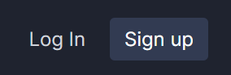
Enter your credentials and click Log In
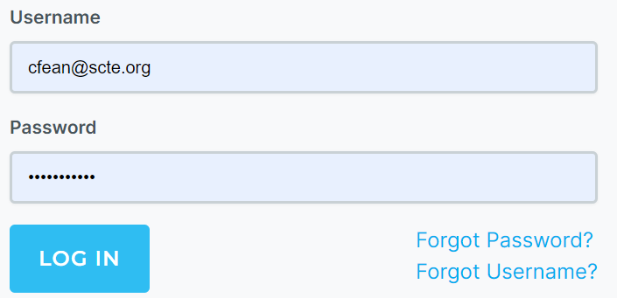
Your name will now appear at the top right-hand side of the page.
Hover over your name and click My Courses.
You will then be routed to our LMS.

Then search for Live Learning.
