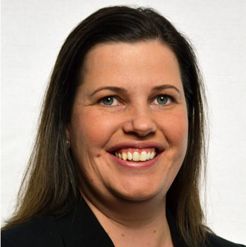

**Robin Fenton**

**Vice President of Membership & Learning Operations**

Robin Fenton is the Vice President of Membership & Learning Operations for the Society of Cable Telecommunications Engineers (SCTE). In this role, she oversees operations impacting 10,000 learners, 3,000 certified professionals, 60 chapters and 18,000 members worldwide. Her responsibilities include developing and executing strategies that encourage member engagement, customer satisfaction, learner development, and empowering volunteers to carry out the mission of SCTE at the local level.

Robin started her SCTE career in 2002 as manager of standards operations for SCTE, where she managed the cable industry standards process from the initial project authorization through committee approval and final American National Standards Institute (ANSI) review. In 2006, she became the director of chapter support, providing resources, tools and support for over 70 chapters and 1,100 volunteers. In addition to cable, her prior work includes utility, manufacturing and broadcasting industry experience.

She earned her master’s in business administration from Pennsylvania State University and her bachelor’s in communications emphasis in broadcasting and public relations from Mansfield University. In 2020, she was recognized as a leader in the cable industry as a CableFax Honoree for Most Powerful Women in Cable.